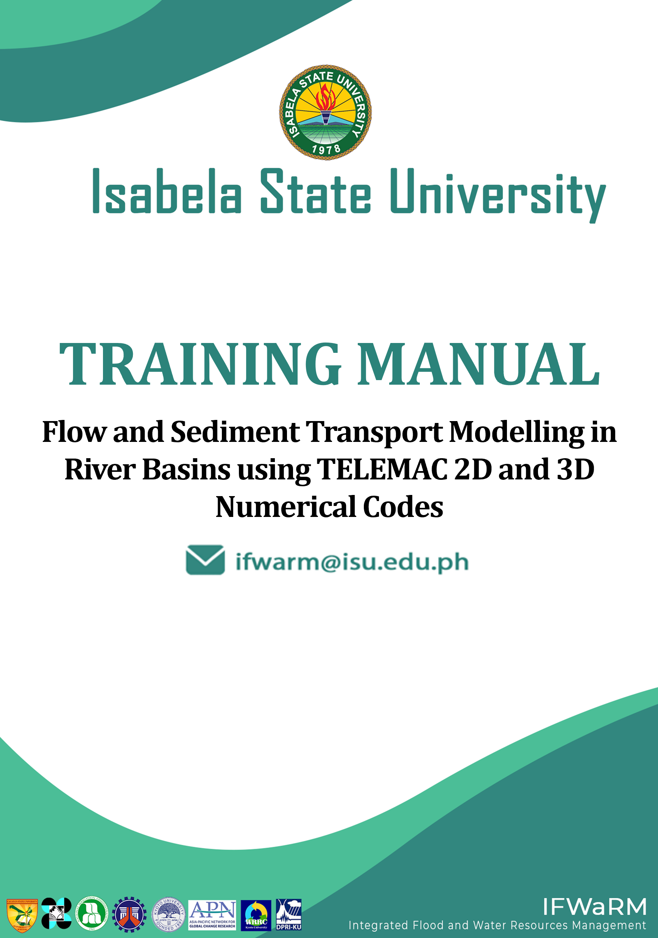

**Training Manual on Flow and Sediment Transport Modelling in River Basins using TELEMAC 2D and 3D Numerical Codes**

Training Manual

Isabela State University

*Water Resources Development Center (WReDC)*

Integrated Flood and Water Resources Management in ASEAN Basins for Integrated Development (IFWaRM)

Cagayan State University

Kyoto University-Disaster Prevention Research Institute (DPRI)

Asia Pacific Network (APN)

Department of Science and Technology

National Irrigation Administration

Contents

Rationale 10

Objectives 11

TELEMAC - MASCARET 12

Main Applications 12

Modules 13

i. Pre-requisites 15

ii. Training Guide 15

iii. Software Resources Options 16

Option I – Manual Installation of TELEMAC-MASCARET and Prerequisites 16

Advantages 16

Disadvantages 16

Option II - Use of Virtual OS (Mint HyFo) within a Virtual Environment 16

Advantages 16

Disadvantages 16

iv. General Computer Requirements 16

1. The TELEMAC File Structure 17

1.1. Mandatory Files 17

1.1.1. The Geometry File 17

1.1.2. The Boundary Conditions File 17

1.1.3. The Steering File 17

1.2. Optional Files 17

1.2.1. Stage-discharge (or WSE-Q) File (txt - ASCII) 17

1.2.2. Friction Data File (tbl/txt - ASCII) 17

1.2.3. The Results/Restart file (SLF or MED) 17

2. Installation Procedures 18

Note: Enable .NET Framework 3.5 (Includes .NET 2.0 and 3.0) 18

2.1. TELEMAC Installation 18

2.1.1. Automatic Installer failure 28

2.1.2. Installing Python 3 31

2.1.3. Adding items into the System Variables Path 34

2.1.4. Example Run Test 45

2.2. Use of Virtual Machine (Mint HyFo VM) 49

2.2.1. Creating and Enabling the Shared Folder option 56

2.3. Installing Blue Kenue 59

3. Pre-processing utilizing Blue Kenue 62

3.1. Generating Selafin File using Blue Kenue (Geometry File) 62

3.1.1. The Blue Kenue Interface 62

3.1.2. Opening/Importing Data in Blue Kenue 63

3.1.3. Viewing Data in Blue Kenue 66

3.1.3. Mesh Generation 68

3.1.4. Interpolating the DEM into the Created Mesh 76

3.1.5. Saving Files and the Workspace 83

3.2. Generating Boundary Conditions File Using Blue Kenue 85

3.3. Understanding and Creating a Steering File (CAS File) 96

3.3.1. Sample Steering File for a **Purely Hydrodynamic Scenario** in Magat Reservoir (Initial/Uncorrected) 96

3.3.2. Sample Steering File for a Purely Hydrodynamic Scenario in Magat Reservoir (Adjusted/Corrected) 98

3.3.3. Sample Steering File for Modelling a Sediment Transport Scenario using TELEMAC coupled with the GAIA Module (Initial/Uncorrected) 99

3.3.4. Sample Steering File for Modelling a Sediment Transport Scenario by Coupling TELEMAC with the GAIA Module (Adjusted/Corrected) 101

3.3.5. Sample Steering File for Modelling a Sediment Transport Scenario using TELEMAC coupled with GAIA Module and imposing a Hydrograph File (Initial/Uncorrected) 102

3.3.6. Sample Steering File for Modelling a Sediment Transport Scenario using TELEMAC coupled with GAIA Module and imposing a Boundary File (Corrected/Adjusted) 103

3.3.7. Creating a Steering File Using Notepad (or any basic text editing software available) 105

4. Running the Model Setup 107

4.1. Running a Hydrodynamic Simulation on Windows Environment 107

Step 1: Open DOS Command Prompt. 107

Step 2: Change the directory in the TELEMAC config file folder. 108

Step 3: Load the config file. 109

Step 4: Change the directory in the **Simulation_Files** folder 110

Step 5: Start the simulation. 110

4.2. Mint HyFo (Linux) 114

Step 1: Boot up your virtual machine. 114

Step 2: Open Terminal. 114

Step 3: Change the directory in the TELEMAC config file folder. 115

Step 4: Load the config file. 115

Step 5: Change the directory in the **Simulation_Files** folder 116

Step 6: Start the simulation. 116

5. Post-Processing 117

5.1. Post-Processing Using Blue-Kenue 117

5.1.1. Visualizing Velocity in Blue Kenue 119

Appendix I: Enabling .NET Framework 3.5 123

Appendix II: List of Possible Errors 125

Appendix III: General Summary of Steps in Running a Model 128

Appendix IV: Visualized Results Files 129

Scenario 1 – Initial/ Uncorrected Steering File 129

Scenario 1– Adjusted Steering File 129

Scenario 2 – Initial/ Uncorrected Steering File 130

Scenario 2 – Adjusted Steering File 130

Scenario 3 – Initial/ Uncorrected Steering File 131

Scenario 3 – Adjusted Steering File 131

Appendix V: Downloading the latest release, TELEMAC v8p3 132

Appendix VI: Importing an existing shapefile as an outline. 135

**References** 137

# List of Figures

Figure 1 The open TELEMAC-MASCARET webpage 17

Figure 2 Registration Section Used in Creating and Logging in to Account 18

Figure 3 The Automatic Installer Link 18

Figure 4 The Automatic Installation: Opentelemac-Windows Link 19

Figure 5 The TELEMAC-MASCARET License Agreement 19

Figure 6 Approximate download size of the installer 20

Figure 7 The Open TELEMAC-MASCARET Setup Wizard 20

Figure 8 The License Agreement before proceeding to installation 20

Figure 9 The Components Selector Dialog Box (1) 21

Figure 10 Ready to install dialog Box 21

Figure 11 The Setup Dialog Box 22

Figure 12 . The Setup Dialog Box for the Prerequisites 22

Figure 13 The Component Selector Dialog Box 23

Figure 14 Popup Window for numpy-1.7.1 23

Figure 15 Finishing Setup for the Prerequisites 24

Figure 16 The Starting Dialog Box for the Source Code 24

Figure 17 The Component Selector for the Open TELEMAC-MASCARET Source Code 25

Figure 18 The Version Installation Setup 25

Figure 19 Starting the Installation of the TELEMAC-MASCARET Source Code 26

Figure 20 The Command Line Window during the Installation 26

Figure 21 The Dialog Box after a Successful SVN Checkout 27

Figure 22 The open TELEMAC-MASCARET root folder 27

Figure 23 A Sample Error Encountered during the TELEMAC Installation Process 28

Figure 24 The Default Installation Directory for TELEMAC 28

Figure 25 Renaming Newly Created Folder to "v8p2r1" 28

Figure 26 The SVN Checkout 28

Figure 27 The URL for the Repository and Checkout Directory 29

Figure 28 A screenshot during the SVN chekout 29

Figure 29 Right click >> **"SVN Update**" 30

Figure 30 A Snapshot of a Successful Checkout 30

Figure 31 The Python.org Download Site 31

Figure 32. Installation of the Latest Version of Available Python 31

Figure 33. A Snapshot of a Successful Setup 32

Figure 34 Typing cmd in the Search Files and Programs Box 32

Figure 35 The Windows Command Prompt Terminal 33

Figure 36 Installation of Required Packages in Python3 33

Figure 37 Successful installation of Required Libraries 33

Figure 38 Editing the System Environment Variables 34

Figure 39 The System Properties Window 34

Figure 40 The Environment Variables Window 35

Figure 41 The Edit Environment Variable Window 36

Figure 42 Adding a New Path 36

Figure 43 The Config Files in the Folder 37

Figure 44 The Configs File Directory 37

Figure 45 Initiation of the "Change Directory" Command in the cmd Environment 38

Figure 46 Command Line after Changing Directory 38

Figure 47 The Command Line after Entering the **dir** Command 39

Figure 48 Successful Loading of the Config File 39

Figure 49 The Command Line after the **cd..** Command 40

Figure 50 The cmd Line after Changing to the Python3 Directory 40

Figure 51 Checking the Proper Loading of Config File 41

Figure 52 The Successful Loading of the Config File 41

Figure 53 The Command Used to Compile TELEMAC (for Python3) 42

Figure 54 The Command Line during the Compilation Process 42

Figure 55 The Command Line after the Successful Compilation 43

Figure 56 Successful Loading of the Config File 44

Figure 57 Changing the Directory (1) 44

Figure 58 Changing Directory to the Simulations Files Location 45

Figure 59 Typing dir to Display Contents 45

Figure 60 The Contents of the Okada Folder after Running the **dir** Command 46

Figure 61 The Command Used to Start the Simulation 46

Figure 62 Correct end of run 47

Figure 63. The Mint Hyfo VM Download Section 48

Figure 64. The VirtualBox Webpage 49

Figure 65. The VirtualBox Downloads Section 49

Figure 66. The Oracle VM VirtualBox Custom Setup 50

Figure 67. The VirtualBox Confirmation Message before the Installation Process 50

Figure 68. Beginning the Installation Process 51

Figure 69 The Setup Wizard During the Setup 51

Figure 70. Finishing the Installation Procedure 51

Figure 71. The Virtual Box Interface 52

Figure 72. Launching the Import Appliance Window 52

Figure 73. The Import Virtual Appliance Window 53

Figure 74. The Location of *.ova in a Folder Directory 53

Figure 75. The Selected and Loaded .ova File 54

Figure 76. Tweaking Properties to Suit your Computer Capabilities 54

Figure 77. A Sample Duration of Importation Process 55

Figure 78. Starting the Machine 55

Figure 79. Opening the Machine Settings 55

Figure 80. The Shared Folders Tab 56

Figure 81. The Add Share Folder Window 56

Figure 82. Designating TELEMAC Training Folder 57

Figure 83. The Updated Shared Folder Tab 57

Figure 84. The National Research Council Webpage 58

Figure 85. The Request Form to be Filled Up 58

Figure 86. The Confirmation of the Installation 59

Figure 87. The Duration of the Installation 60

Figure 88. Finishing the Installation Process 60

Figure 89. The Blue Kenue User Interface 61

Figure 90. Parts of the Blue Kenue User Interface 62

Figure 91. The Extracted Contents of the TELEMAC Training Folder 63

Figure 92. Importing the Bathymetry Data Using the Open Button 63

Figure 93. Toggling All Files (*.*) in Opening/Importing Bathymetry Data 64

Figure 94. Viewing Items in Blue Kenue through a Views Object 65

Figure 95. Other View Options Available in Blue Kenue 65

Figure 96. An Example of a 3D Isometric View 66

Figure 97. Step 1: Creating New Closed Line to Represent the Reservoir Boundaries 67

Figure 98. Naming the Newly Created Outline 68

Figure 99. Query upon Pressing ESC 68

Figure 100. The Current Workspace with the Outline in Dragged into the View Object 68

Figure 101. Current Workspace 69

Figure 102. Opening a New T3 Mesh Generator 69

Figure 103. The New T3 Mesh Properties Window 70

Figure 104. Dragging the Generated Outline into the Generator 71

Figure 105. Running the Mesh Generator 72

Figure 106. Running the Generator 72

Figure 107. The Mesh Generator 72

Figure 108. The Mesh Generator after a Successful Run 73

Figure 109. A Newly Generated Mesh 73

Figure 110. Renaming the Mesh 73

Figure 111. The Newly Created Mesh in 2D View 74

Figure 112. Process of Deactivating an Object in the View Section 74

Figure 113. Creating a New Selafin Object 75

Figure 114. Adding a New Variable to the Selafin Object 75

Figure 115. The Add New SELAFIN Variable Window 76

Figure 116 The new **Variable** has been added 76

Figure 117. Adding a 2D Interpolator 76

Figure 118. Dragging the 2017_DEM Item into the Newly Added 2D Interpolator Tool 77

Figure 119. Selecting the Bottom Item 77

Figure 120. The Map Object Tool 78

Figure 121. Choosing the NewInterpolator2D 78

Figure 122. A Successful Interpolation Finished in 1.000 Seconds 79

Figure 123. Bottom Item in 2D View 79

Figure 124. The Mesh before the Interpolation 80

Figure 125. The Mesh after the Interpolation 80

Figure 126. Highlighting Selafin Item and Saving it into File 81

Figure 127 Saving an entire Workspace in Blue Kenue 82

Figure 128. Entering the File Name and Saving Your Workspace 82

Figure 129. Saving All Unsaved Items 83

Figure 130. Current Workspace 84

Figure 131. Steps in Creating a New Boundary Conditions Item 84

Figure 132. Available t3s Objects 85

Figure 133. The Newly Created Boundary Conditions Item 85

Figure 134. Dragging BOTTOM_BC into 2D View 86

Figure 135. The 2D View after Dragging BOTTOM_BC 86

Figure 136. Zooming in on the Upstream Section of the Reservoir 87

Figure 137. Double-clicking a Node to Start 87

Figure 138. Double-clicking the Other End of the Upstream Section 88

Figure 139. Selecting Add Boundary Segment 88

Figure 140. The Conlim Boundary Segment Editor 89

Figure 141. Boundary Properties for the Upstream Boundary Section 89

Figure 142. Base Map and the Digital Elevation File for Magat Reservoir 90

Figure 143. Zooming in on the Discharge Section 91

Figure 144. Double-clicking up to the End of the Downstream Section 91

Figure 145. Adding Boundary Segment for the Downstream Boundary 92

Figure 146. Boundary Properties for the Downstream Boundary Section 92

Figure 147. Rename the Items 93

Figure 148. Saving the Generated Conlim Item 93

Figure 149. Saving the Boundary Conditions into a File 94

Figure 150. Various Types of Boundary Conditions 94

Figure 151. Using Notepad in the Windows Files and Programs Search Option 104

Figure 152. A Sample Steering File for a Purely Hydrodynamic Scenario 104

Figure 153. Adding .cas File Extension 105

Figure 154. Typing cmd in the Search Files and Programs Box 106

Figure 155. The Windows Command Prompt Terminal 107

Figure 156. Command Line Interface after Changing Directory. 107

Figure 157. Typing dir to Display All Files inside the Directory 108

Figure 158. Directory Showing pysource.win10pll.bat 108

Figure 159. Directory Showing the Proper Loading to Avoid Returning Errors 109

Figure 160. Typing dir in the Next Line 109

Figure 161. The Contents of the Current Directory 110

Figure 162. Starting the Simulation through Line of Code 110

Figure 163. A Snapshot at the Start of the Simulation 111

Figure 164. A Snapshot during the Simulation 111

Figure 165. A Successful End of Run 112

Figure 166. Booting the Virtual Machine 113

Figure 167. The Min Hyfo User Interface 113

Figure 168. The Mint HyFo Terminal 113

Figure 169. Changing the Directory (2) 114

Figure 170. Loading the Config File 114

Figure 171. Changing the Directory (3) 115

Figure 172. The Correct Run in Mint Hyfo 115

Figure 173. The New File Called Magat_V2.slf 116

Figure 174. The Blue Kenue User Interface 116

Figure 175. Opening Magat_V2.slf 117

Figure 176. A successful Reading and Opening of the Results File 117

Figure 177 Results file content successfully loaded 118

Figure 178. Velocity UV under 2D View 118

Figure 179. Right Clicking on the VELOCITY UV to Display the Result 119

Figure 180. The 2D View with the Animate Playback Option 119

Figure 181. The Animated VELOCITY UV 120

Figure 182. The Display Option Properties 120

Figure 183. The Activation of the Legend Box 121

Figure 184. A Simple Visualization of the VELOCITY Profile Using Blue Kenue 121

Figure 185. Searching for Windows Features 122

Figure 186. The Windows Features window 122

Figure 187. Enabling the .NET Framework 3.5 123

Figure 188. TELEMAC Automatic Installation Failure 124

Figure 189. pip3 Error 124

Figure 190. The Configparser Error 125

Figure 191. No Module Named Request Error 125

Figure 192. Scenario 1 Velocity Profile Visualized in BlueKenue 128

Figure 193 Scenario 1 Velocity Profile Visualized in BlueKenue 128

Figure 194. Scenario 2 Velocity Profile Visualized in BlueKenue 129

Figure 195. Scenario 2 Sediment Transport Profile Visualized in BlueKenue 129

Figure 196. Scenario 3 Velocity Profile Visualized in BlueKenue 130

Figure 197. Scenario 3 Sediment Transport Profile Visualized in BlueKenue 130

Figure 198. Logging-in to your Telemac account 131

Figure 199. The Latest News section of the Telemac website 131

Figure 200. A short release statement regarding the availability of v8p3 version 132

Figure 201. The source code download section 132

Figure 202. Extracting the contents of the downloaded compressed file 133

Figure 203. Importing a shapefile 134

Figure 204. The Magat Reservoir outline loaded as a shapefile 135

# Rationale

Climate change poses great threats from disastrous floods and drought to the world, of which Japan, Vietnam, and Philippines are among the most affected countries. Human interventions such as deforestation, dam constructions, and expansion of irrigation system have magnified the impacts of climate change. Flood and sediment management in the river basin scale has also become a crucial issue for the Cagayan River Basin in the Philippines.

To resolve this issue, reliable numerical tools are needed. Numerical models do not only offer the potential to characterize flood inundation map, but also help in designing mitigating measures and support effective land use and emergency planning. In the same light, significant efforts have been made to use remotely sensed data (e.g., Classified Aerial Imagery, Light Detection and Ranging (LiDAR) Terrain Measurements) capable of providing high-resolution Digital Model Terrain (DTM) in 2D or even in 3D space, thereby guiding mesh generation and model parameterization.

TELEMAC’s applications range is very wide and comes with a range of modules for two-dimensional (2D) and three-dimensional (3D) modeling of hydro-morphodynamic processes of various water bodies from mountain rivers to coastal deltas under the influence of tides. Also, multiple sediment transport phenomena can be modeled and coupled with steady or unsteady flow conditions

Consequently, this training workshop provides an overview of the capabilities, limitations, and challenges related to hydraulic modelling of flow and sediment transport in rivers. Hence, the Isabela State University in the Philippines has organized this workshop training course in collaboration with Kyoto University on February 25-28, 2022. The details of the training course and other relevant information are given hereafter.

# Objectives

After completing this training, the participants are expected to:

1. Generate a computational mesh from a topographic data set using free pre-processing software Blue Kenue ([www.nrc-cnrc.gc.ca/eng/solutions/advisory/blue_kenue_index.html](http://www.nrc-cnrc.gc.ca/eng/solutions/advisory/blue_kenue_index.html));
2. Create input files to execute TELEMAC2D and TELEMAC3D;
3. Assess the impact of imposed flow on near- and far-field river hydrodynamics; and
4. Analyze and visualize TELEMAC output files using third party charting and data analysis software.

# TELEMAC - MASCARET

TELEMAC-MASCARET or simply TELEMAC, is an integrated suite of solvers for use in the field of free-surface flow, waves, water quality and sediment transport (Galland, Goutal, & Hervouet, 1991). Having been used in the context of many studies throughout the world, TELEMAC has become a major standard in its field. It was made “open source” in 2010 to be freely available to the whole community of consultants, universities, and researchers while being actively supported and continuously developed by a consortium of industrials, consultants, and research organizations. Anyone can, therefore, take advantage of TELEMAC and assess its performance. For more information about TELEMAC-MASCARET see [www.openTELEMAC.org](http://www.opentelemac.org).

Furthermore, this training course covers a broad range of modelling techniques for fluvial processes using the TELEMAC suite of computer models. Lectures will provide both theoretical background and practical aspects of modelling flow and sediment transport processes. Introductory topics, which can be grasped by the participants without a background in numerical methods, will be followed by advanced topics such as mesh generation/optimization, selection of numerical schemes, and flow and sediment interactions.

Thus, the capabilities and benefits of the TELEMAC modelling system will be shown by hands-on application using data sets acquired on real rivers.

## Main Applications

TELEMAC can be used in the following but not limited to:

* Flood Studies
* Estuary Management and Development
* River Restoration Studies
* Dam Bursts
* Hydro Sedimentary Studies
* Wate Quality
* Dumping of Dredged Materials
* Impact of Hydraulic Structures
* Study of Marine Climates
* Harbor Installation Studies

## Modules

(Adapted from the [www.openTELEMAC.org](http://www.opentelemac.org) website)

1. SISYPHE - Sediment Transport and Bed Evolution

It is a state-of-the-art sediment transport and bed evolution module of the TELEMAC-MASCARET modelling system which can be used to model complex morphodynamics processes in diverse environments such as coastal, rivers, lakes, and estuaries for different flow rates, sediment size classes, and sediment transport modes.

1. NESTOR- Modelling Dredging Operations in the River Bed

NESTOR, coupled with the morphodynamic module SISYPHE, offers the possibility of using documented data from dredging operations to model the resulting changes in the bottom level. Thus, the period, volume of sediment removed during that period, and size and location of the dredging site can be defined. This data can subsequently be used to determine the resulting bottom level for that site.

1. MASCARET- One- Dimensional Free Surface Flow Modelling

MASCARET includes one-dimensionnal free surface flow modelling engines. Based on the Saint-Venant equations, different modules can model various phenomena over large areas and for varied geometries: meshed or branched network, subcritical or supercritical flows, steady or unsteady flows.

1. TELEMAC-2D

TELEMAC-2D is used to simulate free-surface flows in two dimensions of horizontal space. At each point of the mesh, the program calculates the depth of water and the two velocity components.

1. TELEMAC- 3D

TELEMAC-3D is a three-dimensional (3D) model that uses the same horizontally unstructured mesh as TELEMAC-2D. The wave formulation for the updating of free surface is used for efficiency. The model mesh is developed as a series of model planes between the bed and surface planes. In addition, flexibility in the placement of these planes permits the use of a sigma grid (each plane at a given proportion of the spacing between bed and surface) or several other strategies for intermediate plane location. One useful example is to include some planes which are at a fixed distance below the water surface, or above the bed. In the presence of a near surface thermocline or halocline, this is advantageous in so far to avoid the mixing of water between the near surface planes where the greatest density gradients are located.

1. TOMAWAC

TOMAWAC is used to model wave propagation in coastal areas. By means of a finite-element type method, it solves a simplified equation for the spectro-angular density of wave action. This is done for steady-state conditions (i.e., with a fixed depth of water throughout the simulation).

1. ARTEMIS

ARTEMIS is a scientific software dedicated to the simulation of wave propagation towards the coast or into harbours over a geographical domain of about few square kilometers. The domain may be larger for simulation of long waves or resonance. The frequency dependence and directional spreading of the wave energy is considered by ARTEMIS.

# Pre-requisites

This training course is much suited to individuals with basic knowledge on hydrological/ hydraulic modelling, rainfall-runoff analysis, river catchment, open-channel flow, and sediment transport mechanics. It can serve as an introduction to numerical modelling of flow and sediment transport in rivers.

# Training Guide

This training manual is based from the user manuals provided by the TELEMAC developers at <http://wiki.opentelemac.org> and the Hydro-Informatics website, <https://hydro-informatics.com/index.html> by Sebastian Schwindt © Copyright 2022.

TELEMAC’s applications range is very wide and comes with a range of modules for two-dimensional (2D) and three-dimensional (3D) modeling of hydro-morphodynamic processes of various water bodies from mountain rivers to coastal deltas under the influence of tides. Also, multiple sediment transport phenomena can be modeled and coupled with steady or unsteady flow conditions.

On this note, this manual will only feature the following tutorials:

* Generating a Selafin *.slf* geometry mesh using BlueKenue
* Creating a boundary condition *.cli* file using BlueKenue
* Creating and understanding a Steering *.cas* file.
* Setup a purely hydrodynamic, steady Telemac2d simulation in the first scenario
* Couple hydrodynamics (i.e., Telemac2d) with morphodynamics (i.e., Sediment transport) in the second and third scenario simulations.

# Software Resources Options

## Option I – Manual Installation of TELEMAC-MASCARET and Prerequisites

### Advantages

* There is a full control over modules to be installed (high flexibility).
* The latest version of TELEMAC can be installed and updated regularly.
* Up-to-date compilers and all libraries exactly match the system.
* It is works best with larger datasets and more computation-demanding activities (i.e., real world simulations).

### Disadvantages

* The variety of installation options may cause errors when incompatible packages are combined.
* The installation of optional modules such as AED2, HPC, and parallelism may be challenging.
* The installation may take at least two hours depending on the internet speed.

## Option II - Use of Virtual OS (Mint HyFo) within a Virtual Environment

### Advantages

* It has ready-to-use environment with TELEMAC v8p3 installed and dynamically compiled with parallelization enabled through *openmpi.*
* It is specifically tailored to shorten the lengthy and time-consuming installation of TELEMAC and other prerequisites.

### Disadvantages

* It has limited computing ability.

# General Computer Requirements

* Intel Core i5-8th Gen or Ryzen 5 3000 Series processors and above
* RAM: 8 GB Minimum; 32 GB and above is much preferred
* Disk Space: at least 50 GB
* CPU Cores: 4 cores minimum; 8 cores and above is preferred
* Processor speed: 2.3 GHz and above

# The TELEMAC File Structure

## Mandatory Files

### The Geometry File

The geometry file in *.slf (selafin or SERAFIN) or *.med (MED file) format contains binary data about the mesh with its nodes. It can be created using Blue Kenue or through SALOME-HDRO.

### The Boundary Conditions File

The boundary file in *.cli format contains information about inflow and outflow nodes (coordinates and IDs). The *.cli file can be opened and modified with any text editor, which is not recommended to avoid inconsistencies. Preferably use Fudaa PrePro or Blue Kenue for generating and/or modifying *.cli files.

### The Steering File

The steering file is the main simulation file with information about mandatory files (e.g., the selafin geometry or the boundary), optional files, and simulation parameters. The steering file can be created or edited with a basic text editor or advanced software such as Fudaa PrePro or Blue Kenue.

## Optional Files

### Stage-discharge (or WSE-Q) File (txt - ASCII)

It defines a stage-discharge file to use a stage (water surface elevation WSE) - discharge relationship for boundary conditions. Such files typically apply to the downstream boundary of a model at control sections (e.g., a free overflow weir).

Also, stage-discharge files can be used by defining the following keyword in the steering file: “STAGE-DISCHARGE CURVES FILE: YES”.

### Friction Data File (tbl/txt - ASCII)

This optional file enables the definition of bottom friction regarding the roughness law to use and associated function coefficients.

### The Results/Restart file (SLF or MED)

A restart file stems from a previous TELEMAC simulation but is not needed to exist prior to any simulations. It can, however, speed up simulations.

Definitions adapted from the Hydro-informatics website <https://hydro-informatics.com/index.html>.

# Installation Procedures

## Note: Enable .NET Framework 3.5 (Includes .NET 2.0 and 3.0)

MPICH2, one of the prime components of TELEMAC requires the older version .NET Framework 2, which must be enabled through the Windows Features. This will prevent some future errors in regards with using the MPICH.

Please see Appendix I for instructions.

## TELEMAC Installation

Notes:

* If the software is already installed, please proceed to the next section.
* Account for at least 2 hours (depending on internet speed) for the installation.
* Internet connection is required.

1. Open your browser and head to [www.opentelemac.org](http://www.opentelemac.org) and Click “**LOGIN**”.

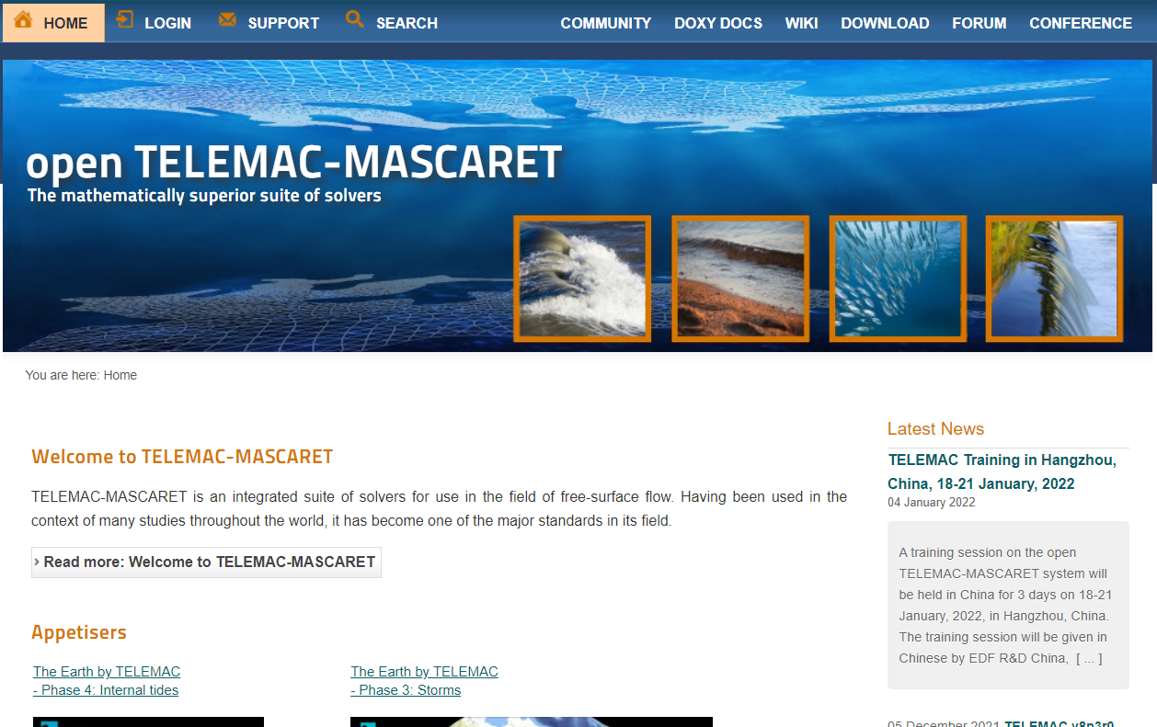

Figure 1 The open TELEMAC-MASCARET webpage

1. To be able to download a copy of the installer, you must create an account first and log in. Create your own account by clicking “**REGISTER**”.

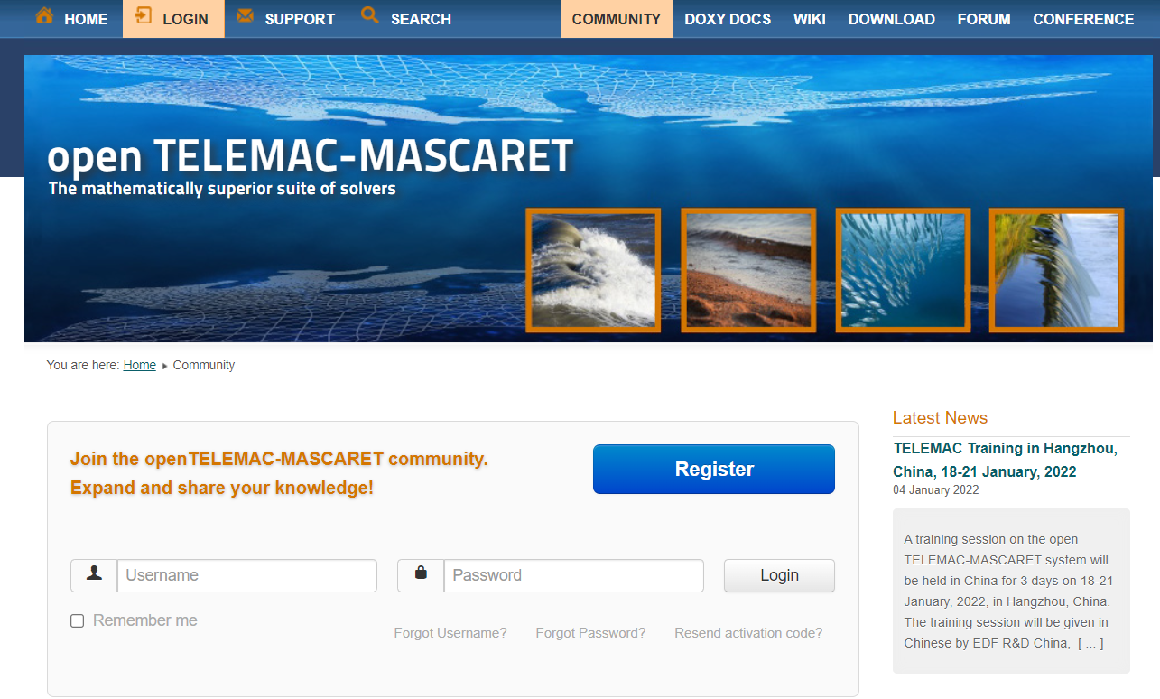

Figure 2 Registration Section Used in Creating and Logging in to Account

1. Once logged-in, head to the “**DOWNLOAD**” section and find the “**automatic installer**” option.

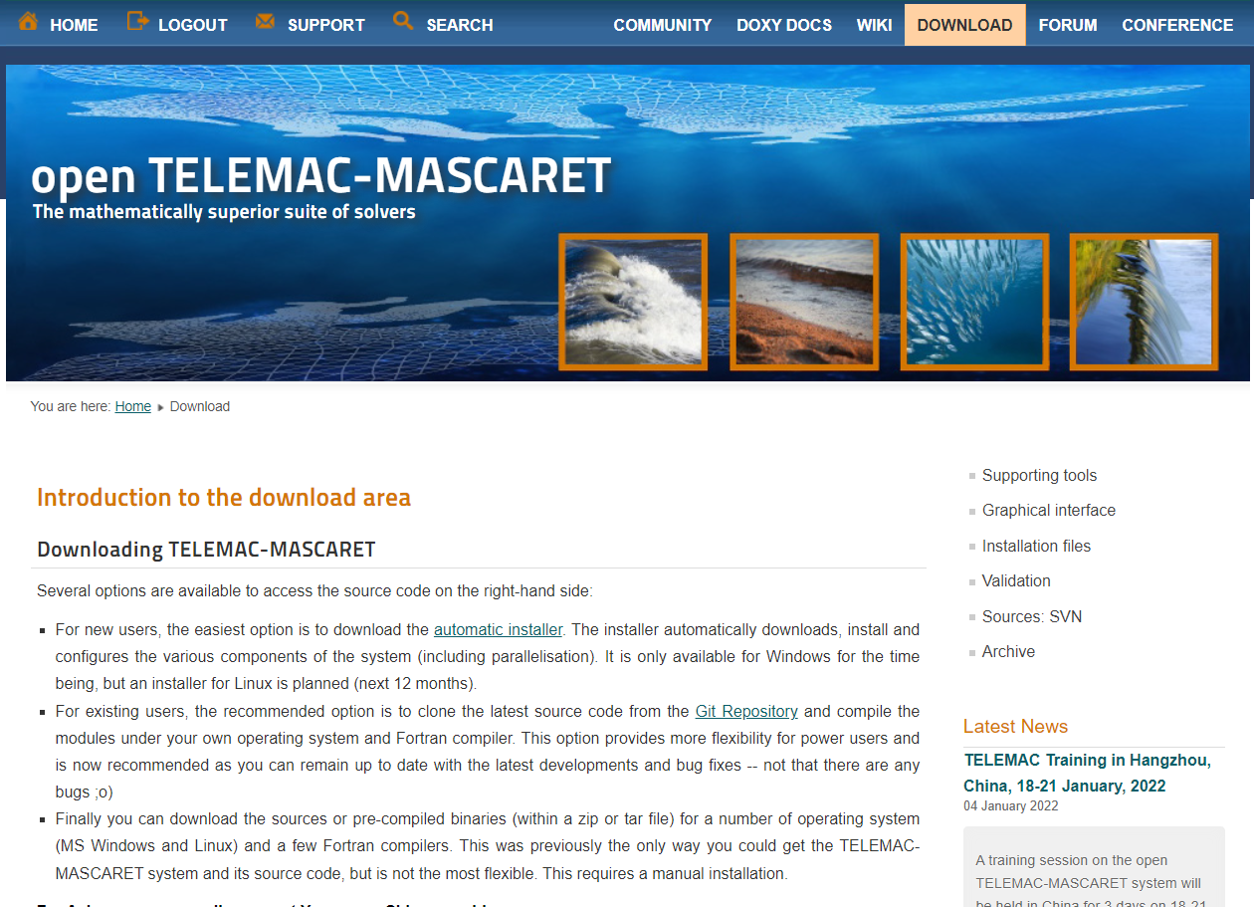

Figure 3 The Automatic Installer Link

1. Scroll down until the “**Automatic installation: opentelemac-windows**” section and click the link.

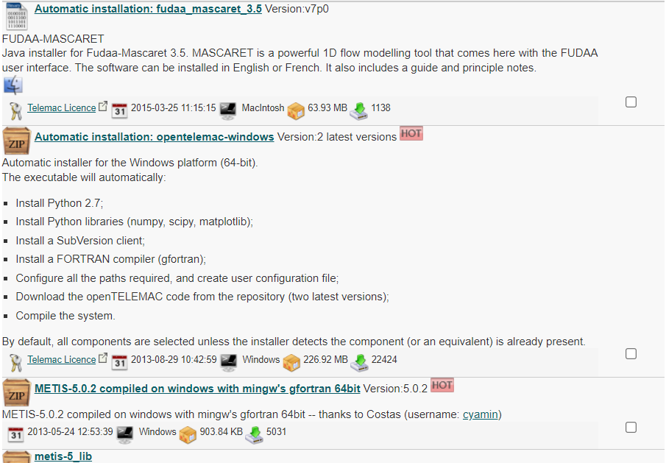

Figure 4 The Automatic Installation: Opentelemac-Windows Link

1. Read provided License Agreement, and, if you accept, tick the “**I Accept the above listed conditions**” option and then click “**Download**”.

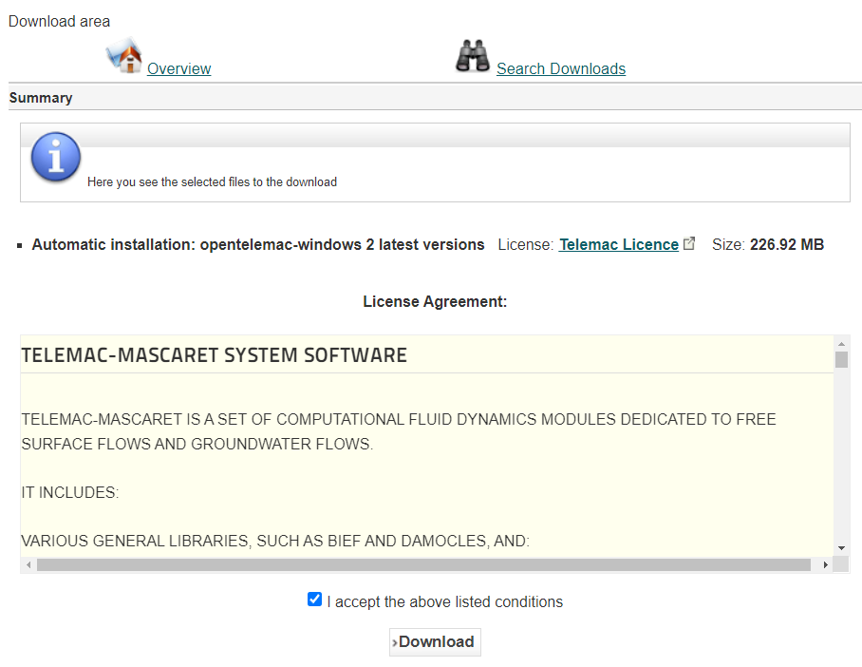

Figure 5 The TELEMAC-MASCARET License Agreement

1. Save the file into your computer and wait for it to finish. The file is about 227 MB.

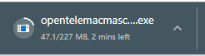

Figure 6 Approximate download size of the installer

1. Once finished, open the installer and click “**YES**” to proceed.
2. Once opened, click “**NEXT**” in the setup wizard to continue.

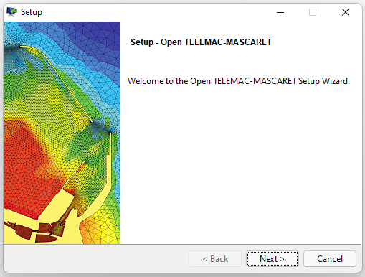

Figure 7 The Open TELEMAC-MASCARET Setup Wizard

1. Read the license and agreement, and if you accept, mark the “**I accept**…” option and click “**Next”**.

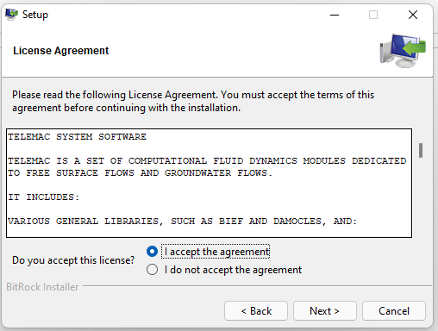

Figure 8 The License Agreement before proceeding to installation

1. Click “**Next**” to proceed.

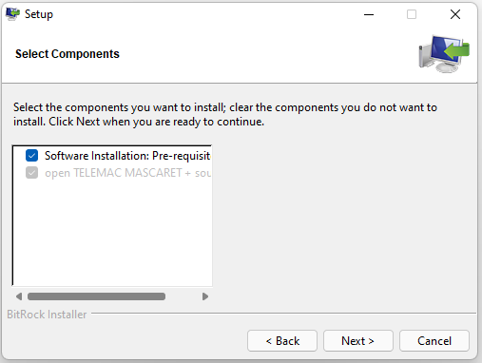

You can opt not to install pre-requisites if they have been already installed.

Figure 9 The Components Selector Dialog Box (1)

1. Click “**Next**” to start the set up.

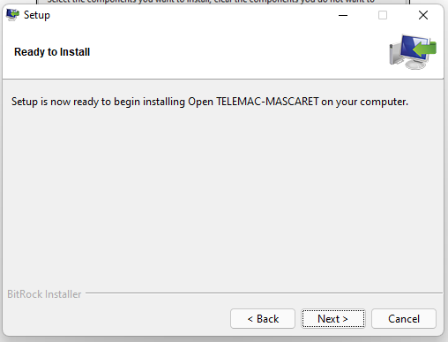

Figure 10 Ready to install dialog Box

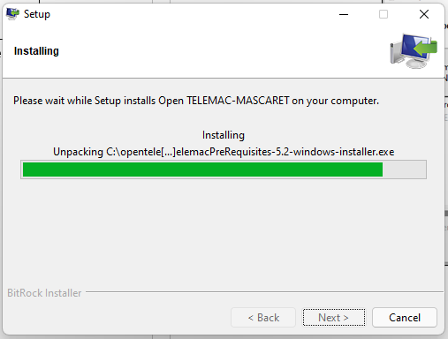

Figure 11 The Setup Dialog Box

1. The setup will now start installing the TELEMAC prerequisites. Just click “**Next**” to continue.

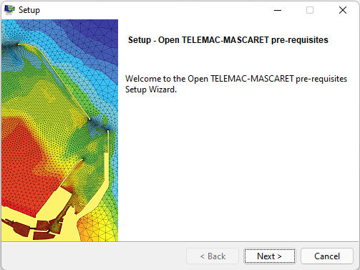

Figure 12 . The Setup Dialog Box for the Prerequisites

1. Make sure to select all the available components to be installed and then click “**Next**”

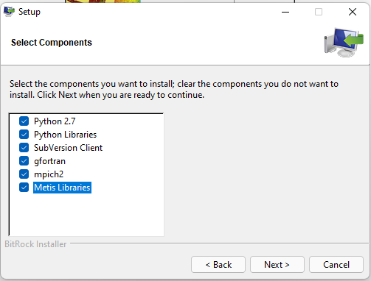

Figure 13 The Component Selector Dialog Box

1. Simply click “**Next**” in every pop-up window (i.e., numpy, scipy, matplotlib) that opens for the current installation.

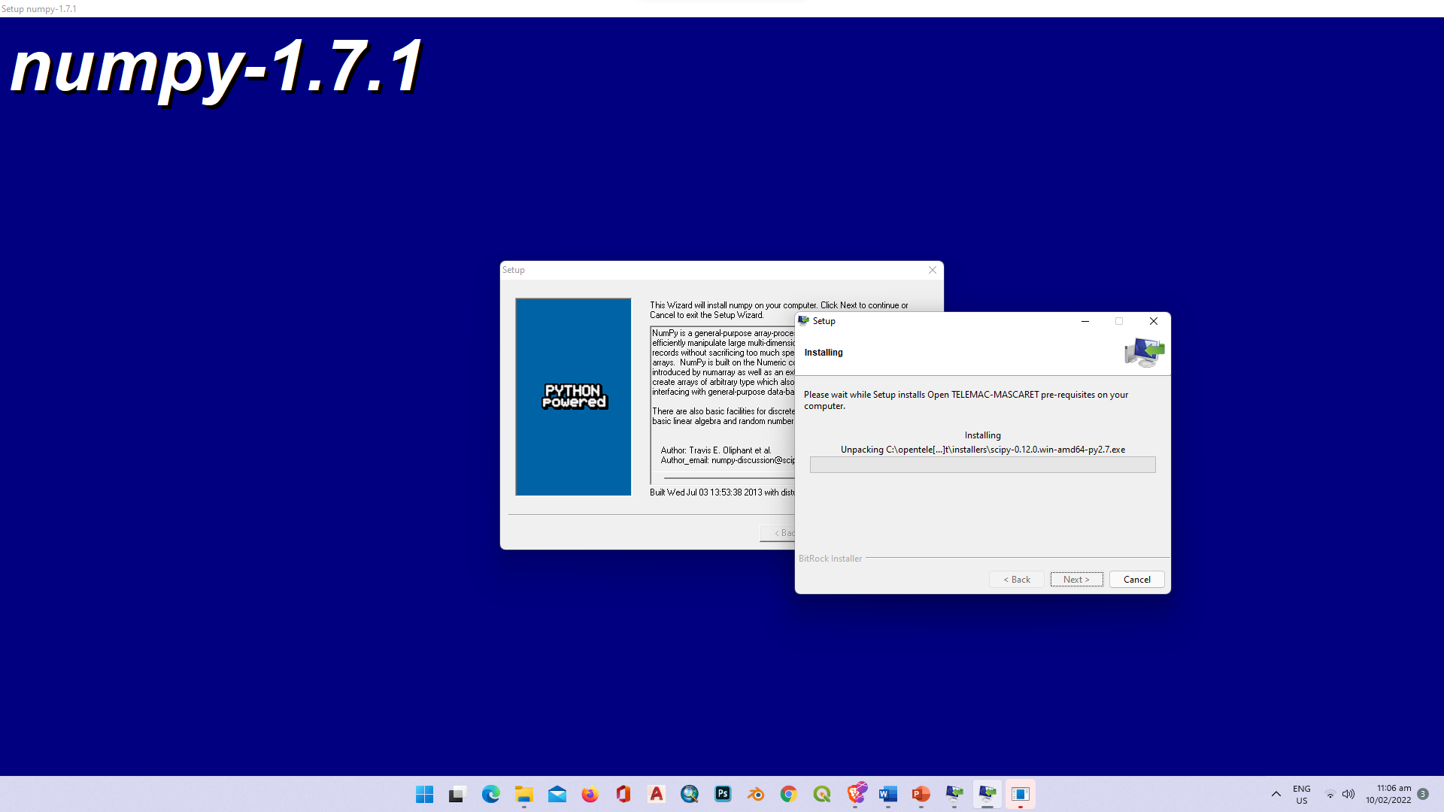

Figure 14 Popup Window for numpy-1.7.1

1. Once the setup for the prerequisites is finished, click on “**Finish**”

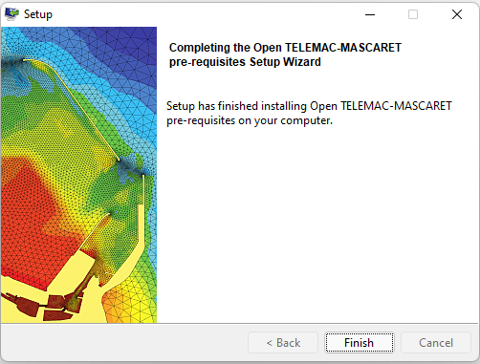

Figure 15 Finishing Setup for the Prerequisites

1. After the pre-requisites, setup for TELEMAC MASCARET and its source code will begin. Click “**Next**” >> “**Next**” to continue.

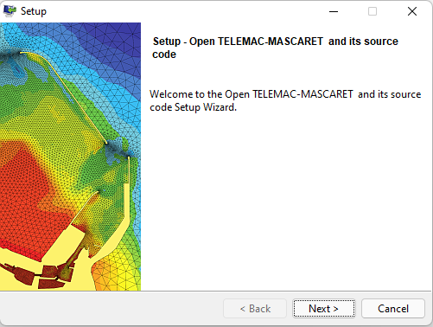

Figure 16 The Starting Dialog Box for the Source Code

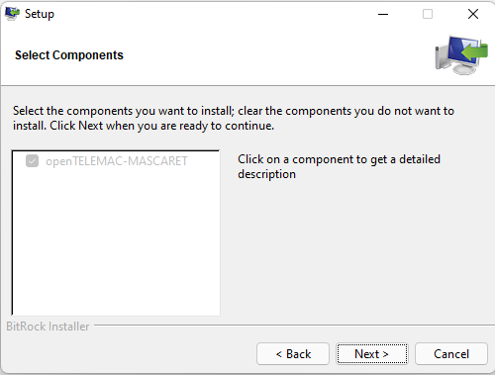

Figure 17 The Component Selector for the Open TELEMAC-MASCARET Source Code

1. Select the “**v7p0**” version or the **latest version** displayed and click “**Next**”>> “**Next**” to continue.

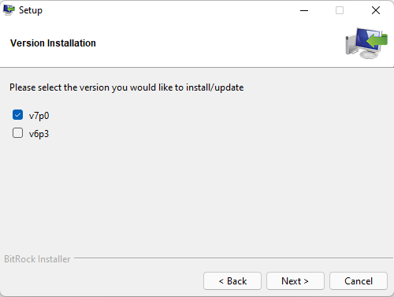

Figure 18 The Version Installation Setup

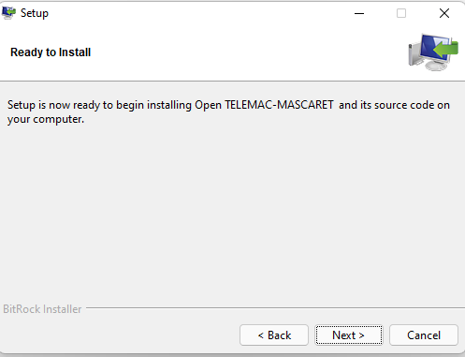

Figure 19 Starting the Installation of the TELEMAC-MASCARET Source Code

1. A command prompt window will open and install the necessary files through the SVN repository. The time of installation varies with the speed of your internet connection.

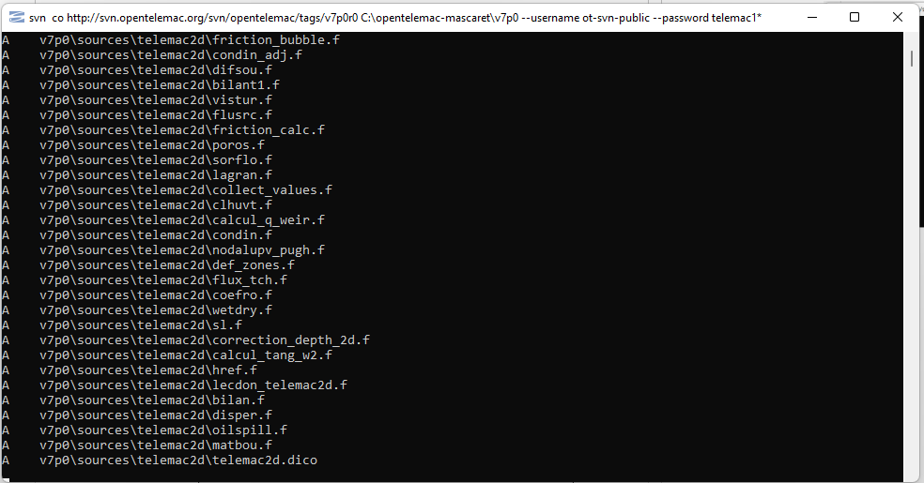

Figure 20 The Command Line Window during the Installation

1. After a successful checkout, a folder called v7p0 (or whatever the version selected beforehand) should have been created at the opentelemac-mascaret root folder containing all files and dependencies.

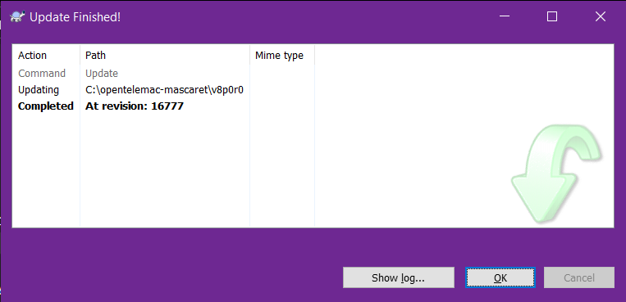

Checkout Finished!

Figure 21 The Dialog Box after a Successful SVN Checkout

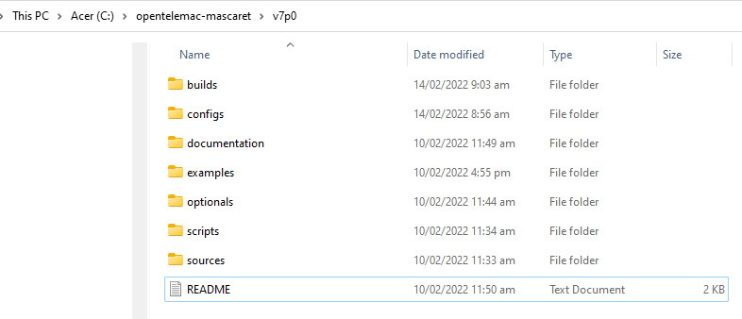

Figure 22 The open TELEMAC-MASCARET root folder

1. To test whether TELEMAC has been successfully installed, please follow the process described in the next section.

### Automatic Installer failure

1. However, if, for some reasons, the automatic installation fails, please follow the following instructions:

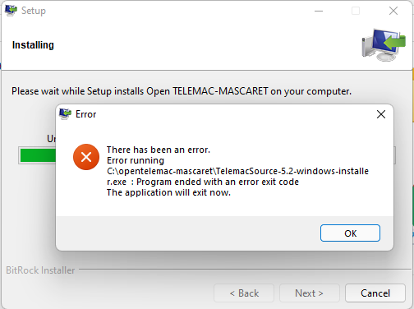

Figure 23 A Sample Error Encountered during the TELEMAC Installation Process

1. Since the automatic installation has encountered an error, we must manually install open TELEMAC-MASCARET.
2. To start, navigate into your installation folder (**C:\opentelemac-mascaret**)

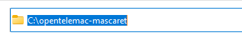

Figure 24 The Default Installation Directory for TELEMAC

1. In this directory, create a new folder called “**v8p2r1**”.

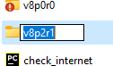

Figure 25 Renaming Newly Created Folder to "v8p2r1"

1. Right click on the newly created “**v8p2r1**” folder and select “**SVN Checkout**”

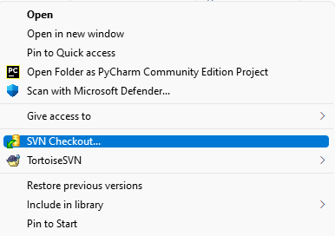

Figure 26 The SVN Checkout

1. A checkout window will be shown. On the URL repository, type <http://svn.opentelemac.org/svn/opentelemac/tags/v8p2r1/>. Then at the checkout directory, type C:\opentelemac-mascaret\v8p2r1, then click “**OK**”

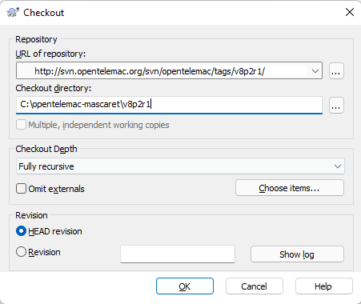

Figure 27 The URL for the Repository and Checkout Directory

1. Username: **ot-svn-public**
2. Password: **telemac1\***
3. The checkout process will download all the source codes and sub-folders and may take some time, depending on your download speed.

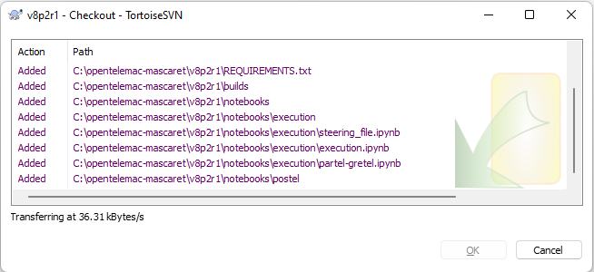

Figure 28 A screenshot during the SVN chekout

1. If ever the checkout crashed, you do not have to start again. Just right click on the **v8p2r1** folder and choose SVN Update to carry on the downloading process.

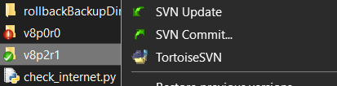

Figure 29 Right click >> **"SVN Update**"

1. Once the checkout is finished, click “**OK**”.

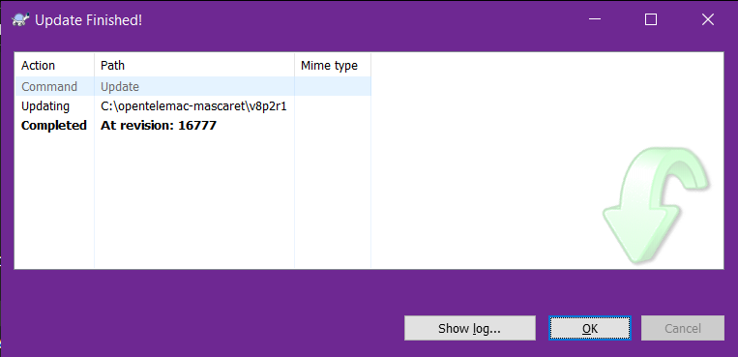

Figure 30 A Snapshot of a Successful Checkout

### Installing Python 3

1. Next step is to download the latest version of Python by going to <https://www.python.org/downloads/> . Python has been installed earlier along with the prerequisites. However, the version downloaded was not updated (python 2.7) whereas to be able to run advanced simulations (i.e., coupling with Gaia), python 3.0 and above is required. Additionally, python have already ended support of the 2.7 version last 2020-01-01.

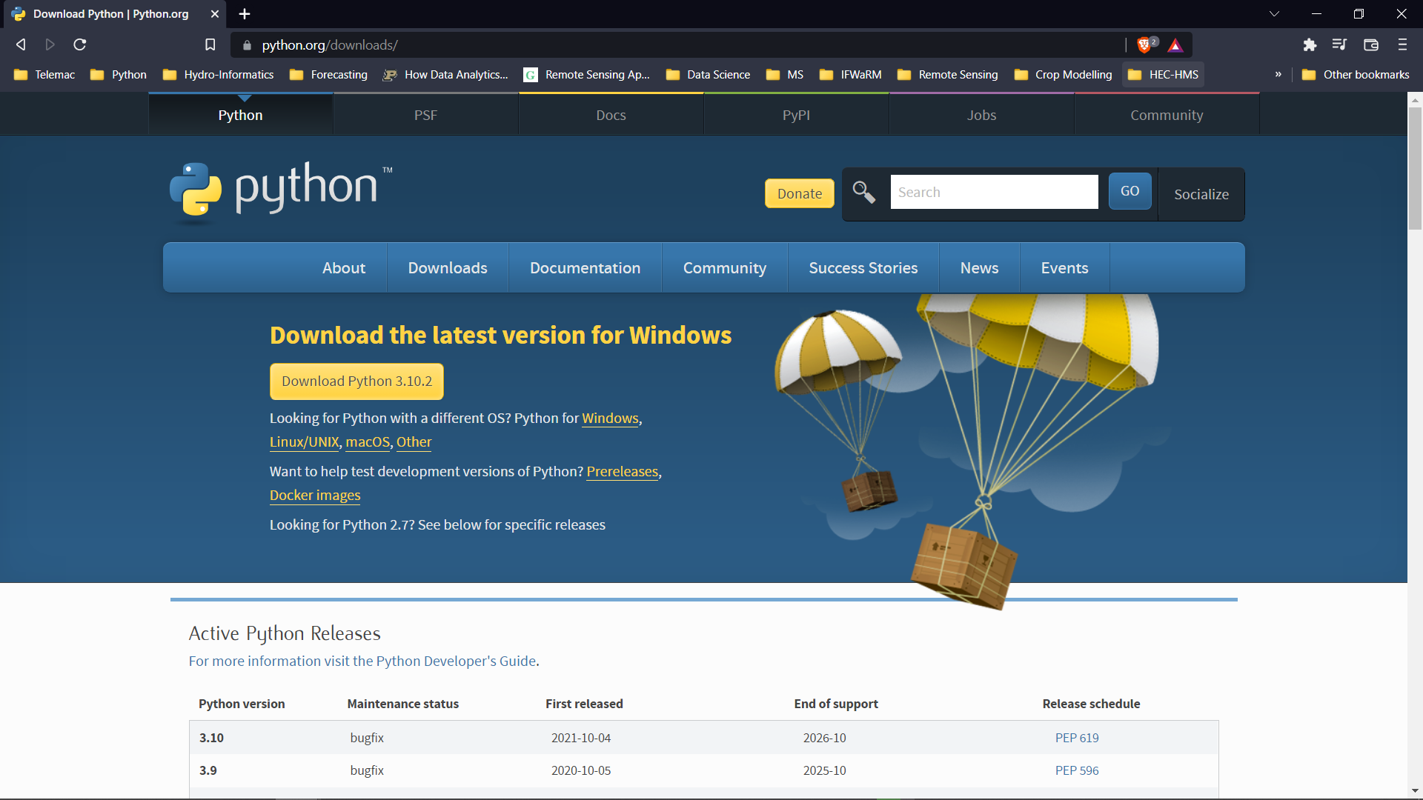

Figure 31 The Python.org Download Site

1. After downloading the latest version, run the installer. For this manual, the latest version available is python 3.10.2.

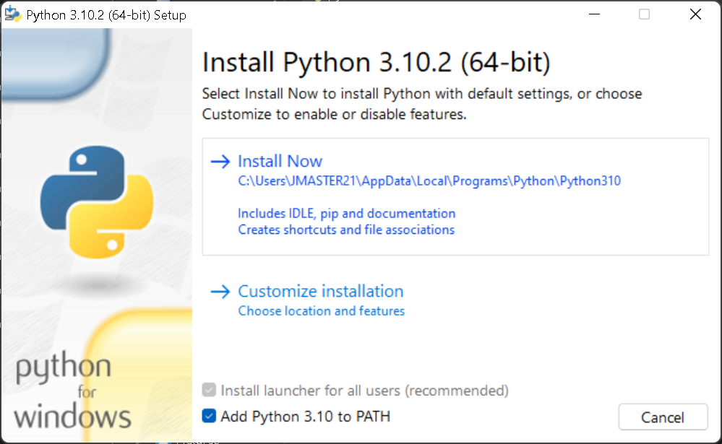

Make sure that the “**Add Python 3.10 to path**” option is selected before proceeding.

Figure 32. Installation of the Latest Version of Available Python

1. Click **Install Now.**

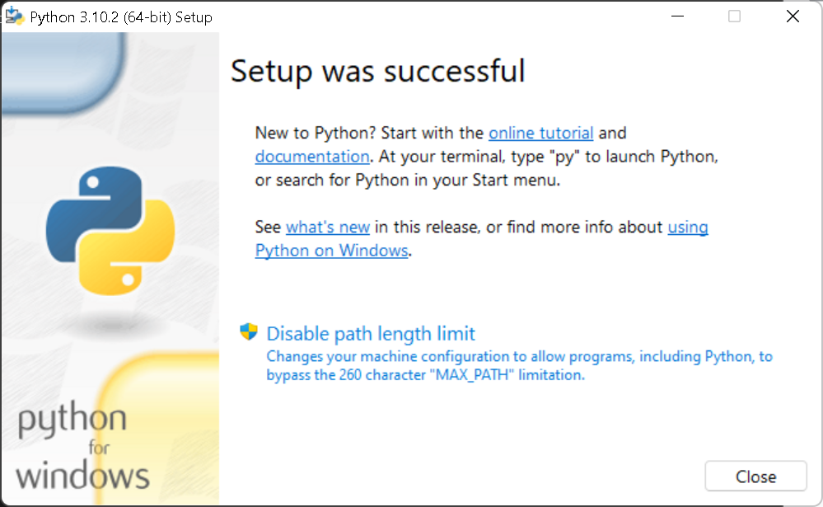

Figure 33. A Snapshot of a Successful Setup

1. After successful installation, we now manually install some packages using a package manager called **pip.**
2. Open DOS Command prompt. If you do not know where the command prompt is, go to the Windows start menu (or press windows key) and type “**cmd**” in the “Search files and programs” box and press **Enter**

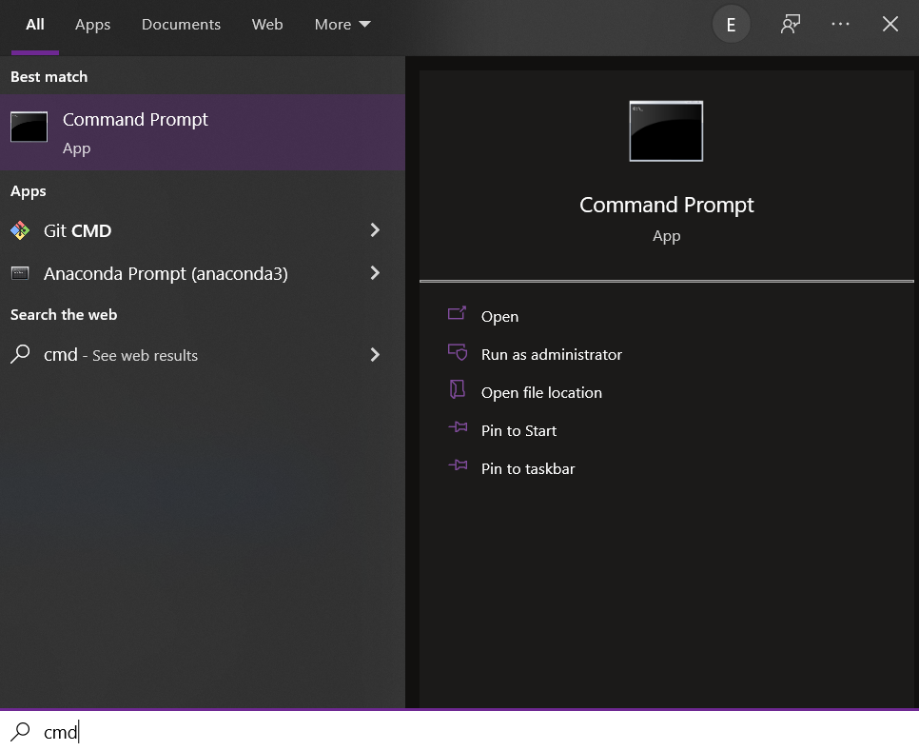

Figure 34 Typing cmd in the Search Files and Programs Box

1. Pressing enter would open the windows command prompt terminal:

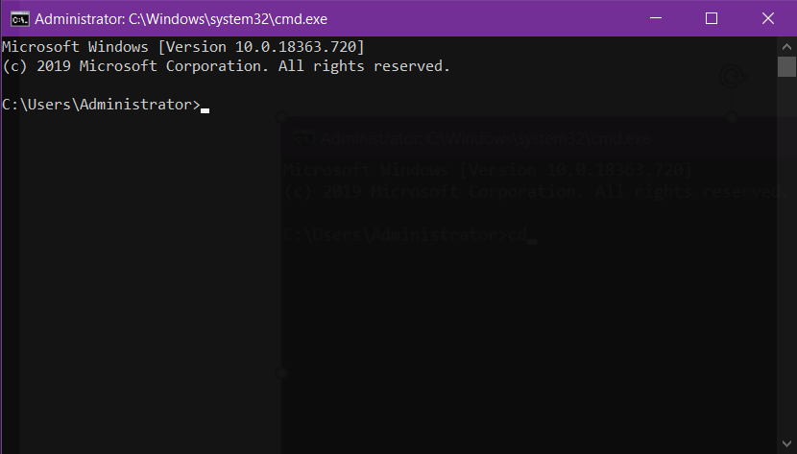

Figure 35 The Windows Command Prompt Terminal

1. In the cmd terminal, type “**pip3 install numpy scipy matplotlib**” without the quote marks then press **Enter**.

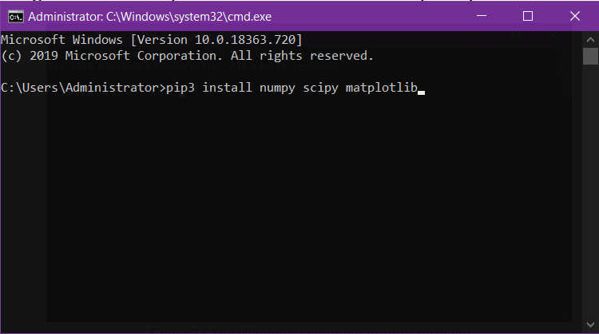

Figure 36 Installation of Required Packages in Python3

*Note: Make sure that you have a stable internet connection*

1. After running the above command, you should see a **Successfully installed** printout.

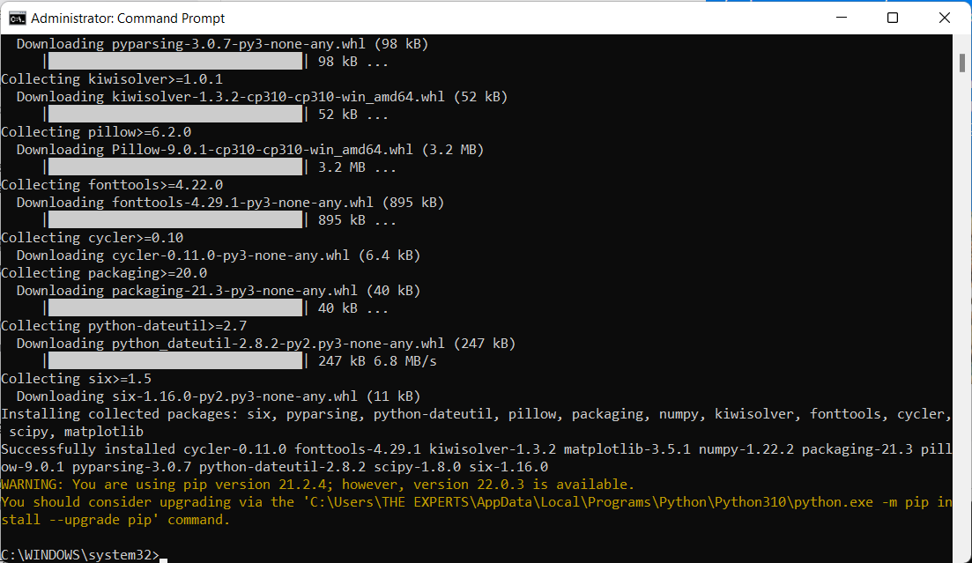

Figure 37 Successful installation of Required Libraries

### Adding items into the System Variables Path

1. Once python and the libraries are installed, the next step is to make sure that the **path** to python3.10 and your newly created folder are recognized by your system. To do so, go to Windows start menu or simply press the windows start button and type “**variables**” and press “**Enter”**.

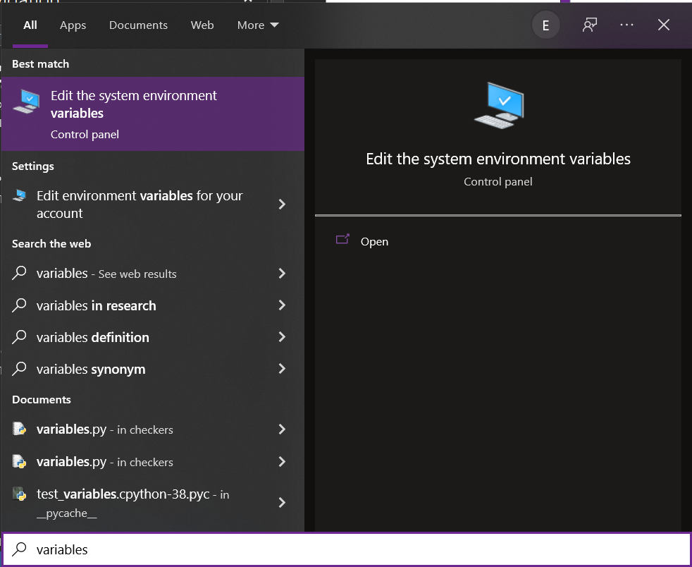

Figure 38 Editing the System Environment Variables

1. After pressing Enter, a system properties window will open then click on **“Environment variables**”.

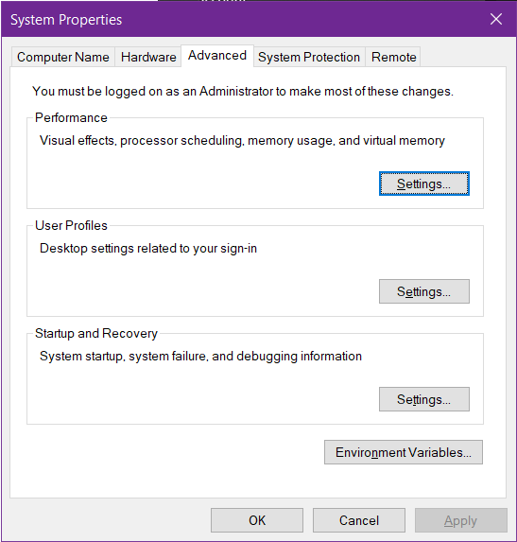

Figure 39 The System Properties Window

1. After that, another window for **Environment Variables** will pop up.

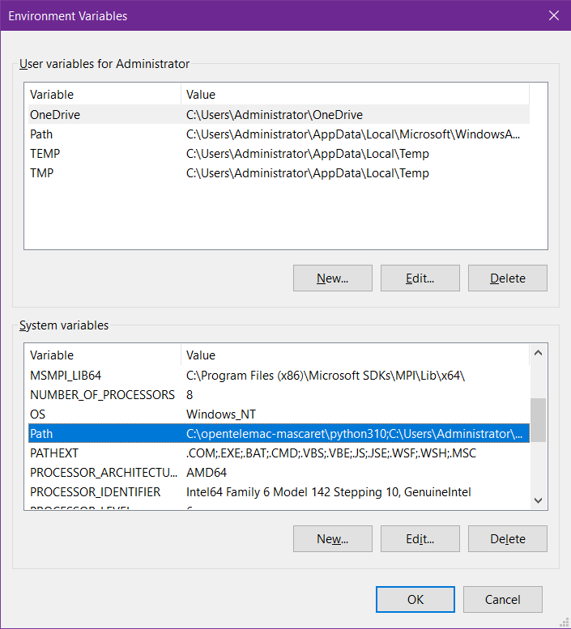

Figure 40 The Environment Variables Window

1. Under **System Variables**, double click on “**Path**”. Doing so will open another window called “**Edit Environment Variable**” and in this window, make sure that the following directory paths are added:

C:\Users\\**your_username*\*\AppData\Local\Programs\Python\Python310\

C:\opentelemac-mascaret\mingw64\bin

C:\opentelemac-mascaret\mpich2\bin

C:\opentelemac-mascaret\mpich2\lib

C:\opentelemac-mascaret\python27

*Note: Insert your computer’s user name at the <your_username>, and make sure to remove the asterisk signs afterwards.*

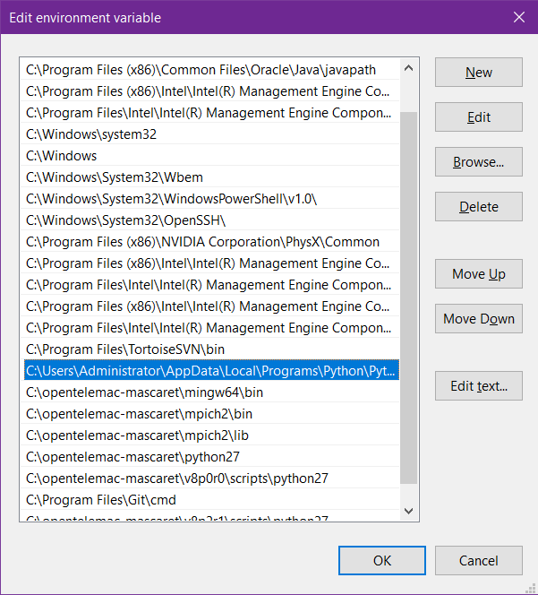

Figure 41 The Edit Environment Variable Window

1. If they are not yet present, add them individually by clicking “**New**” and typing each of them individually and clicking “**OK**” once finished.

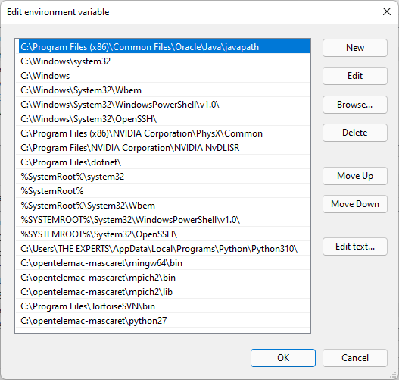

Figure 42 Adding a New Path

1. Click “**OK**” for each of the windows previously opened.
2. Next, download the provided config and batch file in the Config_Files folder inside the drive link provided.

<https://drive.google.com/drive/folders/1Zq848RdjXnW6o4KWjoastSbvnAO_CE1s?usp=sharing>

1. Extract both files (i.e., **pysource.win10pll.bat** and **Win10gfortPLL.cfg**) into the directory **C:\opentelemac-mascaret\v8p2r1\configs**

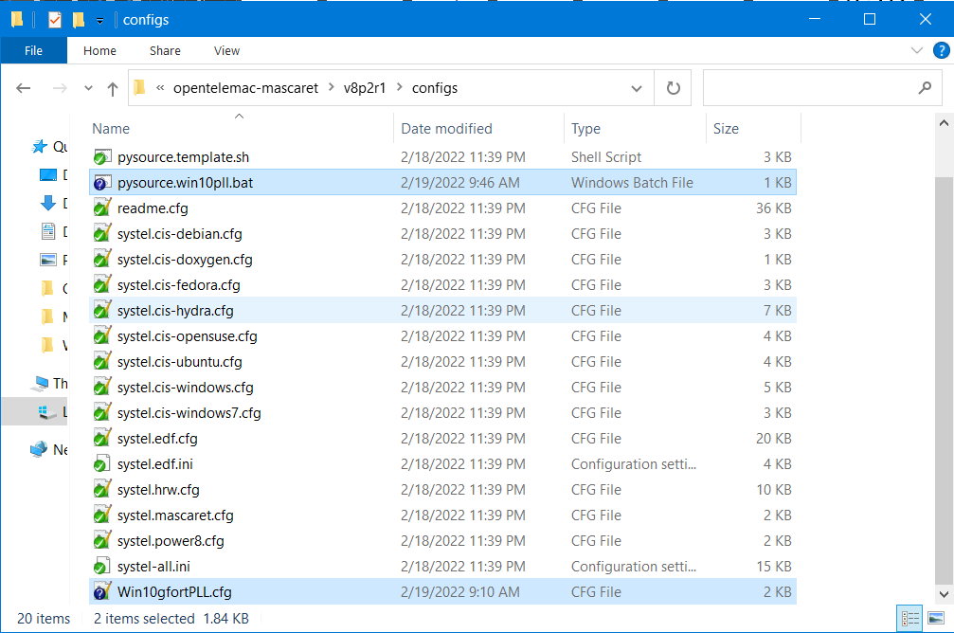

Figure 43 The Config Files in the Folder

1. After placing both the config and batch files, copy the path of that directory.

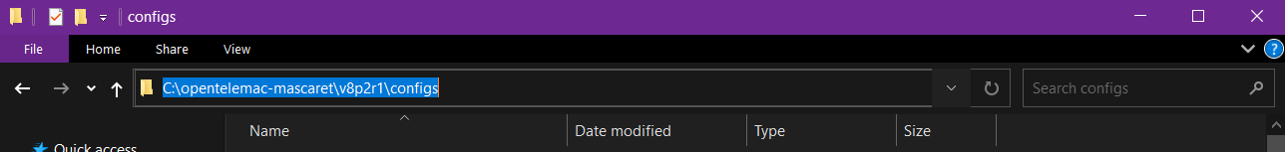

Ctrl + C

Figure 44 The Configs File Directory

1. Open DOS Command prompt terminal. If you do not know where the command prompt is, see Figure 34 .
2. In the cmd terminal, type **cd** and paste the copied directory of the configs file earlier. Alternatively, you can manually type:

**cd C:\opentelemac-mascaret\v8p2r1\configs** then press **Enter.**

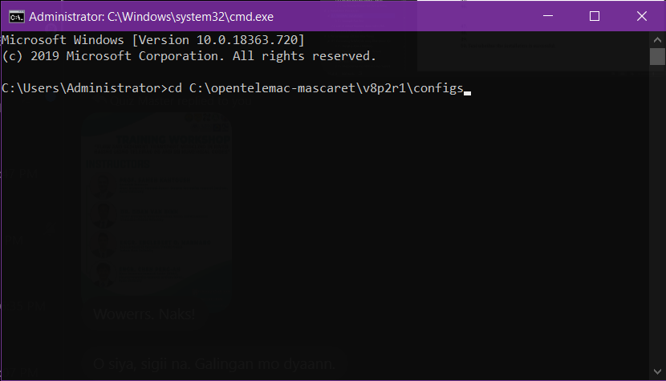

Figure 45 Initiation of the "Change Directory" Command in the cmd Environment

1. Pressing enter will change the directory where you are currently working on.

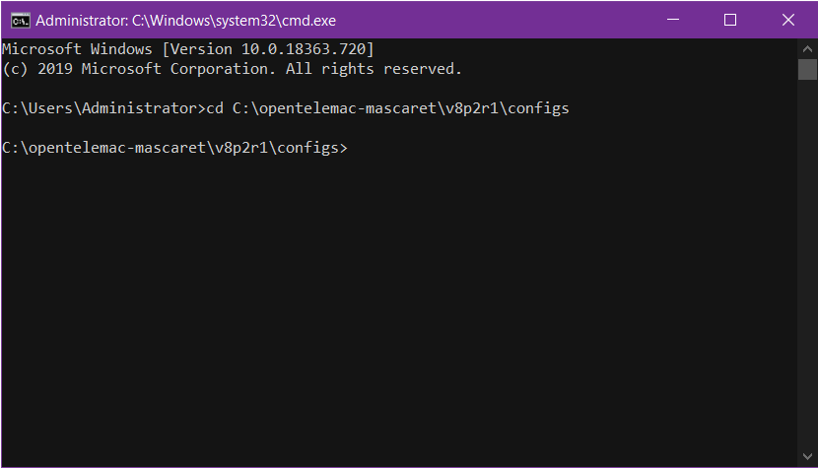

Figure 46 Command Line after Changing Directory

1. Remember that this directory is where we have extracted both the config and batch files from earlier. What we are going to do is to load the config file into the command prompt environment.
2. Additionally, you can opt to display the contents of this directory by typing **dir** and pressing **Enter.**

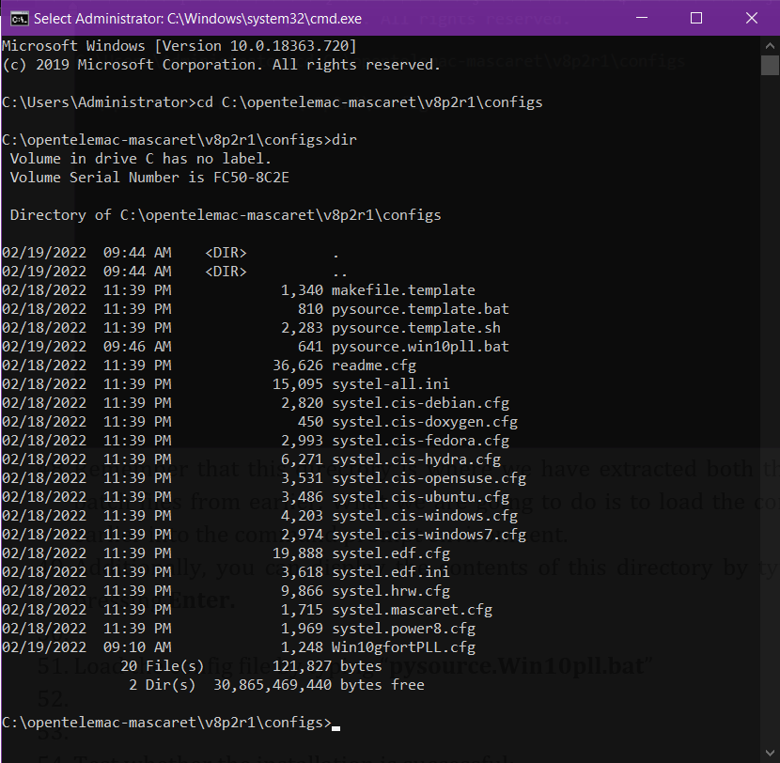

Figure 47 The Command Line after Entering the **dir** Command

1. Load the config file by typing “**pysource.Win10pll.bat**” and pressing **Enter**.

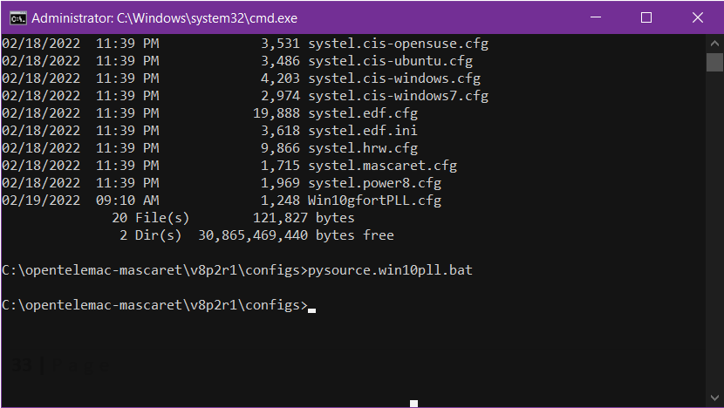

Figure 48 Successful Loading of the Config File

1. If the command line didn’t return any errors, then you have successfully loaded the config file.
2. The next step would be to now compile TELEMAC. But first, we must change directory again.
3. Continuing from the same terminal, type “**cd..**” (again, without the quote marks). This command is used to return the directory one step backward.

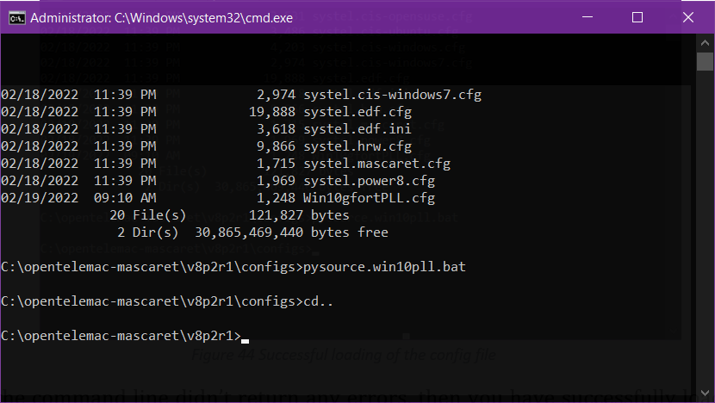

Figure 49 The Command Line after the **cd..** Command

1. Now, type “**cd scripts\python3**”. Again, this just means that we are going to change directories.

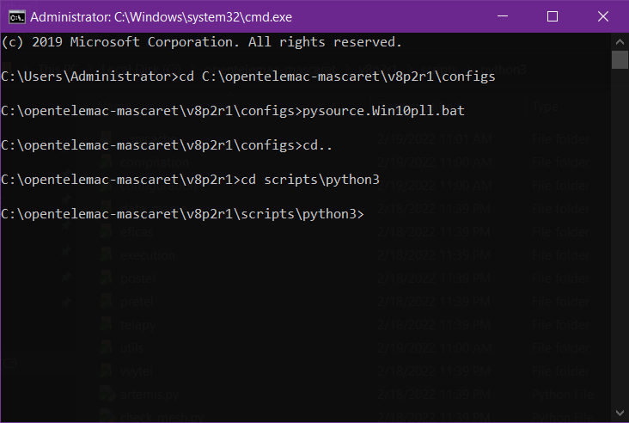

Figure 50 The cmd Line after Changing to the Python3 Directory

1. In the python3 directory, type “**python config.py**” and press **Enter** to check whether we have successfully loaded the config file from earlier.

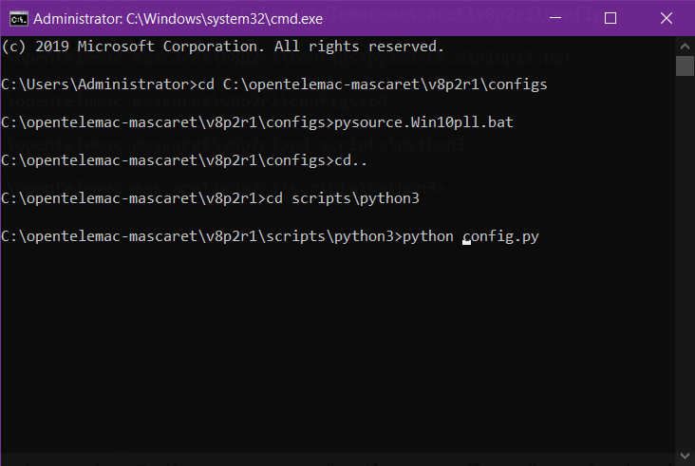

Figure 51 Checking the Proper Loading of Config File

1. After pressing **Enter**, cmd will load options and configurations and should display the available modules and a message “**My work is done**”.

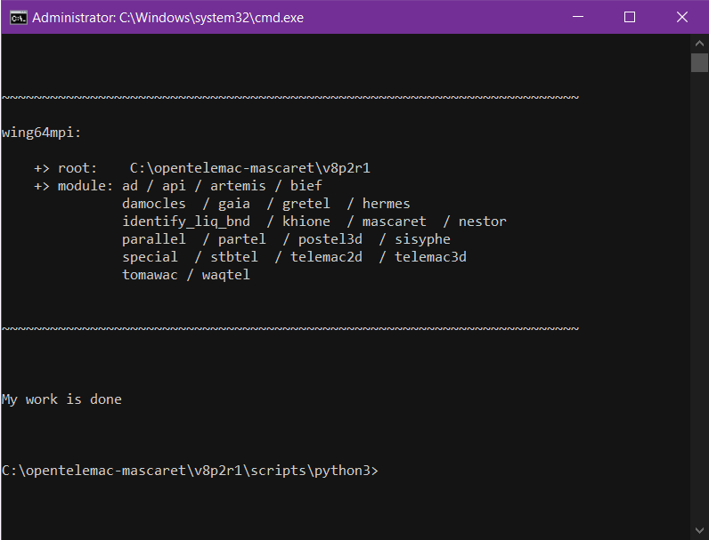

Figure 52 The Successful Loading of the Config File

1. Next, without leaving the same directory, type “**python compile_telemac.py**” and press **Enter**.

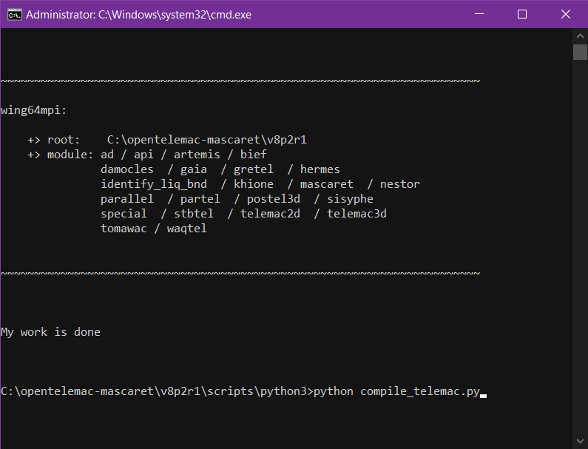

Figure 53 The Command Used to Compile TELEMAC (for Python3)

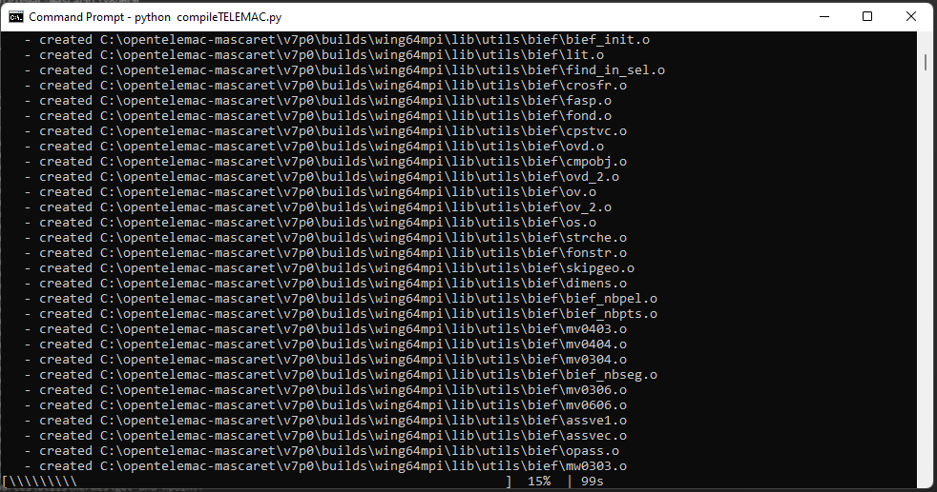

Figure 54 The Command Line during the Compilation Process

1. The compiling process will take a little while to be completed.
2. After a successful run, the command line should display the message “**My work is done**”.

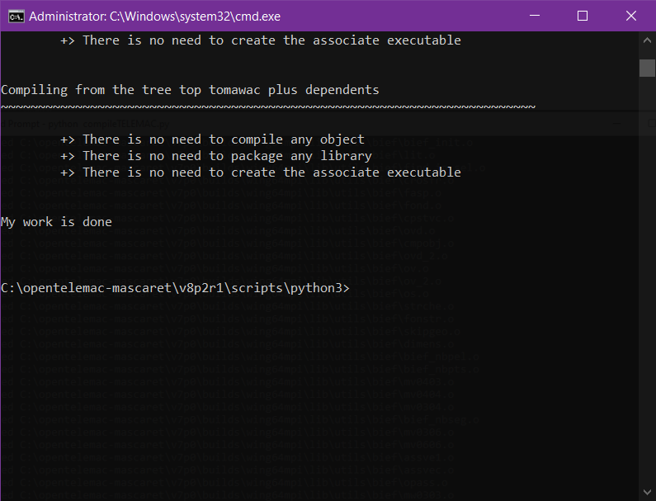

Figure 55 The Command Line after the Successful Compilation

1. The next step would be to test whether the installation is successful or not. Proceed to the next section to run a Sample test.

### Example Run Test

1. Open the Figure 34 . If you forgot how to do so, see Figure 43 .
2. Load configurations file. See page Figure 43 .



Figure 56 Successful Loading of the Config File

1. The next step is to change the directory into one of the example files from the TELEMAC root folder. Type “**cd..**” and press **Enter.**

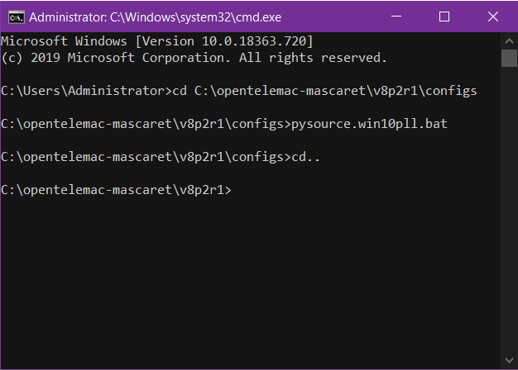

Figure 57 Changing the Directory (1)

1. Type “**cd examples\telemac2d\okada**” and hit **Enter**.

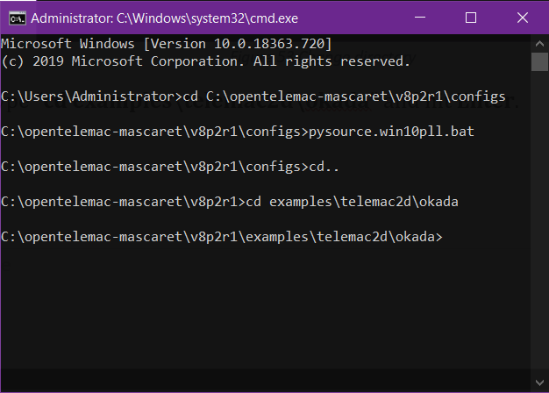

Figure 58 Changing Directory to the Simulations Files Location

1. Now that we are in the directory where simulation files (okada) are located, we can start the simulation proper.
2. Type **dir** to display the contents of the said folder.

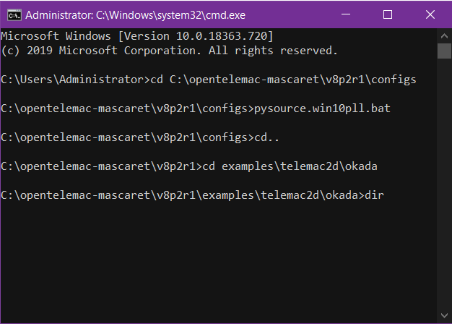

Figure 59 Typing dir to Display Contents

1. Note that all the mandatory files (i.e., the *.cli, *.slf, and *.cas files) are available in this folder.

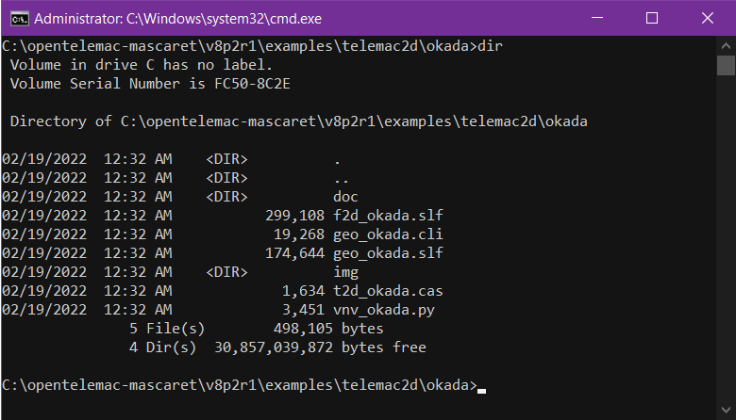

Figure 60 The Contents of the Okada Folder after Running the **dir** Command

1. To start the simulation, type **“telemac2d.py t2d_okada.cas**” and press **Enter**.

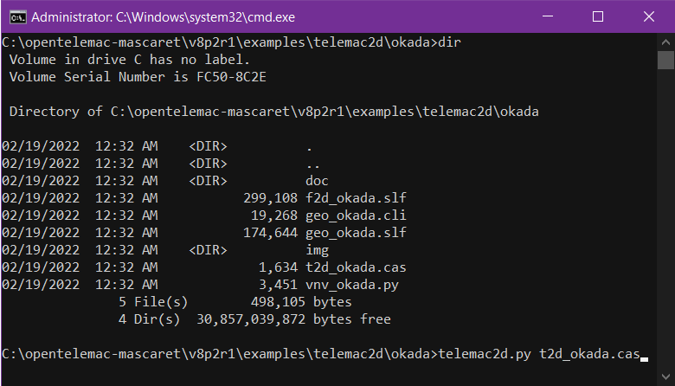

Figure 61 The Command Used to Start the Simulation

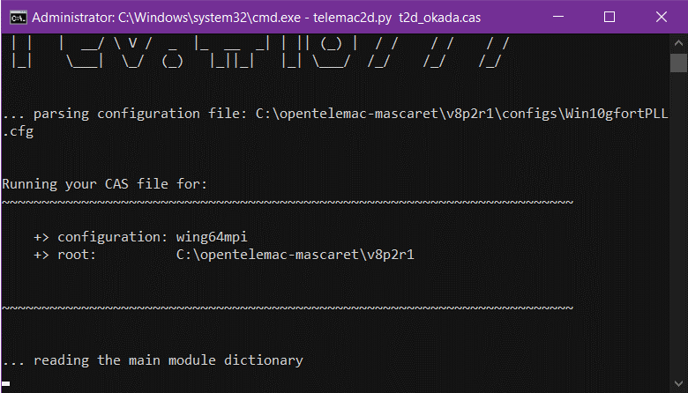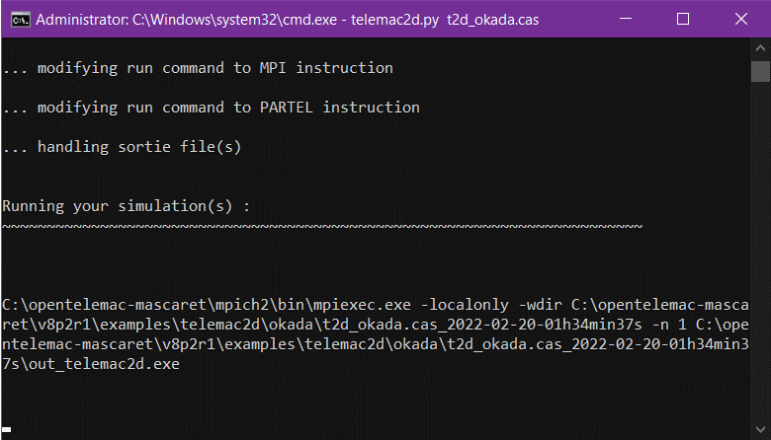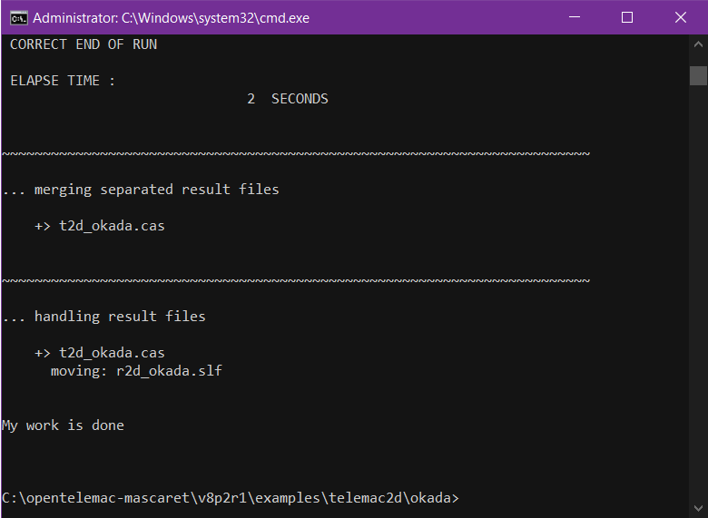

Figure 62 Correct end of run

1. “**My work is done**” message signifies that our installation worked and that TELAMAC has been successfully installed.

## Use of Virtual Machine (Mint HyFo VM)

This is specifically tailored to shorten the lengthy and time-consuming installation of TELEMAC-MASCARET and other prerequisites. This VM machine comes with the following pre-installed software courtesy of Dr. Sebastian Schwindt of Stuttgart University with the following capabilities:

* Atom IDE (all-in-one IDE for Python scripting and editing markdown, restructured text, or LaTeX files)
* JupyterLab (start in terminal with jupyter-lab)
* QGIS
* TELEMAC v8p3 (dynamically compiled stand-alone installation with parallel libraries enabled)
* Note that Python, LibreOffice, and Firefox are pre-installed in Linux Mint.

**Note: Please skip this section if you have successfully installed TELEMAC on your computer and have successfully conducted a sample run without any errors.**

1. Download a copy of the Mint Hyfo Virtual Machine at <https://bwsyncandshare.kit.edu/s/Cx2cwsZHnpQdoTt>. Click “**Download**” button.

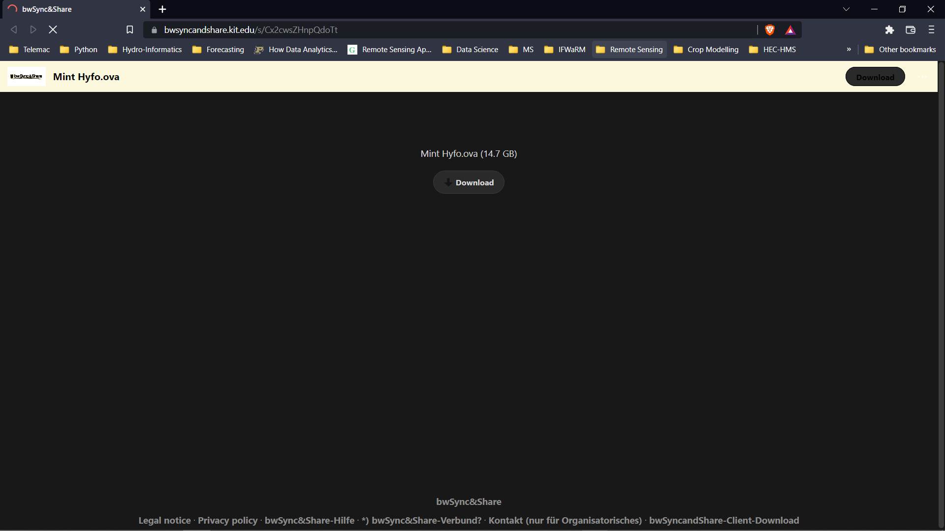

Figure 63. The Mint Hyfo VM Download Section

1. Download a copy of the Virtual Box installer at <https://www.virtualbox.org/> then proceed to the “**Downloads**” section.

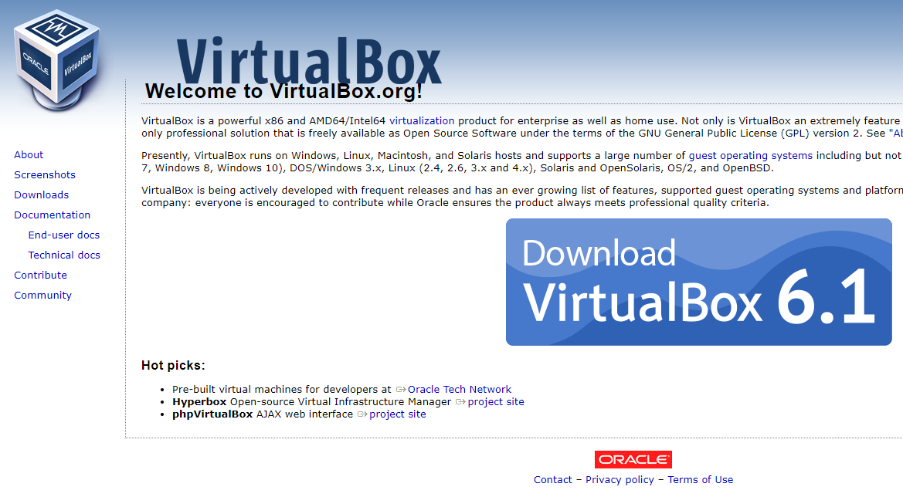

Figure 64. The VirtualBox Webpage

1. Depending on your system, click the available packages to begin the downloading process.

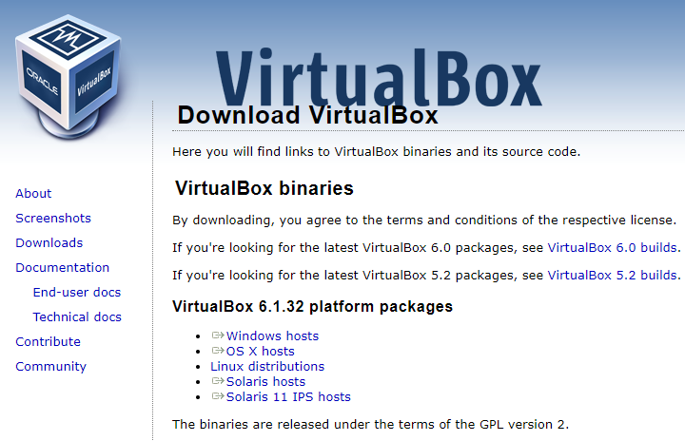

Figure 65. The VirtualBox Downloads Section

1. Open the downloaded “**VirtualBox-6.1.32-xxxx-xxx**” installer and click “**Yes**” to begin the installation.
2. Click “**Next**”>>” **Next**”>> “**Next**” in the setup wizard to continue.

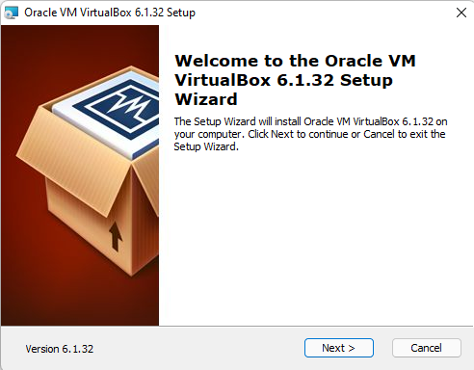

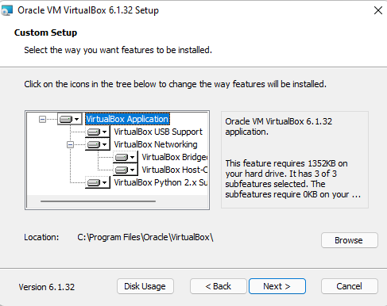

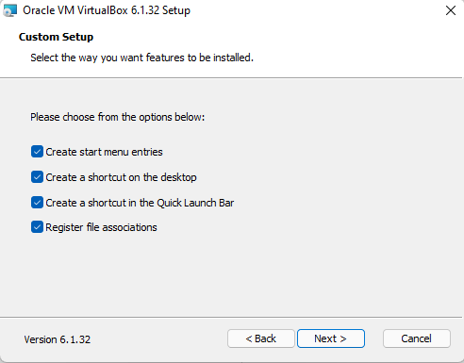

Figure 66. The Oracle VM VirtualBox Custom Setup

1. Then select “**Yes**” to proceed.

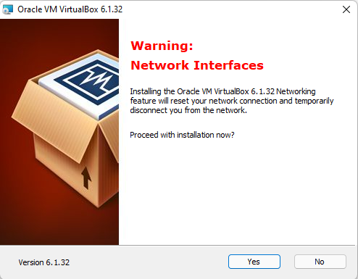

Figure 67. The VirtualBox Confirmation Message before the Installation Process

1. Click “**Install**” to begin.

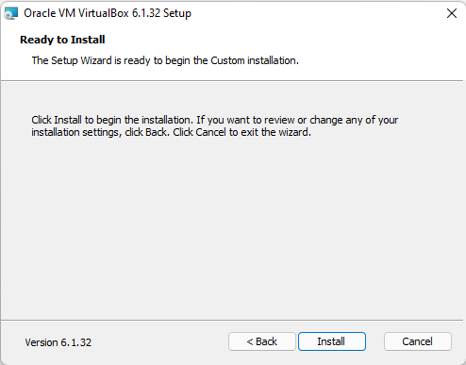

Figure 68. Beginning the Installation Process

1. Wait for the setup to finish.

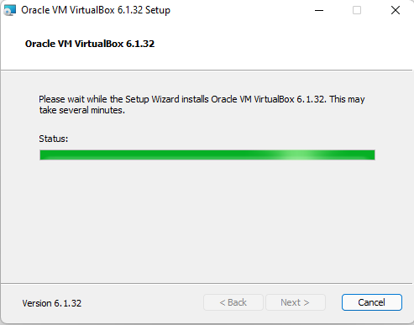

Figure 69 The Setup Wizard During the Setup

1. Once finished, make sure that the “**Start Oracle… after installation**” option is ticked, then click “**Finish**”.

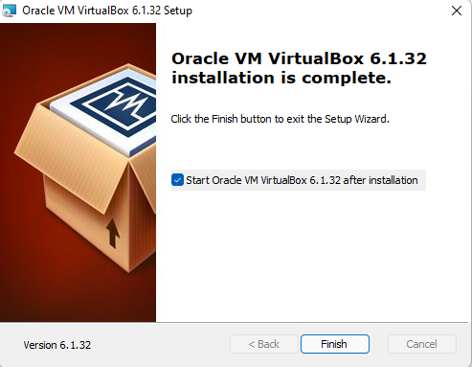

Figure 70. Finishing the Installation Procedure

1. A new window showing the VirtualBox interface will pop out.

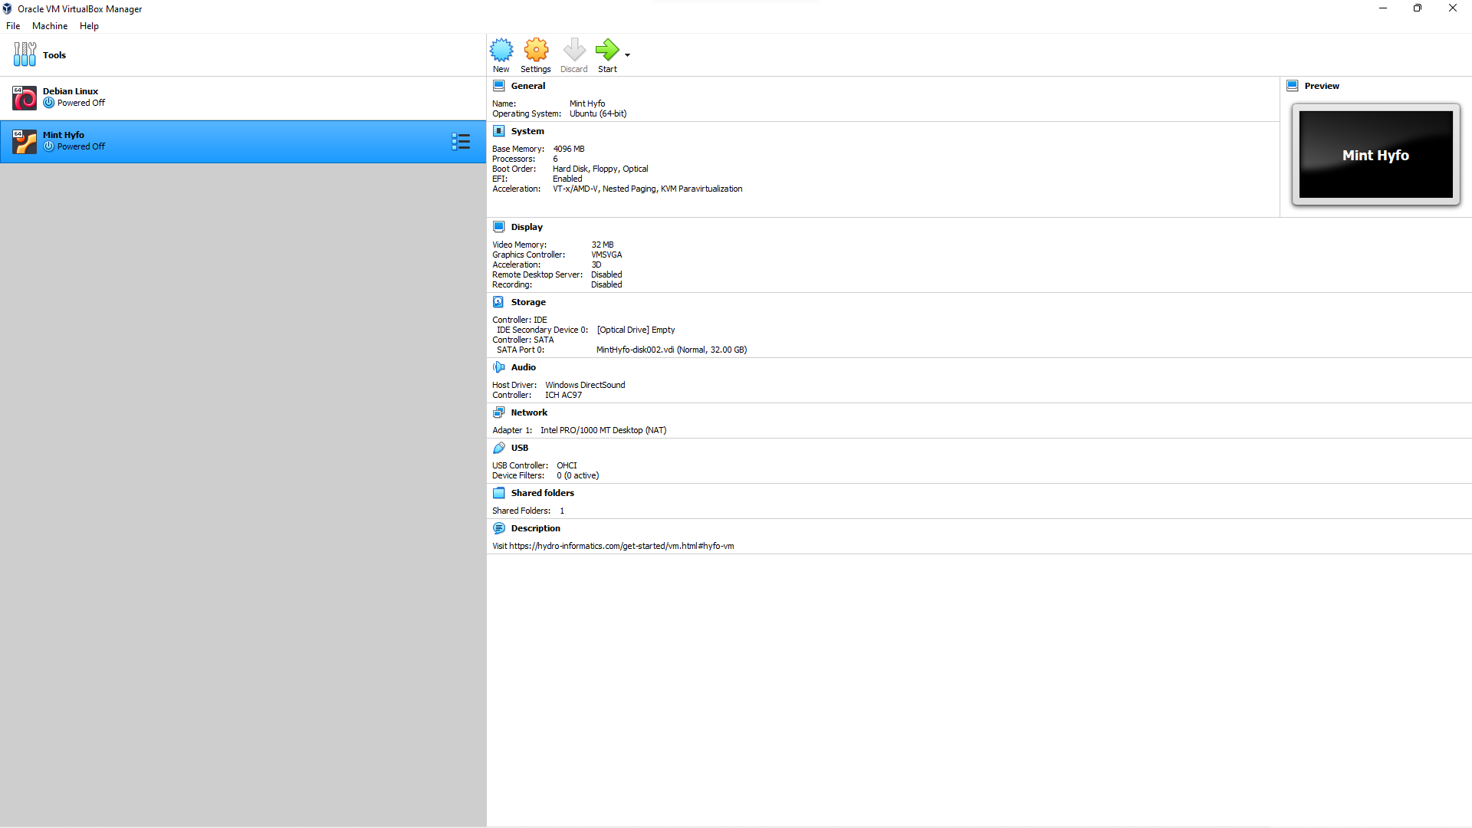

Click **File** >> **Import Appliance**

Figure 71. The Virtual Box Interface

1. At the Menu Bar, click “**File**”> “**Import Appliance**”.

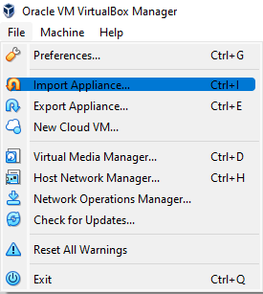

Figure 72. Launching the Import Appliance Window

1. A new “**Import Virtual Appliance**” window will pop up.

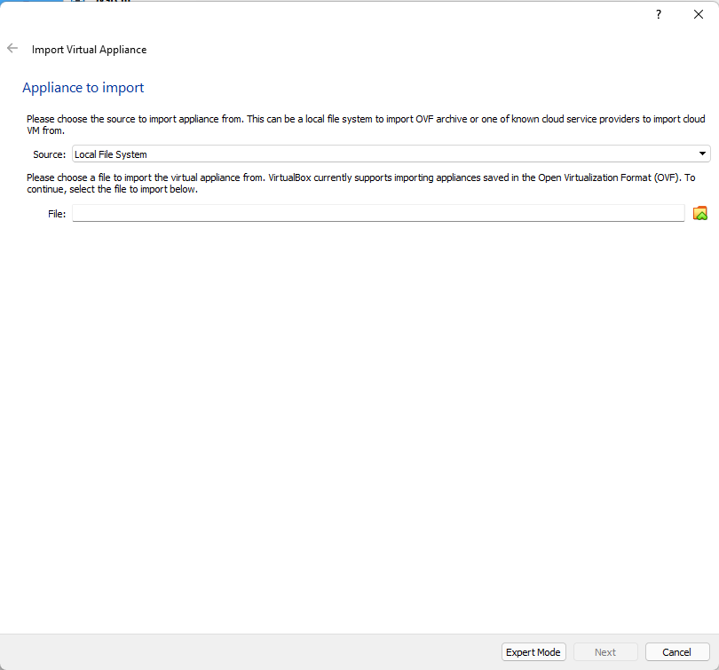

Click this icon to import the downloaded *.ova file.

Figure 73. The Import Virtual Appliance Window

1. Click the icon to navigate the folder where the downloaded **Mint Hyfo VM** (.ova) is stored. (i.e., Downloads)
2. In this example, the .ova file is located at the shown directory. Click “**Open**” to proceed.

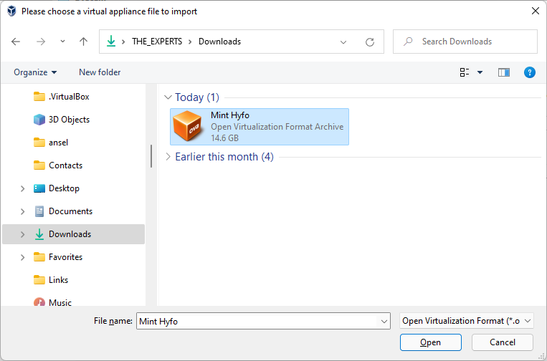

Figure 74. The Location of *.ova in a Folder Directory

1. Once the *.ova file is selected, click “**Next”.**

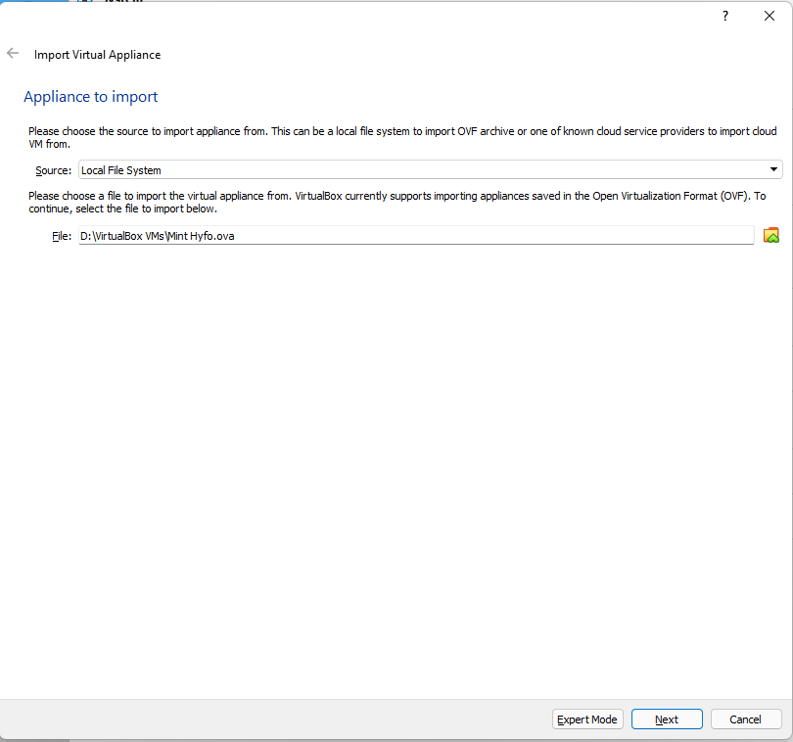

Figure 75. The Selected and Loaded .ova File

1. Modify the numbers of CPU and RAM according to your computer’s available resources.

**RAM**: 1024 x *No. of desired RAM*.

Example: 1024 x 4GB = 4096.

Once finished, click “**Import**”.

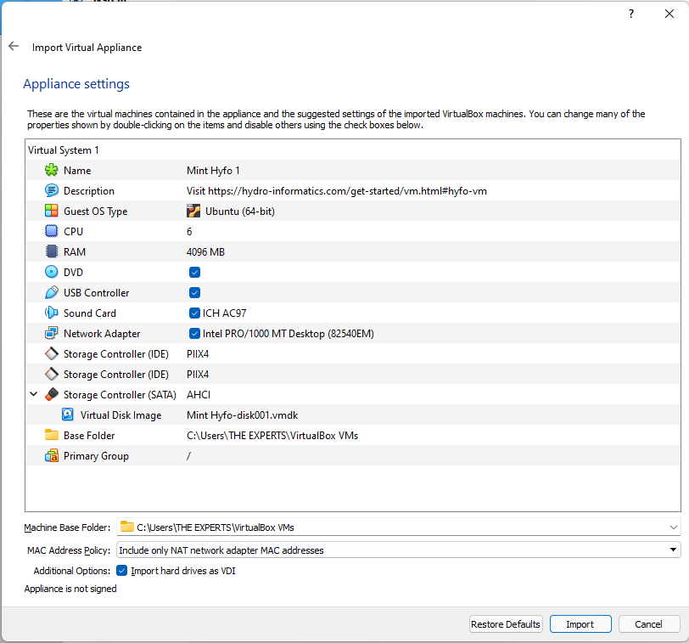

Figure 76. Tweaking Properties to Suit your Computer Capabilities

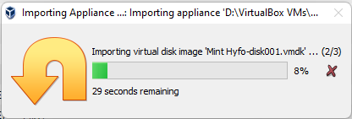

Figure 77. A Sample Duration of Importation Process

1. Once finished importing, the Mint Hyfo is now ready and can be started using the “Start” button.

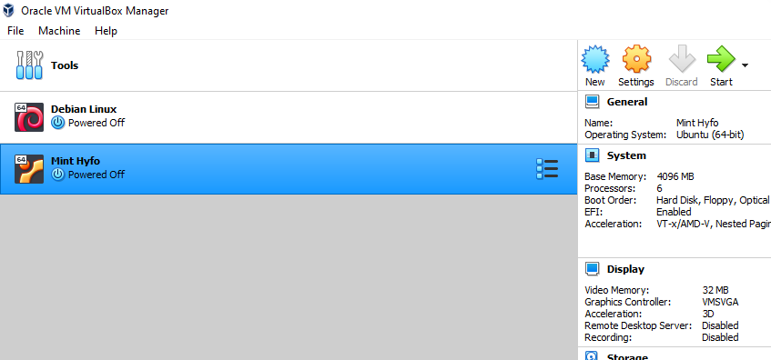

Figure 78. Starting the Machine

### Creating and Enabling the Shared Folder option

1. Click the Settings icon.



Figure 79. Opening the Machine Settings

1. Click the **Shared Folders** tab.

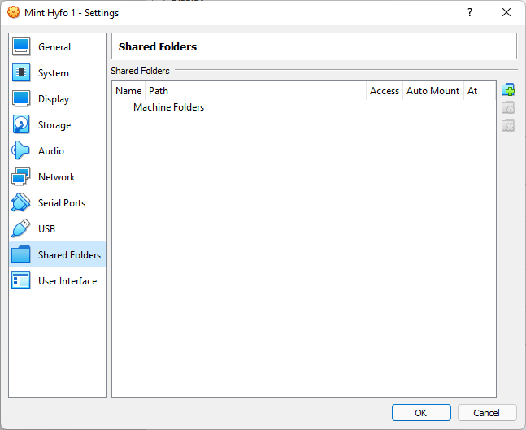

Click the **Add New Shared Folder** icon

Figure 80. The Shared Folders Tab

1. Designate a folder where the **host** (your computer) can share a folder with your virtual machine (Mint HyFo) to facilitate easy file transfer.

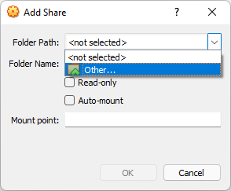

Figure 81. The Add Share Folder Window

1. You may designate the TELEMAC Training folder as your shared folder.
2. Check the **Auto Mount** option and click **OK**.

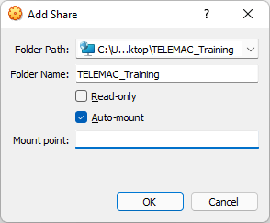

Figure 82. Designating TELEMAC Training Folder

1. Click **OK.**

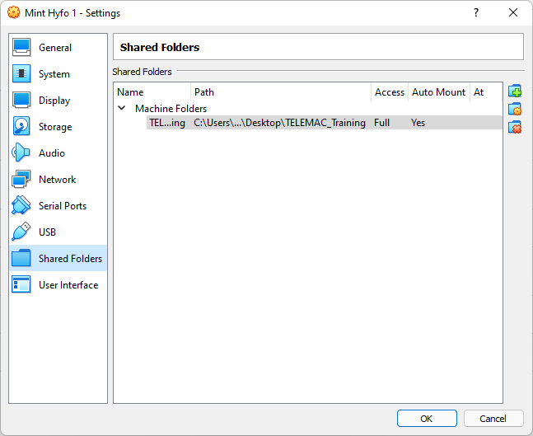

Figure 83. The Updated Shared Folder Tab

*Note:*

*This shared folder will be very useful in facilitating file transfer especially since pre-processing will be done in host computer and the simulation will be done in the virtual machine, and then the results file will be transferred again into the host computer for post-processing.*

## Installing Blue Kenue

1. Open your web browser and navigate to <https://nrc.canada.ca/en/research-development/products-services/software-applications/blue-kenuetm-software-tool-hydraulic-modellers>. Click the “**Download Blue Kenue**” button.

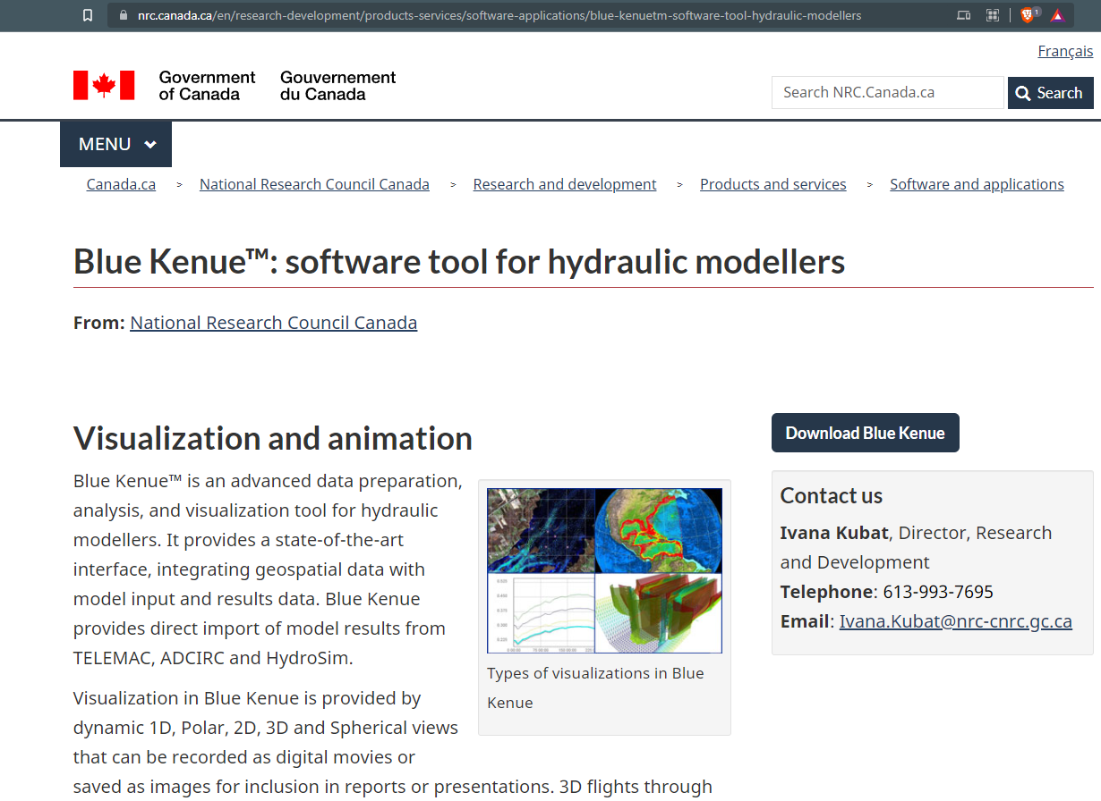

Figure 84. The National Research Council Webpage

1. Fill up the request form then click “**Submit**” once finished.

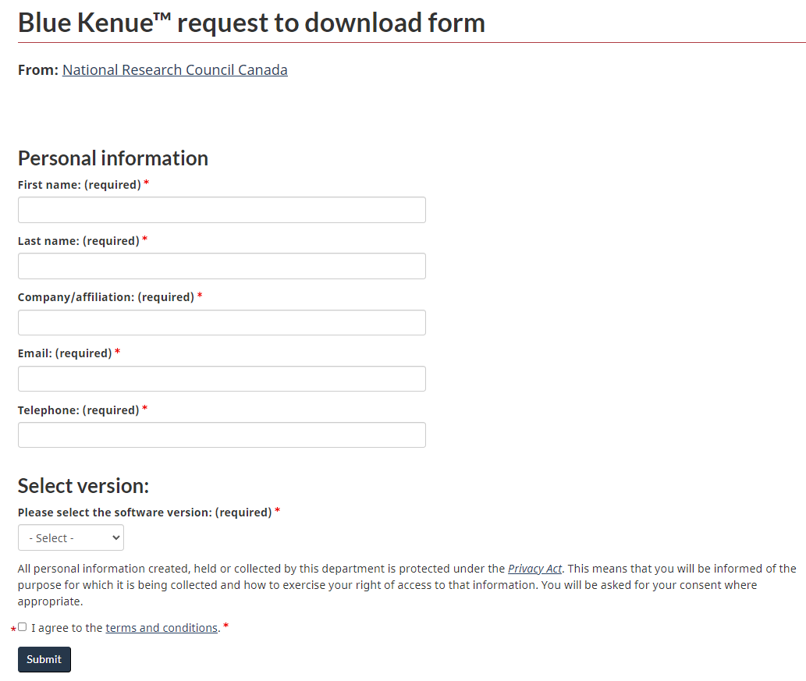

Figure 85. The Request Form to be Filled Up

1. Download the application, wait for it to finish, and then open the file to start installing. Then click “**Next**”>>” **Next**”>>” **Next**” to proceed.

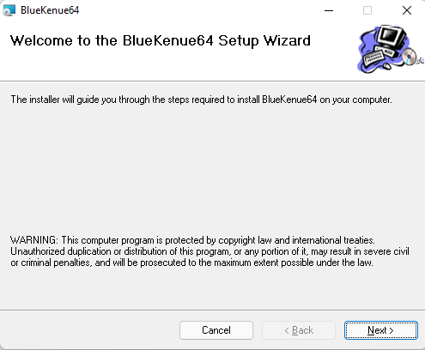

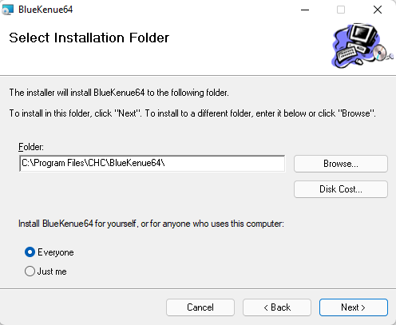

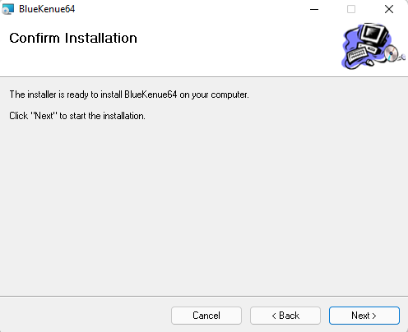

Figure 86. The Confirmation of the Installation

1. Wait for a few second and once finished, you can click close to finish the installation.

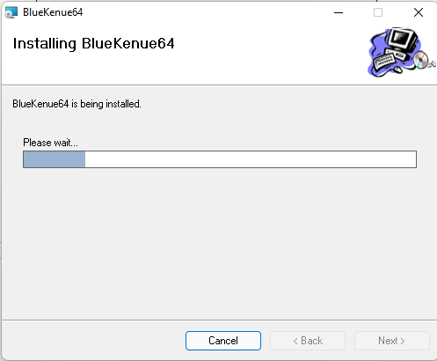

Figure 87. The Duration of the Installation

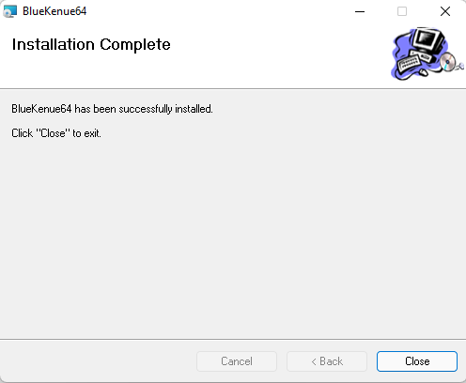

Figure 88. Finishing the Installation Process

# Pre-processing utilizing Blue Kenue

Pre-processing encompasses the abstraction of the river landscape into a computational mesh (grid) with boundary conditions and interpolation of DEM data into generated computational mesh. Many software tools can be used for this purpose such as:

1. QGIS and the BASEmesh plugin
2. The National Research Council Canada’s Blue Kenue GUI software (primarily for Windows but can be used in Linux systems using Wine).
3. SALOME-HYDRO for generating computational meshes in the MED files format

However, this manual will only focus on utilizing Blue Kenue since it is advantageous for computation speed and model stability.

## Generating Selafin File using Blue Kenue (Geometry File)

Blue Kenue™ is an advanced data preparation, analysis, and visualization tool for hydraulic modelers. It provides a state-of-the-art interface, thereby integrating geospatial data with model input and results data. It also provides direct import of model results from TELEMAC and other software.

The geometry file in *.slf (selafin or SERAFIN) format contains binary data about the mesh with its nodes.

### The Blue Kenue Interface

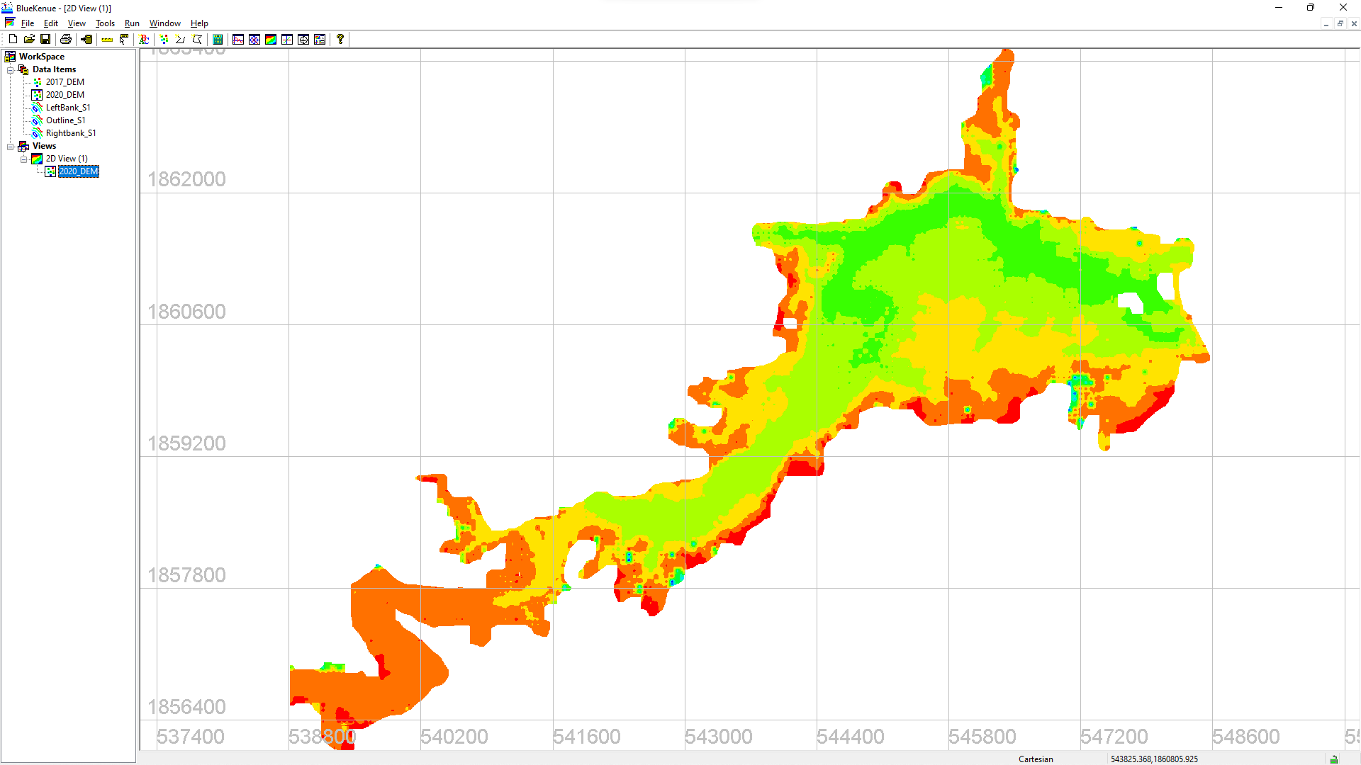

Figure 89. The Blue Kenue User Interface

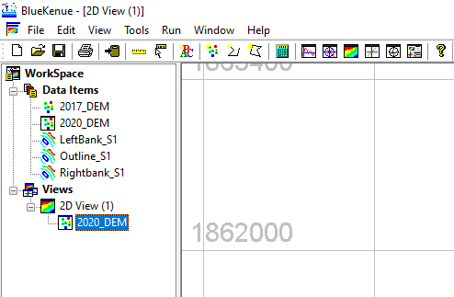

Figure 90. Parts of the Blue Kenue User Interface

1. Title Bar
2. Menu Bar
3. Tool Bar
4. Workspace
5. Data Items
6. Views
7. Canvass

### Opening/Importing Data in Blue Kenue

1. Download and extract the TELEMAC Training Folder from the Google drive and extract the contents from your desired directory. In this manual, we are going to extract the contents into the **desktop folder**. The contents of the extracted TELEMAC Training folder are shown on the next page:

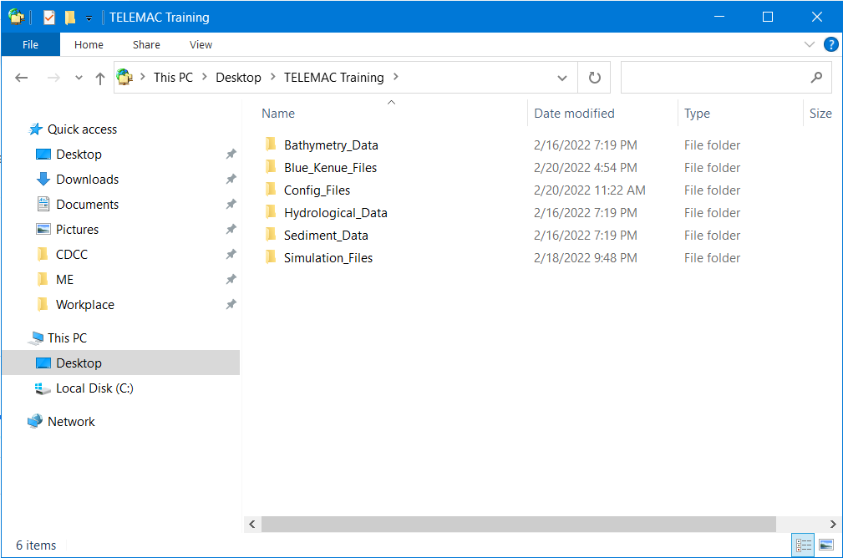

Figure 91. The Extracted Contents of the TELEMAC Training Folder

1. Start Blue Kenue application and open the (.xyz) geometry file from the extracted **TELEMAC Training Folder** >> **Bathymetry_Data** >> **2017_DEM.xyz**. In order to see your XYZ dataset, change the file type drop-down menu from Selafin to All Files as shown in Figure 84.

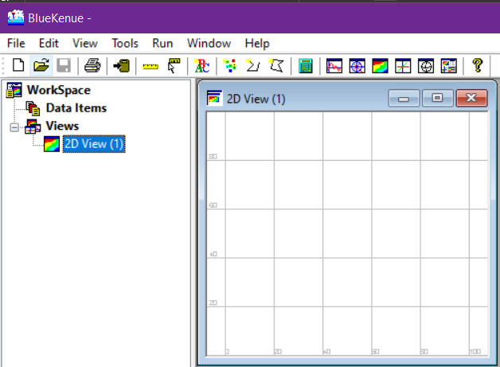

Open the (.xyz) geometry file using the **open** button.

Figure 92. Importing the Bathymetry Data Using the Open Button

1. From the “**Open Files**” window, click the “**Telemac Selafin File(*.slf)**” and change it to “**All Files**” to see your XYZ data set.

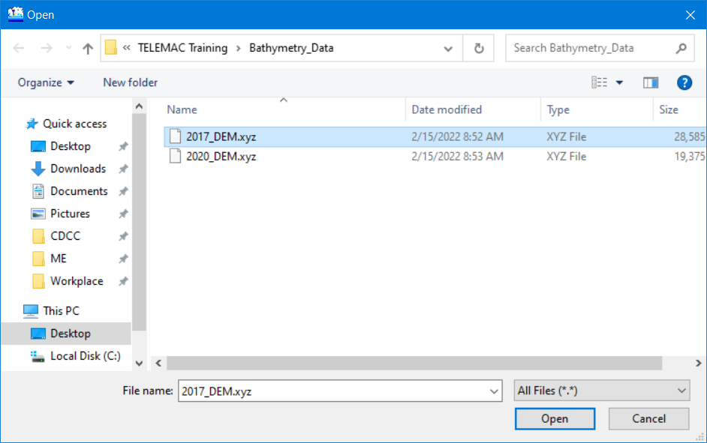

Open the (.xyz) geometry file.

In order to view the XYZ dataset, select

All Files option from the drop-down list.

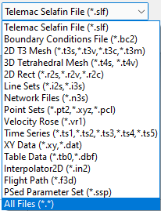Figure 93. Toggling All Files (*.*) in Opening/Importing Bathymetry Data

### Viewing Data in Blue Kenue

1. Notice that the “**DEM_2017**” is now displayed under the Data Items. Drag it into the “**2D View**” to display the item in the canvass.

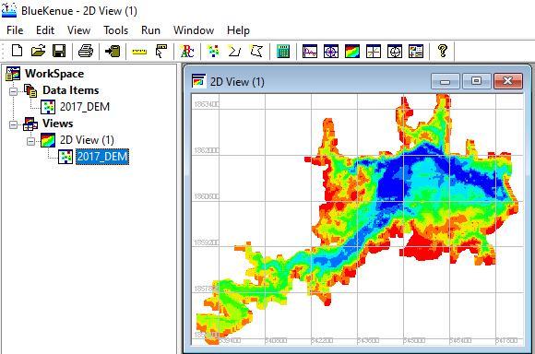

Drag DEM xyz data into the 2D view object.

Figure 94. Viewing Items in Blue Kenue through a Views Object

*Note: In Blue Kenue, data items are not automatically displayed in the canvas. You must drag the item into the “****View****” section. Additionally, other view options like “****1D View****”, “****3D******View*** *“, “****Polar Views****”, “****Spherical Views****”, and “****Report View****” can also be used from the tool bar. Try to hover your mouse into each option. The example shown in Figure 87 features the 3D view option.*

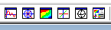

Figure 95. Other View Options Available in Blue Kenue

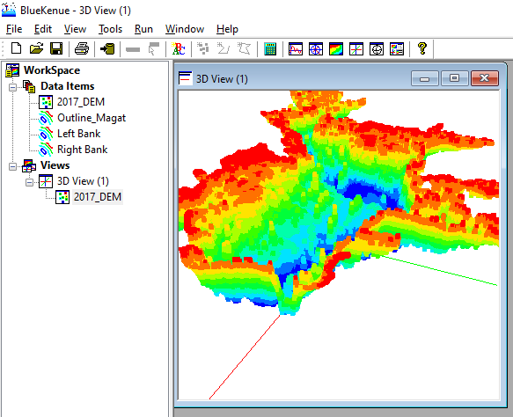

Figure 96. An Example of a 3D Isometric View

### Mesh Generation

#### Step 1: Model Boundary (Closed Line)

1. In Blue Kenue, the “**New Closed Line**” tool is used to delineate the outline or boundary of the area to be studied.



Create a new closed line to represent the extent of the Magat Reservoir.

Figure 97. Step 1: Creating New Closed Line to Represent the Reservoir Boundaries

1. Click the “**New Closed Line**” icon. Notice that your mouse pointer icon will change into something like this: . Try to follow the extent of the DEM file and delineate the outline boundaries. You can use the mouse wheel to zoom in and out, and then left click-drag to pan.
2. Start by clicking the edge of the DEM and work your way around it by patiently left-clicking along the edge lines. Notice the magenta-colored connecting lines being generated.

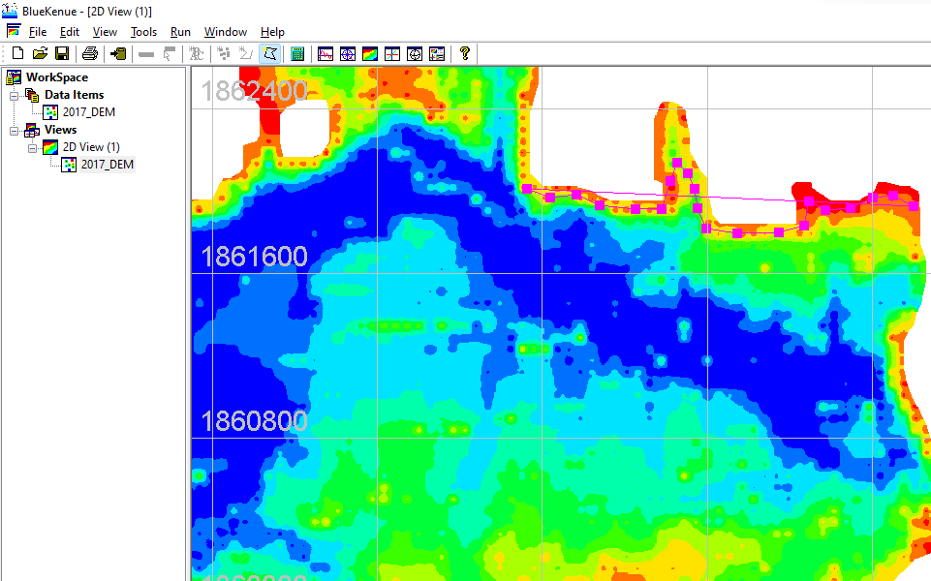

Upon finishing creating the outline, press **ESC** to name the object.

Figure 98. Naming the Newly Created Outline

1. Once finished, press the “**ESC**” button on your keyboard. A query toast will pop up. Enter the desired outline name (i.e., Outline Magat). The units should be in meters (m) and leave the rest at their default values.

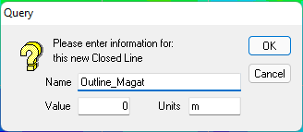

Figure 99. Query upon Pressing ESC

1. Again, drag the newly created item into the 2D view. See figure 85 for reference.

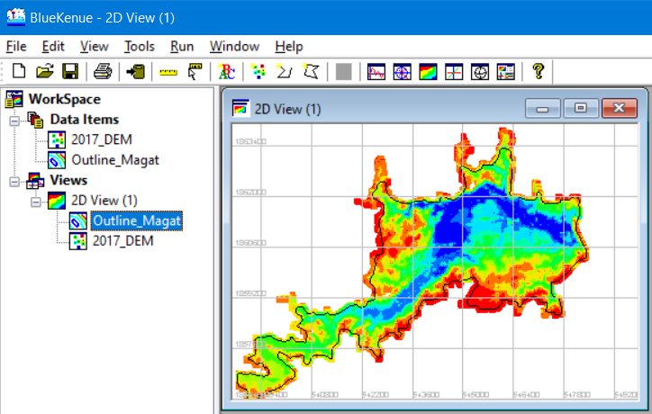

Figure 100. The Current Workspace with the Outline in Dragged into the View Object

Note: Please see Appendix VI: Importing an existing shapefile as an outline.

#### Step 2: The T3 Mesh Generator

In order to create a spatial representation of the domain to be studied (in this case, the Magat River Main Reservoir), a computational mesh must be created first.

Now, in generating a mesh, a closed line (outline) is enough and can be generated using the steps shown above.

Continuing from the previous steps, you should have a workspace in Blue Kenue with the following files already opened:

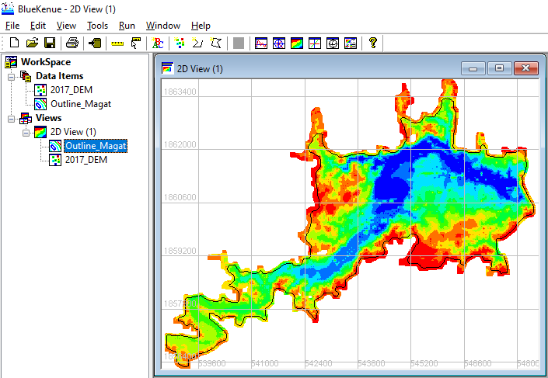

Open a **New** **T3 Mesh Generator**

Figure 101. Current Workspace

1. From the Menu bar, click “**File**” > “**New**” > “**T3 Mesh Generator**”.

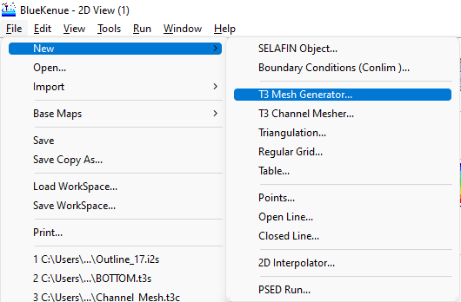

Figure 102. Opening a New T3 Mesh Generator

*Note: The T3 Mesh Generator is used to produce two-dimensional scalar triangular meshes that can be used in models such as TELEMAC and similar programs*

1. Upon clicking, a properties window for the “**newT3Mesh**” will pop up:

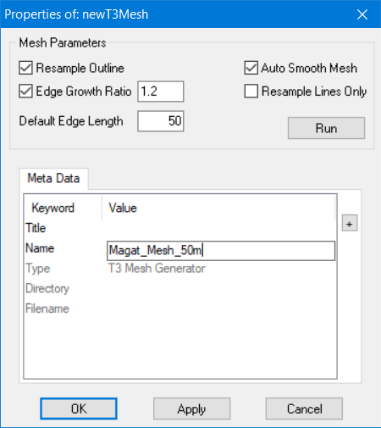

Set **Default Edge Length** to maximum size of element desired.

Change **T3 Mesh Generator Name.**

Figure 103. The New T3 Mesh Properties Window

1. Change “**Default Edge Length**” to “**50”.** Leave the rest settings at their default settings. If desired, you can change the “**Name**” of newT3Mesh by simply clicking at the “**newT3Mesh**” and typing the desired new name (i.e., “**Magat_Mesh_50m**”. Don’t run yet, just click “**OK**”.

*Note:*

* *Resample Outline: If this box is checked, the Mesher will resample the supplied outline, considering the values provided by the various density objects and the default edge length. If this box is unchecked, then only the points that comprise the polygon used to define the outline will be used as edge nodes for the triangular mesh. This box is checked by default.*
* *Auto Smooth Mesh: If this box is checked, the mesh will be adjusted by the Laplacian mesh smoothing algorithm after the mesh has been generated. This box is checked by default.*
* *Edge Growth Ratio: This box, if checked, defines the maximum ratio between the lengths of edges at a given node. This box is checked by default, and has a default value of 1.2.*
* *Resample Lines Only: If this box is checked, the outline and softlines will be resampled according to the density objects but no mesh will be produced.*
* *Default Edge Length: This value defines the default distance between nodes using the same units as the closed polygon that defines the perimeter of the mesh. The default value is 1, whereas the lower edge length is equal to higher density.*

1. Drag “**Outline_Magat**” into the “**Outline**” slot.

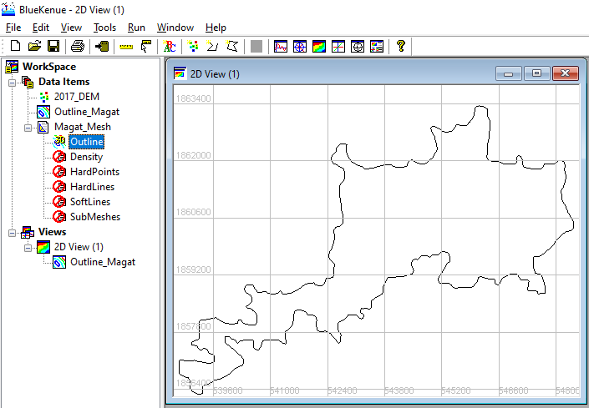

Drag **Outline_Magat** into the generator’s slot for **Outline**

Figure 104. Dragging the Generated Outline into the Generator

*Note:*

* *For now, we can leave the other slots untouched.*
* *Hard points specify the locations of certain nodes as well as modify the local density of nodes.*
* *Any combination of points, polylines, closed polygons, triangular meshes, or rectangular grids are used by the density object to define areas of constant or varying density.*
* *Closed hard lines are used to produce islands with fixed outline geometry. These are also used in generated break lines with fixed geometry.*
* *Closed soft lines are used to produce islands with geometry determined from the density object. On the other hand, open soft lines produce break lines where the node spacing is determined from the density object.*

1. Once the “**Outline**” slot is filled, go to the “**Magat_Mesh_50m**” properties again by either double-clicking it or right-click >> P**roperties**.

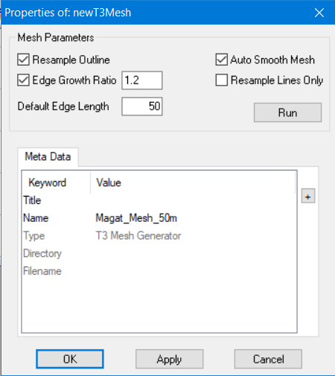

Figure 105. Running the Mesh Generator

1. We can now click “**Run**”. A dialog containing Outer Boundary Area and other parameters will appear. Simply Click “**Yes**” to continue.

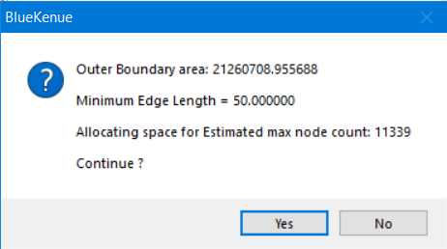

Figure 106. Running the Generator

1. In this example, the program can generate mesh within about a few seconds.

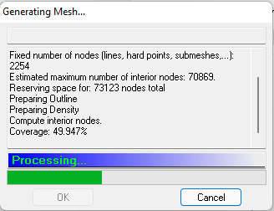

Figure 107. The Mesh Generator

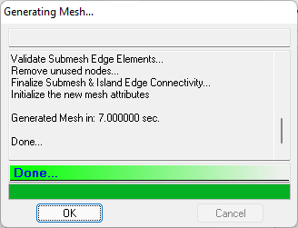

Figure 108. The Mesh Generator after a Successful Run

1. Click “**Ok**”>> “**Ok”.**
2. Once finished, notice that a child object called “**New Mesh (NodeType)**” has been added under the “**Magat_Mesh_50m**” item. Then, rename it into “**Magat_Full_Mesh**”.

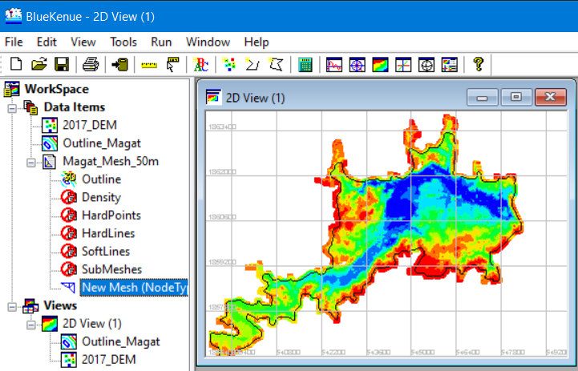

A new item called **New Mesh (NodeType)** is generated.

Figure 109. A Newly Generated Mesh

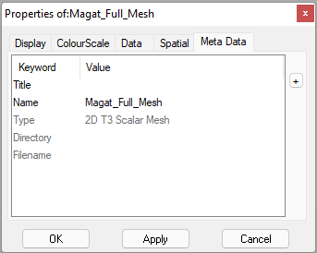

Rename mesh by going into its properties, under the Meta Data.

Figure 110. Renaming the Mesh

1. To see whether the process has been successful, drag the newly generated and renamed “**Magat_Full_Mesh**” into the 2D View.

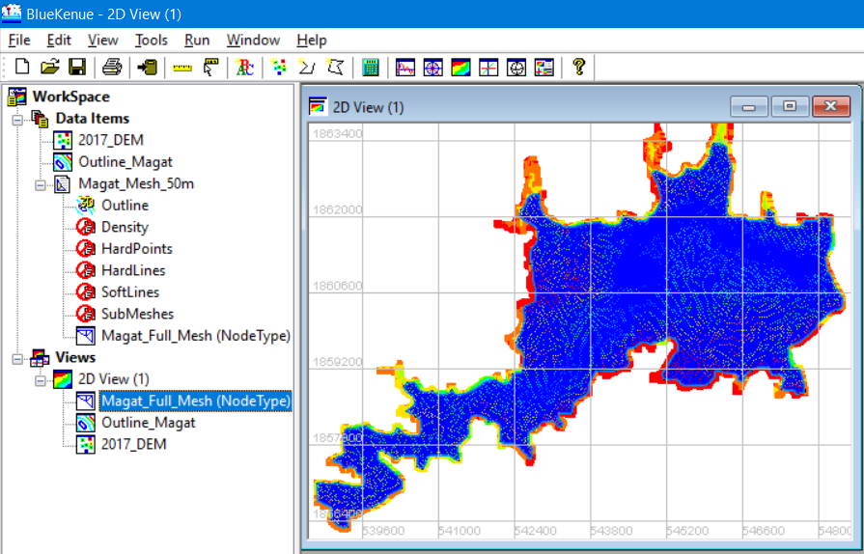

Drag the created mesh into 2D view

Figure 111. The Newly Created Mesh in 2D View

1. To deactivate an object in the 2D view, simply right click the object of interest and click “**Visible”**.

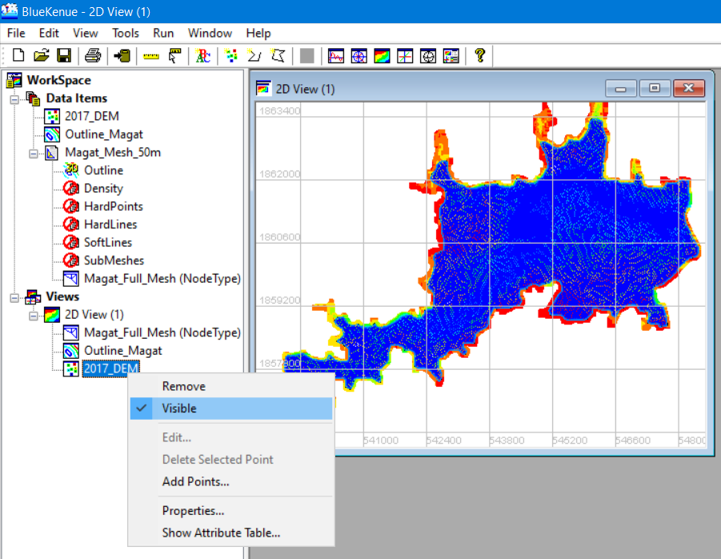

To deactivate an object in the **Views** section, **Right click** > **Visible.** A check mark means the object is visible.

Figure 112. Process of Deactivating an Object in the View Section

### Interpolating the DEM into the Created Mesh

1. Continuing from the last section, create a new Selafin object by clicking the “**New Selafin Object**” icon, which will create a “**newSelafin**” object under the Data Items Menu.

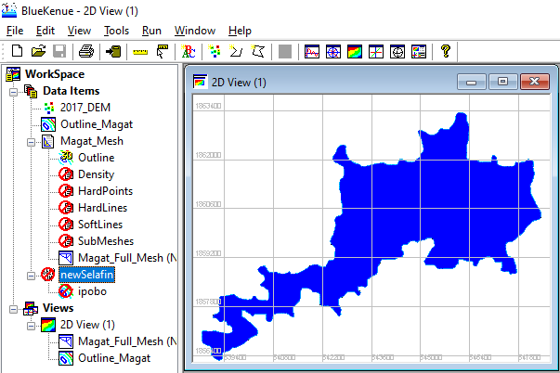

Right click and select **Add Variable.**

Create a **New Selafin Object.**

Figure 113. Creating a New Selafin Object

1. Right click the said Selafin object and select “**Add Variable**”.

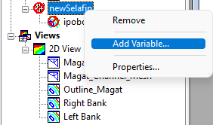

Figure 114. Adding a New Variable to the Selafin Object

1. After which, an “**Add New SELAFIN Variable**” window opens.

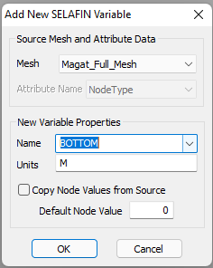

Change mesh property to **BOTTOM** and make sure units is in **m (meters).**

Change the source mesh to **Magat_Full_Mesh.**

Figure 115. The Add New SELAFIN Variable Window

1. Leave the rest at their default values, then click “**OK**”.

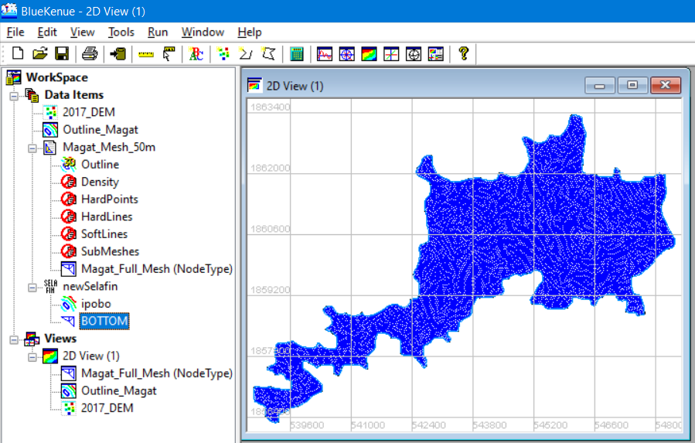

A new **Variable** called **BOTTOM** has been created.

Figure 116 The new **Variable** has been added

1. Next, from the Menu Bar, click “**File”** >> “**New**” >> “**2D Interpolator**”.

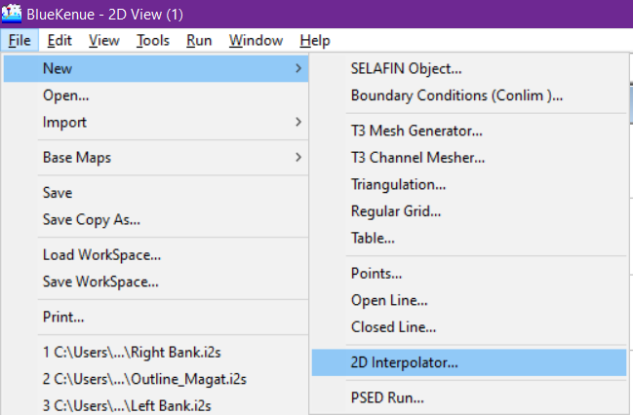

Figure 117. Adding a 2D Interpolator

1. Notice that a “**newInterpolator2D**” is now available at the Data Items menu.
2. Drag the “**2017_DEM**” into the newly created 2D interpolator.

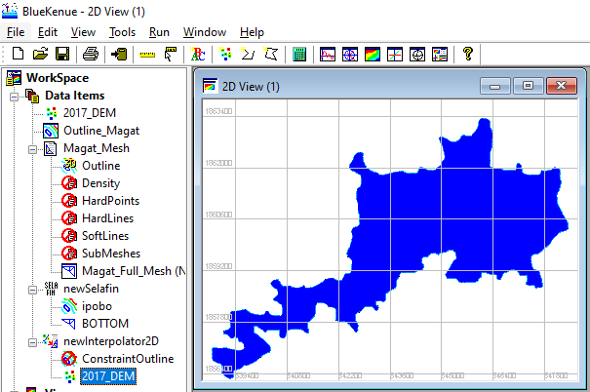

Drag **2017 DEM** into **2D interpolator.**

Figure 118. Dragging the 2017_DEM Item into the Newly Added 2D Interpolator Tool

1. Next, click the “**BOTTOM**” item under the **newSelafin** file to highlight it.

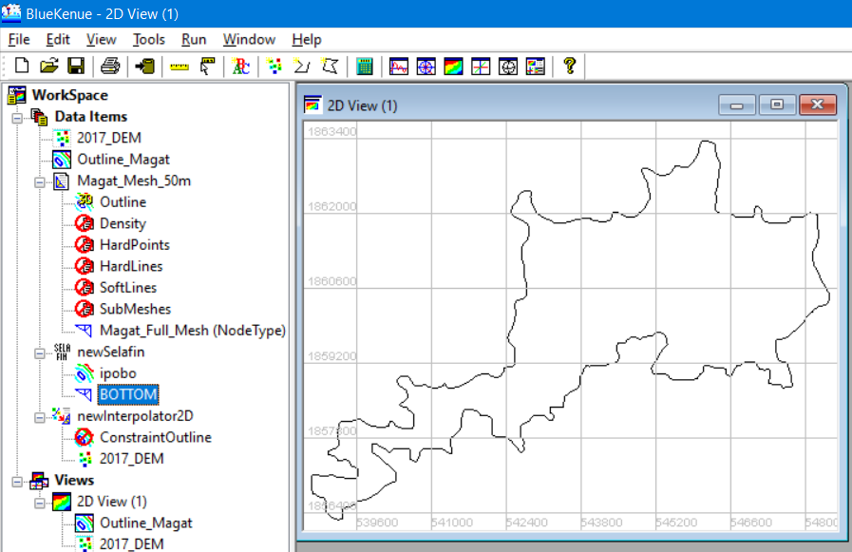

Click **BOTTOM** underthe newSelafin Item to highlight it.

Figure 119. Selecting the Bottom Item

1. Then from the Menu Bar, click “**Tools**” >> “**Map Object**”.

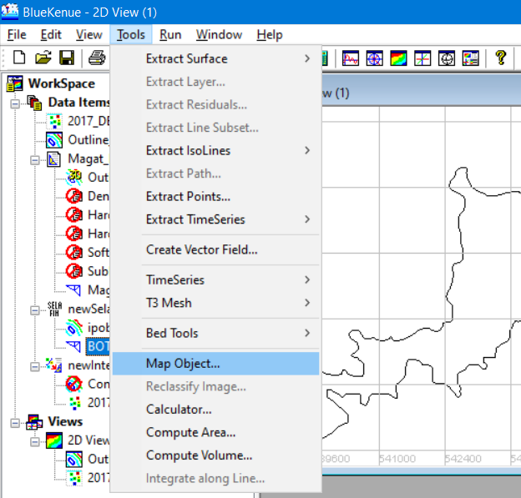

While the **BOTTOM** item is highlighted, activate the **Map Object** tool.

Figure 120. The Map Object Tool

1. A pop-up window appears showing the **Available Objects** from which you select the “**newInterpolator2D**” that we have just created. Then click “**OK**”.

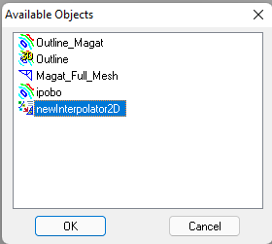

Figure 121. Choosing the NewInterpolator2D

1. A processing window will be shown, then once done, click the “**OK**” button.

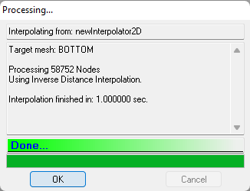

Figure 122. A Successful Interpolation Finished in 1.000 Seconds

1. Now, to check whether the process is successful, drag the “**BOTTOM**” item into the 2D View.

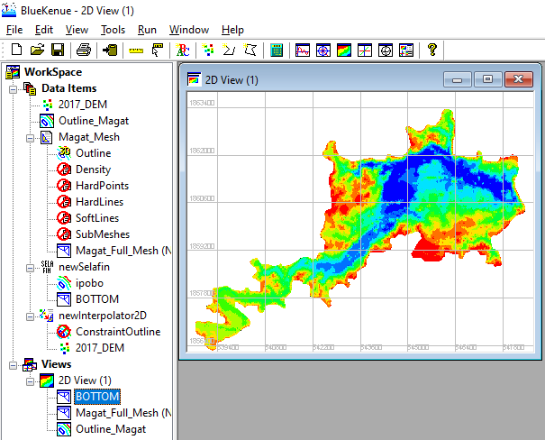

Drag the **BOTTOM** item into 2D view.

Figure 123. Bottom Item in 2D View

1. If you try to zoom in, you can see that the mesh now possesses the same color as that of the DEM file used.

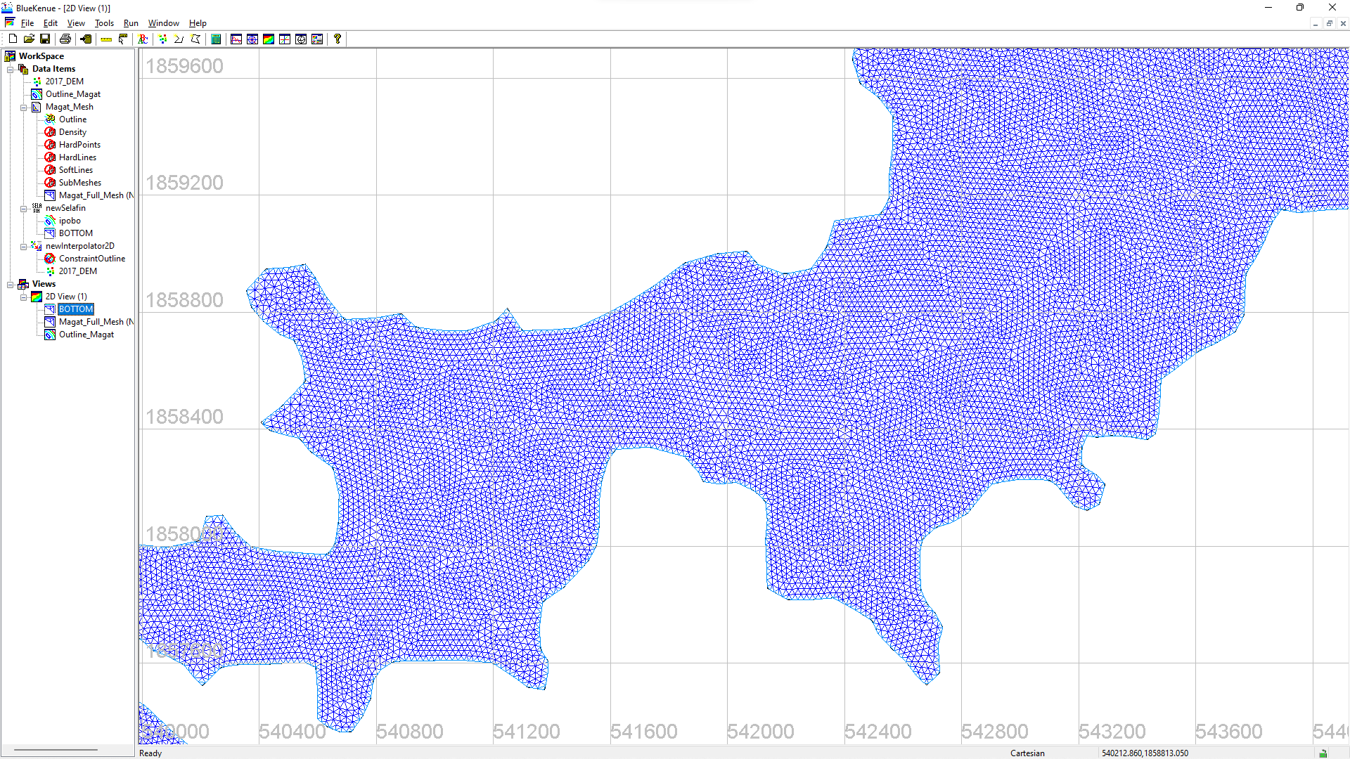

Figure 124. The Mesh before the Interpolation

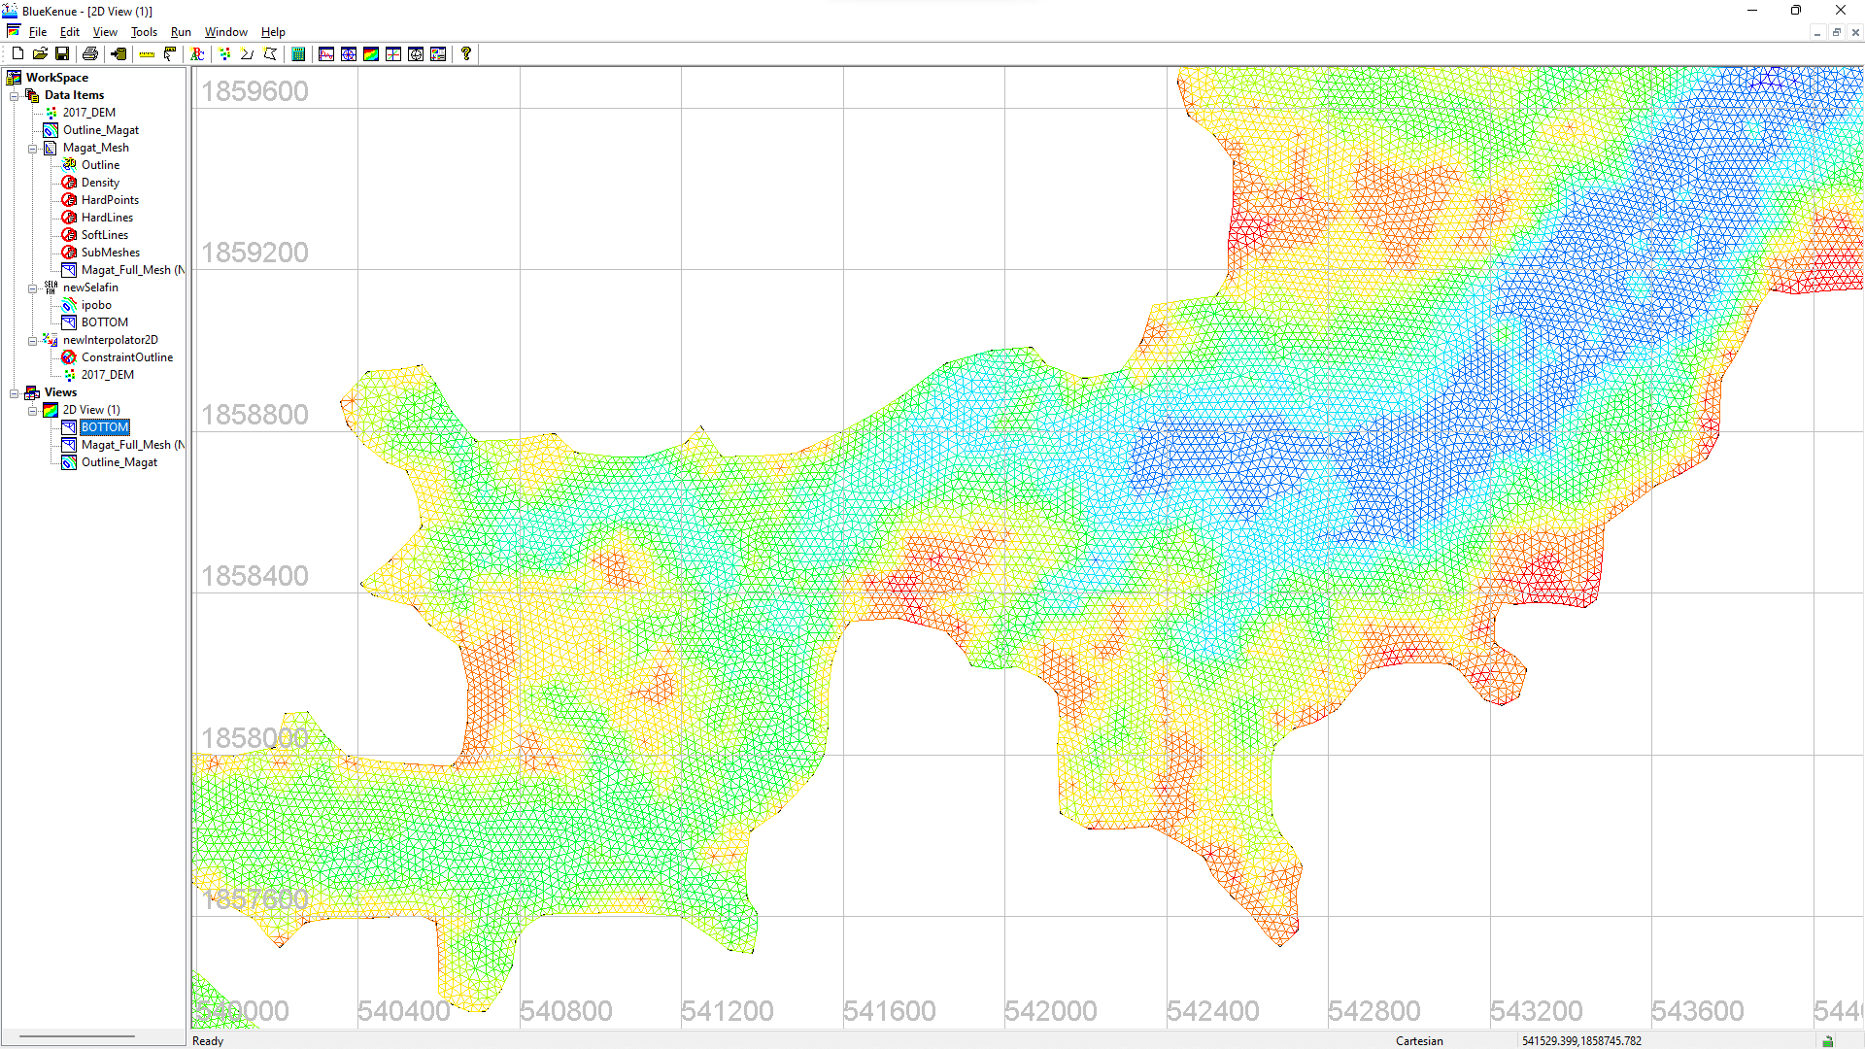

Figure 125. The Mesh after the Interpolation

1. The final step would be to save the Selafin file which is one of the mandatory files needed to run a TELEMAC simulation.
2. Click the “**newSelafin**” item to highlight it, then click the **Save** icon in the file.

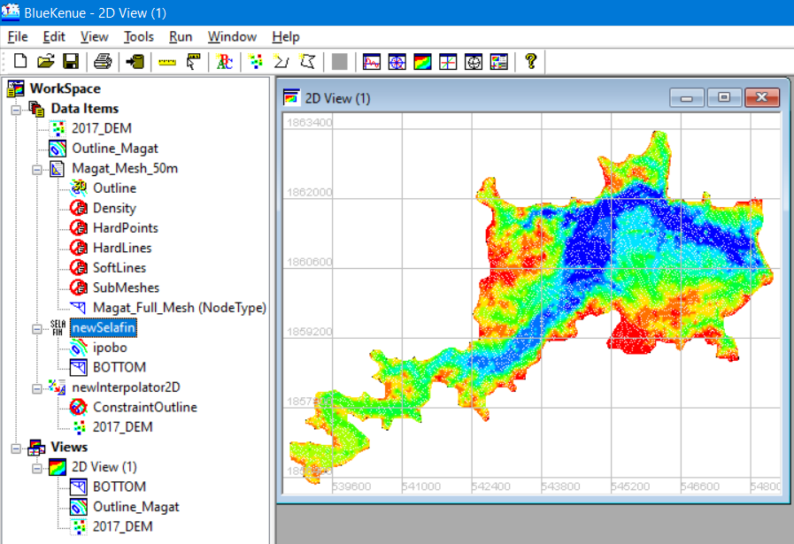

Highlight the **newSelafin** item and click the **Save** icon.

Figure 126. Highlighting Selafin Item and Saving it into File

1. Enter an appropriate name (i.e., Bottom_50m.slf), then click “**Save**”.

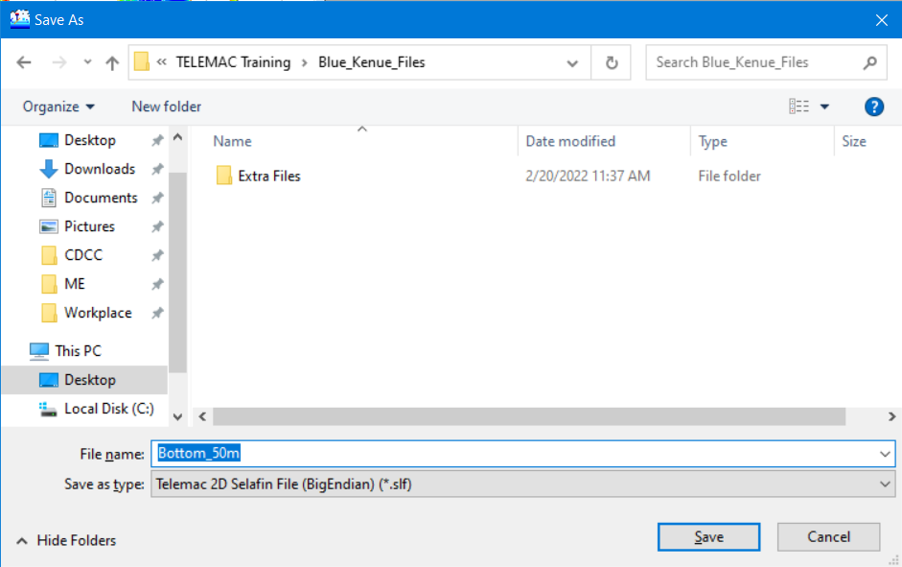

1. Finally, save your workspace by following the steps described on the next page:

### Saving Files and the Workspace

1. We can save the whole workspace into a file which can be useful when transferring into another computer or when picking up from an unfinished session.
2. From the menu bar, click “**File**” >> “**Save Workspace**”.

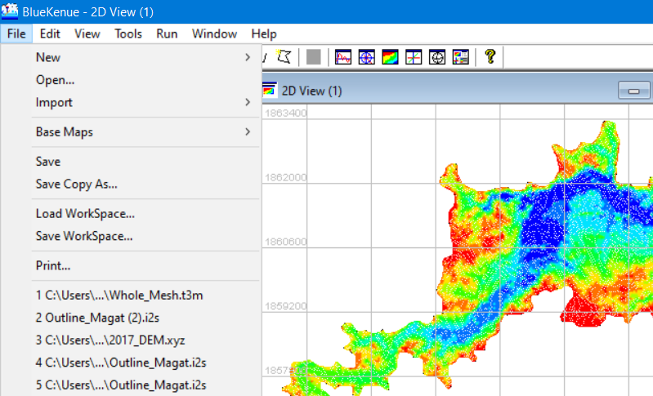

Click **File** >> **Save Workspace.**

Figure 127 Saving an entire Workspace in Blue Kenue

1. Enter a suitable file name for the Workspace (i.e., Magat_Workspace) then click “**Save**”.

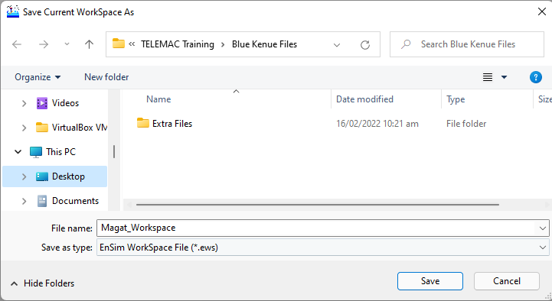

Figure 128. Entering the File Name and Saving Your Workspace

1. A toast with a message that the unsaved objects must be saved first before the Workspace can be saved will pop up. Click “**Yes**” to continue.

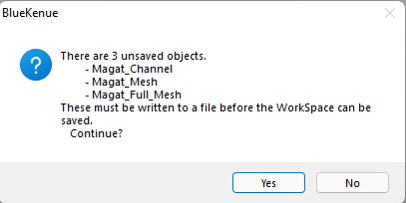

Figure 129. Saving All Unsaved Items

1. Enter appropriate names for each file then click “**Save**”.

*Note: The Workspace File contains all the data object settings, including color scales, legend options, scaling, rendering options, line width, point size etc. for all currently open objects. Aside from saving data object settings, it also saves the settings for all the views and the object view relationships.*

## Generating Boundary Conditions File Using Blue Kenue

Boundary conditions in the TELEMAC modelling system are specified through a table of variables known as the CONLIM table. Each record in this table corresponds to a boundary (or edge) node in a model’s finite element mesh.

The boundary file in *.cli format contains information about inflow and outflow nodes (coordinates and IDs).

1. Continuing from the previous section, we have a workspace containing all the generated meshes and Selafin objects.

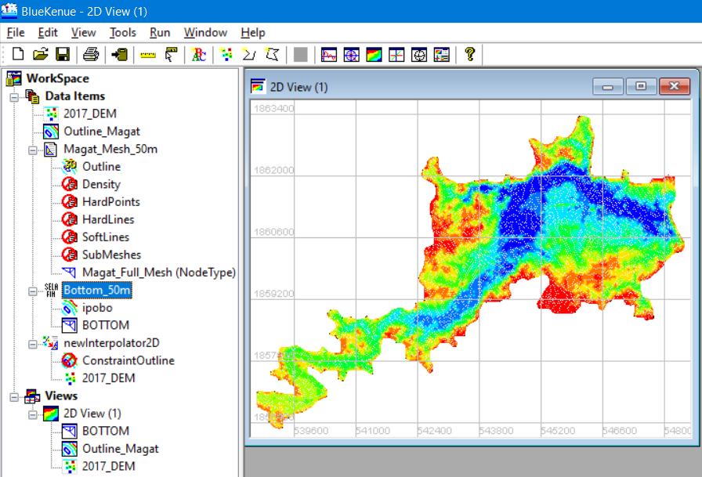

Click **File** >> **New** >> **Boundary Conditions (Conlim).**

Figure 130. Current Workspace

1. From the menu bar, again, click “**File**” >> “**New**” >> “**Boundary Conditions (Conlim).**”

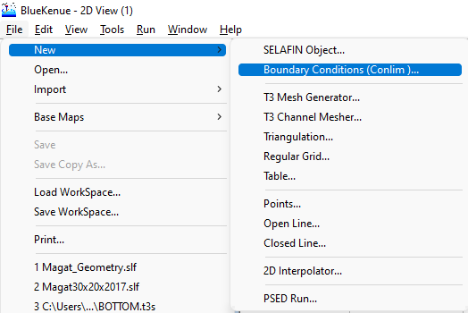

Figure 131. Steps in Creating a New Boundary Conditions Item

1. A window showing the available t3s Objects will show. Select “**Bottom**”, then click “**OK**”.

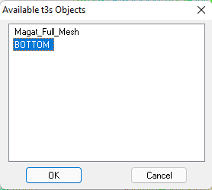

Figure 132. Available t3s Objects

1. Notice that a “**BOTTOM_BC**” item has been added under the Data Item menu.

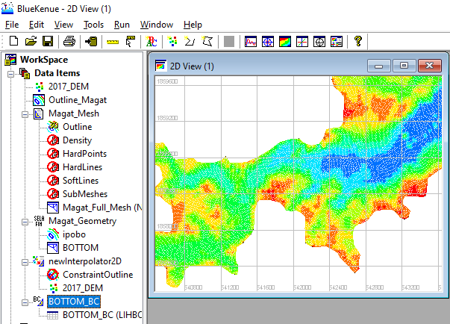

A New **Boundary Conditions (Conlim)** has been added under the **Data Items** menu.

Figure 133. The Newly Created Boundary Conditions Item

1. To start working on the boundary conditions file, drag the “**BOTTOM_BC**” item into the **2D View.**

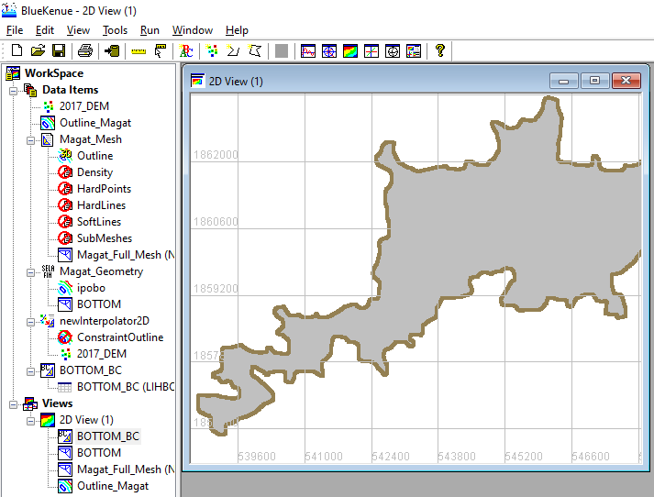

Figure 134. Dragging BOTTOM_BC into 2D View

1. Notice that the color of the mesh in 2D view now turned into gray and the boundary nodes are colored in brown. By default, this node color representation means **Closed Boundary (wall)**.

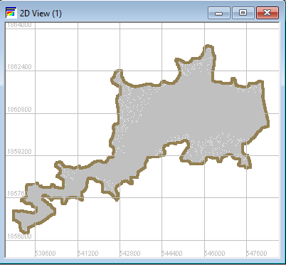

Zoom in into the upstream section of the reservoir.

Figure 135. The 2D View after Dragging BOTTOM_BC

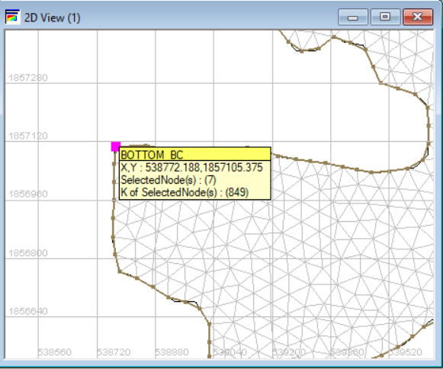

Use your mouse scroll wheel to zoom in.

Figure 136. Zooming in on the Upstream Section of the Reservoir

1. It would help if you maximize your 2D View window.
2. Once zoomed in, point cursor into a node at the edge and double-click. This will create a magenta-colored dot. Now hold “**SHIFT**” key in your keyboard and double-click on the other side of the mesh. This will create a magenta-colored line with nodes.



Hold **SHIFT.**

Figure 137. Double-clicking a Node to Start

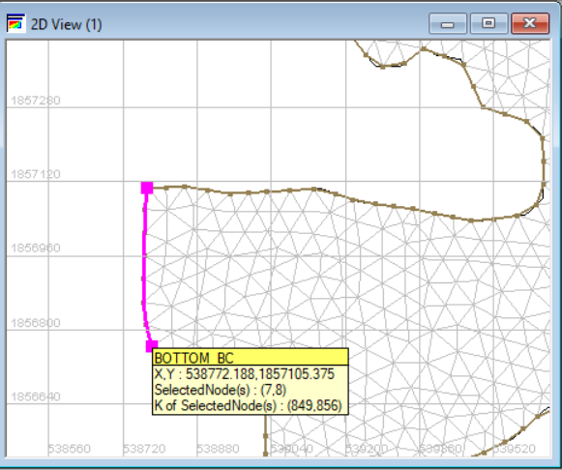

Hold **SHIFT.**

Figure 138. Double-clicking the Other End of the Upstream Section

1. Now, right click the magenta-colored line and select “**Add Boundary Segment**”.

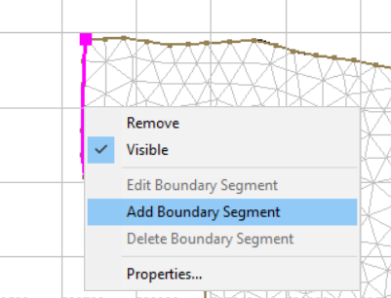

Right click and select “**Add boundary segment”.**

Figure 139. Selecting Add Boundary Segment

1. A “**Conlim Boundary Segment Editor**” window will pop up.

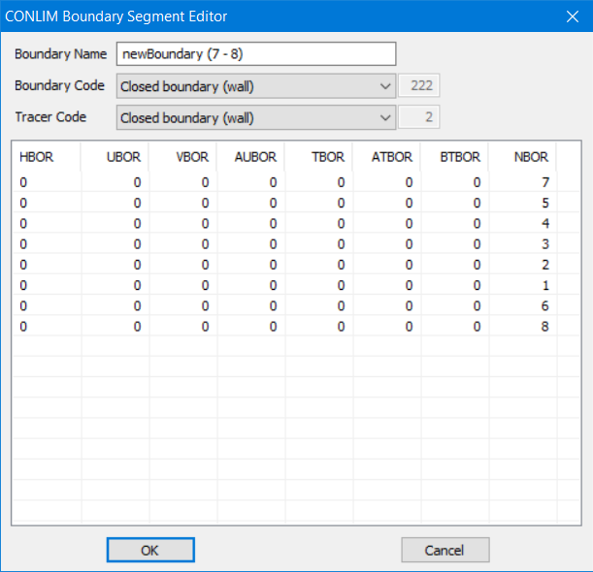

Figure 140. The Conlim Boundary Segment Editor

1. In the “**Boundary Name**” section, type “**Inflow**”, while in the “**Boundary Code**”, choose “**Open boundary with prescribed Q**”. Leave the rest unmodified, click “**OK**”.

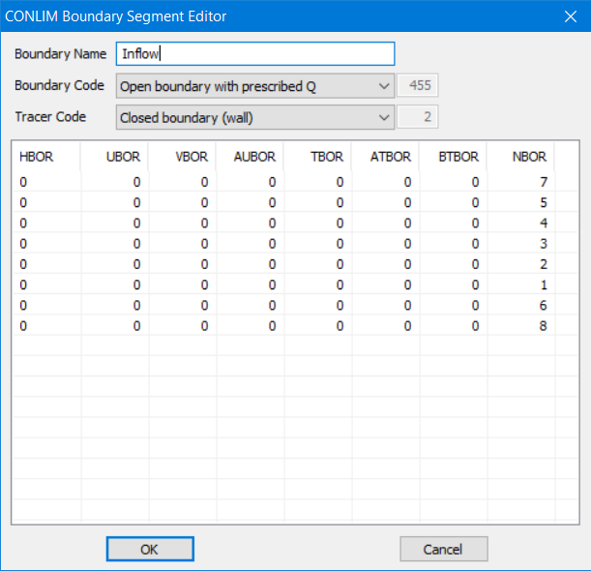

Figure 141. Boundary Properties for the Upstream Boundary Section

*Note:*

* *Q stands for volumetric flowrate, H is for water depth, while UV is for velocity.*
* *Notice that the magenta now turns to blue, a color representation for Open boundary with prescribed Q nodes.*

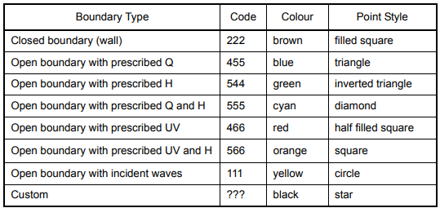

1. Do the same process for the outflow/downstream boundary. A GIS-derived image is attached herein as a reference.

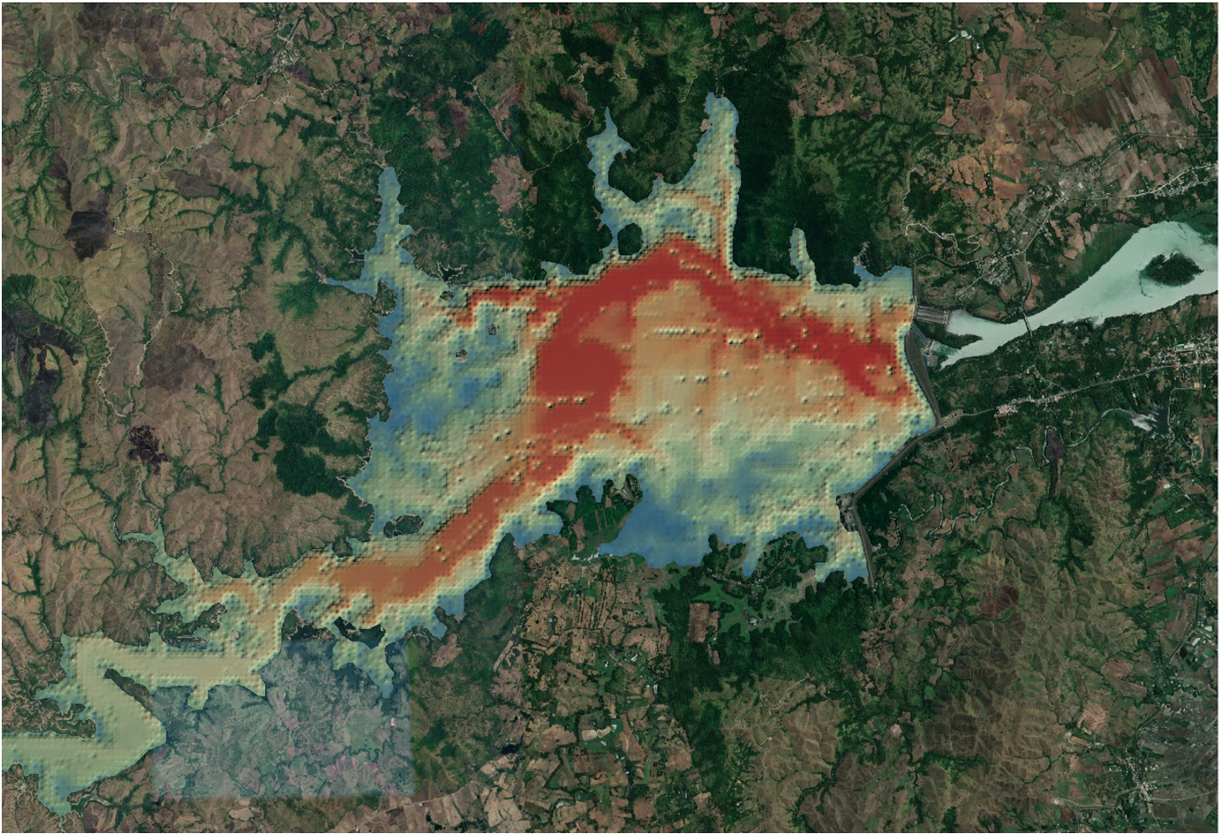

Figure 142. Base Map and the Digital Elevation File for Magat Reservoir

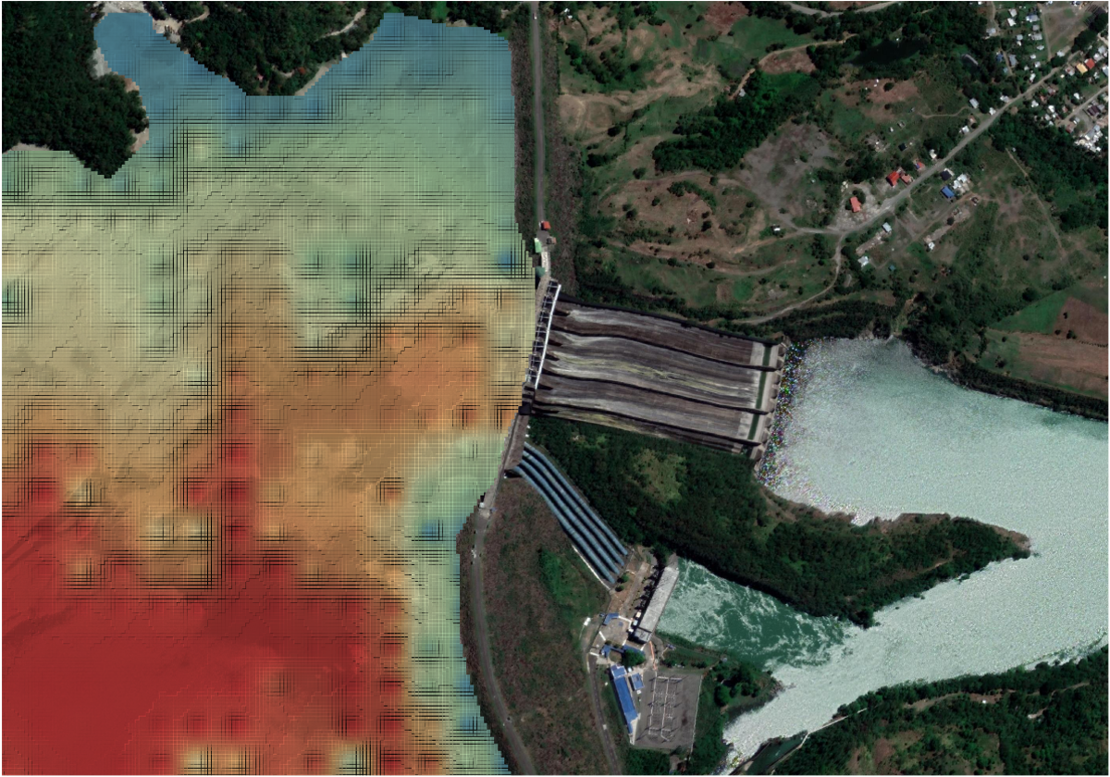

Figure 143. Zooming in on the Discharge Section

1. Back to Blue Kenue, zoom in on the discharge boundary.
2. Execute the same process, double-click to start, hold **SHIFT** key, then double-click again approximately where the penstock pipes end.

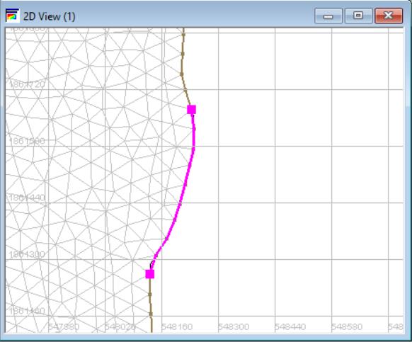

Still while holding **SHIFT** key.

Figure 144. Double-clicking up to the End of the Downstream Section

1. Right click and select “**Add Boundary Segment.**”

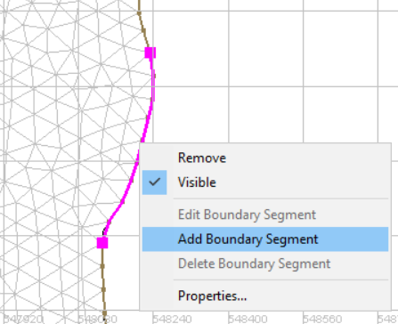

Figure 145. Adding Boundary Segment for the Downstream Boundary

1. In the "**Boundary Name**" section, type "**Outflow**", while in the "**Boundary Code**", choose "**Open boundary with prescribed H**". Leave the rest unmodified, then click "**OK**".

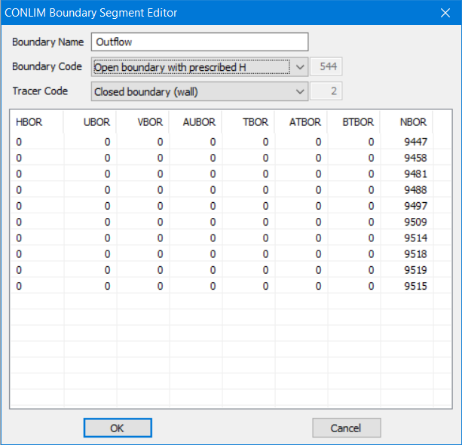

Figure 146. Boundary Properties for the Downstream Boundary Section

1. Again, the magenta-colored nodes now turn to green, a color representation for **Open boundary with prescribed H nodes**.
2. Rename the newly generated Conlim file into “**Boundary_Conditions**”.

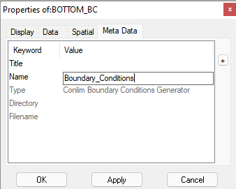

Figure 147. Rename the Items

1. Finally, highlight the child object under it named “**Boundary_Conditions (LIHBOR)** and click the “**Save**” icon to save it into a file.

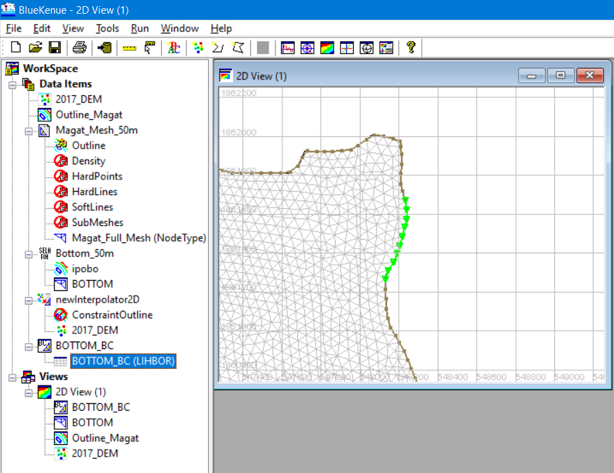

Highlight **BOTTOM_BC(LIHBOR)** and click **save** icon**.**

Figure 148. Saving the Generated Conlim Item

1. Enter appropriate name (i.e., “**Boundary_Conditions**”) and then save.

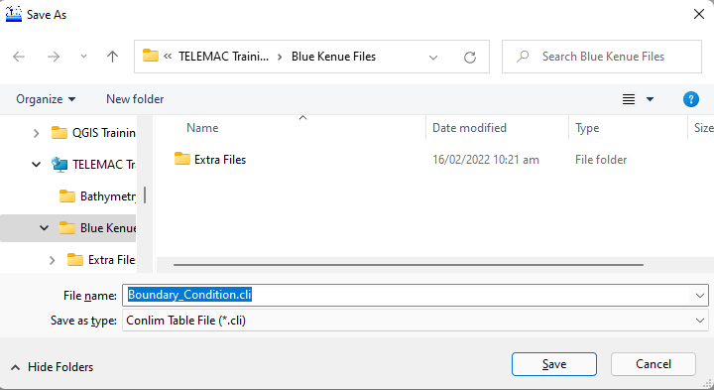

Figure 149. Saving the Boundary Conditions into a File

Note:

*Various Types of Boundary Conditions and their descriptions.*

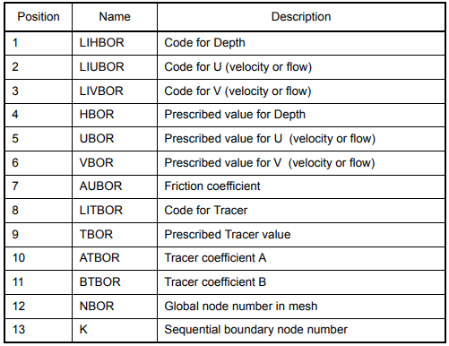

Figure 150. Various Types of Boundary Conditions

1. Finally, save your workspace again by following the steps described above.

## Understanding and Creating a Steering File (CAS File)

The steering file is the file ending in *.cas file extension. It is the main simulation file with information about references to the two mandatory files (i.e., the SELAFIN *.slf geometry and the *.cli boundary files) and optional files, as well as definitions of simulation parameters. It can be created or edited with a basic text editor or advanced GUI software such as Fudaa PrePro or BlueKenue.

In this manual, we will try to show a sample steering file ***before*** and ***after*** corrections and adjustments.

### Sample Steering File for a **Purely Hydrodynamic Scenario** in Magat Reservoir (Initial/Uncorrected)

/----------------------------------------------------------------------

/ FILE DEFINITION

/----------------------------------------------------------------------

BOUNDARY CONDITIONS FILE : 'BOTTOM_BC.cli'

GEOMETRY FILE : 'Bottom_50m.slf'

RESULTS FILE : 'Magat_V2.slf'

/----------------------------------------------------------------------

/ GENERAL OPTIONS

/----------------------------------------------------------------------

TITLE : 'Magat'

/

VARIABLES FOR GRAPHIC PRINTOUTS : 'U,V,F,H,B,S,Q,W,L'

TIME STEP : 60 /it should be determined by Courant Number

NUMBER OF TIME STEPS : 600

GRAPHIC PRINTOUT PERIOD : 1

LISTING PRINTOUT PERIOD : 10

TIDAL FLATS : YES

OPTION FOR THE TREATMENT OF TIDAL FLATS : 1

/----------------------------------------------------------------------

/ BOUNDARY CONDITIONS

/----------------------------------------------------------------------

PRESCRIBED ELEVATIONS :188.28; 0.0 /downstream boundary

PRESCRIBED FLOWRATES :0.0; 183.78 /upstream boundary

/----------------------------------------------------------------------

/ INITIAL CONDITIONS

/----------------------------------------------------------------------

INITIAL CONDITIONS :'CONSTANT ELEVATION'

INITIAL ELEVATION : 188.28 /initial water level

/----------------------------------------------------------------------

/ NUMERICAL OPTIONS (not necessary to modify for beginner)

/----------------------------------------------------------------------

MASS-BALANCE : YES

SOLVER : 1

SOLVER OPTION : 2

SOLVER ACCURACY : 1.E-4

MAXIMUM NUMBER OF ITERATIONS FOR SOLVER : 1000

PRECONDITIONING : 2

TYPE OF ADVECTION : 14;14

SUPG OPTION : 0;0

DISCRETIZATIONS IN SPACE : 11; 11

MATRIX STORAGE : 3

IMPLICITATION FOR DEPTH : 1.0

IMPLICITATION FOR VELOCITY : 1.0

VELOCITY PROFILES : 1;1

MASS-LUMPING ON H : 1.0

MASS-LUMPING ON VELOCITY : 1.0

MASS-LUMPING ON TRACERS : 1.0

TREATMENT OF THE LINEAR SYSTEM : 2

FREE SURFACE GRADIENT COMPATIBILITY : 0.5

CONTINUITY CORRECTION : YES

TREATMENT OF NEGATIVE DEPTHS : 2

OPTION FOR LIQUID BOUNDARIES : 1;1

OPTION FOR THE DIFFUSION OF VELOCITIES : 1

/----------------------------------------------------------------------

/ TURBULENCE MODEL

/----------------------------------------------------------------------

TURBULENCE MODEL : 3 / 1:constant; 3:K-EPSILON; 4:SMAGORINSKI; 5:MIXING LENGTH

VELOCITY DIFFUSIVITY : 1.E-6

TURBULENCE REGIME FOR SOLID BOUNDARIES : 2

/--------------------------------------------------------/

/ FRICTION PARAMETERS /

/--------------------------------------------------------/

LAW OF BOTTOM FRICTION : 4 /2:CHEZY; 4:MANNING; 5:NIKURADSE

FRICTION COEFFICIENT : 0.023

/----------------------------------------------------------------------

*Note:*

*Please see Appendix III to see visualized results files*

*These files will be provided for the actual training session. See* ***Simulation_Files*** *folder.*

### Sample Steering File for a Purely Hydrodynamic Scenario in Magat Reservoir (Adjusted/Corrected)

/----------------------------------------------------------------------

/ FILE DEFINITION

/----------------------------------------------------------------------

BOUNDARY CONDITIONS FILE : 'BOTTOM_BC.cli'

GEOMETRY FILE : 'Bottom_50m.slf'

RESULTS FILE : 'Magat_V2.slf'

/----------------------------------------------------------------------

/ GENERAL OPTIONS

/----------------------------------------------------------------------

TITLE : 'Magat'

/

VARIABLES FOR GRAPHIC PRINTOUTS : 'U,V,F,H,B,S,Q,W,L'

TIME STEP : 25 /it should be determined by Courant Number

NUMBER OF TIME STEPS : 3456

GRAPHIC PRINTOUT PERIOD : 10

LISTING PRINTOUT PERIOD : 10

TIDAL FLATS : YES

OPTION FOR THE TREATMENT OF TIDAL FLATS : 1

/----------------------------------------------------------------------

/ BOUNDARY CONDITIONS

/----------------------------------------------------------------------

PRESCRIBED ELEVATIONS :191.65; 0.0 /downstream boundary

PRESCRIBED FLOWRATES :0.0; 4847.74 /upstream boundary

/----------------------------------------------------------------------

/ INITIAL CONDITIONS

/----------------------------------------------------------------------

INITIAL CONDITIONS :'CONSTANT ELEVATION'

INITIAL ELEVATION : 191.65 /initial water level

/----------------------------------------------------------------------

/ NUMERICAL OPTIONS (not necessary to modify for beginner)

/----------------------------------------------------------------------

/

MASS-BALANCE : YES

SOLVER : 1

SOLVER OPTION : 2

SOLVER ACCURACY : 1.E-4

MAXIMUM NUMBER OF ITERATIONS FOR SOLVER : 1000

PRECONDITIONING : 2

TYPE OF ADVECTION : 14;14

SUPG OPTION : 0;0

DISCRETIZATIONS IN SPACE : 11; 11

MATRIX STORAGE : 3

IMPLICITATION FOR DEPTH : 1.0

IMPLICITATION FOR VELOCITY : 1.0

VELOCITY PROFILES : 1;1

MASS-LUMPING ON H : 1.0

MASS-LUMPING ON VELOCITY : 1.0

MASS-LUMPING ON TRACERS : 1.0

TREATMENT OF THE LINEAR SYSTEM : 2

FREE SURFACE GRADIENT COMPATIBILITY : 0.5

CONTINUITY CORRECTION : YES

TREATMENT OF NEGATIVE DEPTHS : 2

OPTION FOR LIQUID BOUNDARIES : 1;1

OPTION FOR THE DIFFUSION OF VELOCITIES : 1

/----------------------------------------------------------------------

/ TURBULENCE MODEL

/----------------------------------------------------------------------

TURBULENCE MODEL : 3 / 1:constant; 3:K-EPSILON; 4:SMAGORINSKI; 5:MIXING LENGTH

VELOCITY DIFFUSIVITY : 1.E-6

TURBULENCE REGIME FOR SOLID BOUNDARIES : 2

/--------------------------------------------------------/

/ FRICTION PARAMETERS /

/--------------------------------------------------------/

LAW OF BOTTOM FRICTION : 4 /2:CHEZY; 4:MANNING; 5:NIKURADSE

FRICTION COEFFICIENT : 0.023

### Sample Steering File for Modelling a Sediment Transport Scenario using TELEMAC coupled with the GAIA Module (Initial/Uncorrected)

The steering files used in coupling hydrodynamics (TELEMAC 2D/3D) and morphodynamics (Gaia) are fairly the same with the sample described above. However, a couple of new keywords for the sediment transport must be added in the steering file:

/----------------------------------------------------------------------

/ FILE DEFINITION

/----------------------------------------------------------------------

BOUNDARY CONDITIONS FILE : 'BOTTOM_BC.cli'

GEOMETRY FILE : 'Bottom_50m.slf'

RESULTS FILE : 'Magat_V2.slf'

/----------------------------------------------------------------------

/ GENERAL OPTIONS

/----------------------------------------------------------------------

TITLE : 'Magat'

/

VARIABLES FOR GRAPHIC PRINTOUTS : 'U,V,F,H,B,S,Q,W,L'

TIME STEP : 60 /it should be determined by Courant Number

NUMBER OF TIME STEPS : 600

GRAPHIC PRINTOUT PERIOD : 1

LISTING PRINTOUT PERIOD : 10

TIDAL FLATS : YES

OPTION FOR THE TREATMENT OF TIDAL FLATS : 1

Added keywords are highlighted

**/----------------------------------------------------------------------**

**/ COUPLING**

**/----------------------------------------------------------------------**

**COUPLING WITH : 'GAIA'**

**GAIA STEERING FILE : 'Gaia_Magat_2D.cas' /steering file name of gaia**

**/----------------------------------------------------------------------**

/ BOUNDARY CONDITIONS

/----------------------------------------------------------------------

PRESCRIBED ELEVATIONS :188.28; 0.0 /downstream boundary (water level)

PRESCRIBED FLOWRATES :0.0; 183.78 /upstream boundary (inflow discharge)

PRESCRIBED TRACERS VALUES :0.0; 1.0 /upstream boundary (inflow sediment)

/----------------------------------------------------------------------

/ INITIAL CONDITIONS

/----------------------------------------------------------------------

INITIAL CONDITIONS :'CONSTANT ELEVATION'

INITIAL ELEVATION : 188.28 /initial water level

/----------------------------------------------------------------------

/ NUMERICAL OPTIONS (not necessary to modify for beginner)

/----------------------------------------------------------------------

MASS-BALANCE : YES

SOLVER : 1

SOLVER OPTION : 2

SOLVER ACCURACY : 1.E-4

MAXIMUM NUMBER OF ITERATIONS FOR SOLVER : 1000

PRECONDITIONING : 2

TYPE OF ADVECTION : 14;14

SUPG OPTION : 0;0

DISCRETIZATIONS IN SPACE : 11; 11

MATRIX STORAGE : 3

IMPLICITATION FOR DEPTH : 1.0

IMPLICITATION FOR VELOCITY : 1.0

VELOCITY PROFILES : 1;1

MASS-LUMPING ON H : 1.0

MASS-LUMPING ON VELOCITY : 1.0

MASS-LUMPING ON TRACERS : 1.0

TREATMENT OF THE LINEAR SYSTEM : 2

FREE SURFACE GRADIENT COMPATIBILITY : 0.5

CONTINUITY CORRECTION : YES

TREATMENT OF NEGATIVE DEPTHS : 2

OPTION FOR LIQUID BOUNDARIES : 1;1

OPTION FOR THE DIFFUSION OF VELOCITIES : 1

/----------------------------------------------------------------------

/ TURBULENCE MODEL

/----------------------------------------------------------------------

TURBULENCE MODEL : 3 / 1:constant; 3:K-EPSILON; 4:SMAGORINSKI; 5:MIXING LENGTH

VELOCITY DIFFUSIVITY : 1.E-6

TURBULENCE REGIME FOR SOLID BOUNDARIES : 2

/--------------------------------------------------------/

/ FRICTION PARAMETERS /

/--------------------------------------------------------/

LAW OF BOTTOM FRICTION : 4 /2:CHEZY; 4:MANNING; 5:NIKURADSE

FRICTION COEFFICIENT : 0.023

/----------------------------------------------------------------------

As stated, an additional steering file called “**Gaia_Magat_2D.cas**” must be also present and is described herein as:

/ TITLE: Gaia_Magat_2D.cas

/----------------------------------------------------------------------/

GEOMETRY FILE = Bottom_50m.slf

BOUNDARY CONDITIONS FILE = BOTTOM_BC.cli

RESULTS FILE = gai_Magat.slf

/----------------------------------------------------------------------/

/ OUTPUTS /

/----------------------------------------------------------------------/

VARIABLES FOR GRAPHIC PRINTOUTS : 'U,V,H,S,R,B,E,TOB,KS' /evolution du fond

MASS-BALANCE : YES

/----------------------------------------------------------------------/

/ PHYSICAL OPTIONS

/----------------------------------------------------------------------/

CLASSES TYPE OF SEDIMENT : CO

CLASSES SEDIMENT DENSITY : 2650.0

CLASSES SEDIMENT DIAMETERS = 0.000008

CLASSES SETTLING VELOCITIES : -9

NUMBER OF LAYERS FOR INITIAL STRATIFICATION : 1

LAYERS INITIAL THICKNESS : 0.D0

LAYERS MASS TRANSFER : 0.D0

LAYERS PARTHENIADES CONSTANT : 5.D-3

LAYERS MUD CONCENTRATION : 900.D0

LAYERS CRITICAL EROSION SHEAR STRESS OF THE MUD : 0.05

CLASSES CRITICAL SHEAR STRESS FOR MUD DEPOSITION : 1000

SKIN FRICTION CORRECTION : 0

/----------------------------------------------------------------------/

/ NUMERICAL OPTIONS

/----------------------------------------------------------------------/

ADVECTION-DIFFUSION SCHEME WITH SETTLING VELOCITY : 1 / SET_DIF scheme

SOLVER FOR DIFFUSION OF SUSPENSION = 1

### Sample Steering File for Modelling a Sediment Transport Scenario by Coupling TELEMAC with the GAIA Module (Adjusted/Corrected)

/----------------------------------------------------------------------

/ FILE DEFINITION

/----------------------------------------------------------------------

Adjusted parameters are shown in bold letters

BOUNDARY CONDITIONS FILE : 'BOTTOM_BC.cli'

GEOMETRY FILE : 'Bottom_50m.slf'

RESULTS FILE : 'Magat_V2.slf'

/----------------------------------------------------------------------

/ GENERAL OPTIONS

/----------------------------------------------------------------------

TITLE : 'Magat'

/

**VARIABLES FOR GRAPHIC PRINTOUTS : 'U,V,F,H,B,S,Q,W,L,T*'**

**TIME STEP : 25 /it should be determined by Courant Number**

**NUMBER OF TIME STEPS : 3456**

**GRAPHIC PRINTOUT PERIOD : 10**

**LISTING PRINTOUT PERIOD : 10**

TIDAL FLATS : YES

OPTION FOR THE TREATMENT OF TIDAL FLATS : 1

/----------------------------------------------------------------------

COUPLING

/----------------------------------------------------------------------

COUPLING WITH : 'GAIA'

GAIA STEERING FILE : 'Gaia_Magat_2D.cas' /steering file name of gaia

/----------------------------------------------------------------------

/ BOUNDARY CONDITIONS

/----------------------------------------------------------------------

PRESCRIBED ELEVATIONS :**191.65; 0.0** /downstream boundary (water level)

PRESCRIBED FLOWRATES :**0.0; 4847.74** /upstream boundary (inflow discharge)

PRESCRIBED TRACERS VALUES :**0.0; 19.07** /upstream boundary (inflow sediment)

/----------------------------------------------------------------------

/ INITIAL CONDITIONS

/----------------------------------------------------------------------

**INITIAL CONDITIONS :'CONSTANT ELEVATION'**

**INITIAL ELEVATION : 191.65 /initial water level**

/

/----------------------------------------------------------------------

/ NUMERICAL OPTIONS (not necessary to modify for beginner)

/----------------------------------------------------------------------

MASS-BALANCE : YES

SOLVER : 1

SOLVER OPTION : 2

SOLVER ACCURACY : 1.E-4

MAXIMUM NUMBER OF ITERATIONS FOR SOLVER : 1000

PRECONDITIONING : 2

TYPE OF ADVECTION : 14;14

SUPG OPTION : 0;0

DISCRETIZATIONS IN SPACE : 11; 11

MATRIX STORAGE : 3

IMPLICITATION FOR DEPTH : 1.0

IMPLICITATION FOR VELOCITY : 1.0

VELOCITY PROFILES : 1;1

MASS-LUMPING ON H : 1.0

MASS-LUMPING ON VELOCITY : 1.0

MASS-LUMPING ON TRACERS : 1.0

TREATMENT OF THE LINEAR SYSTEM : 2

FREE SURFACE GRADIENT COMPATIBILITY : 0.5

CONTINUITY CORRECTION : YES

TREATMENT OF NEGATIVE DEPTHS : 2

OPTION FOR LIQUID BOUNDARIES : 1;1

OPTION FOR THE DIFFUSION OF VELOCITIES : 1

/----------------------------------------------------------------------

/ TURBULENCE MODEL

/----------------------------------------------------------------------

/

TURBULENCE MODEL : 3 / 1:constant; 3:K-EPSILON; 4:SMAGORINSKI; 5:MIXING LENGTH

VELOCITY DIFFUSIVITY : 1.E-6

TURBULENCE REGIME FOR SOLID BOUNDARIES : 2

/

/--------------------------------------------------------/

/ FRICTION PARAMETERS /

/--------------------------------------------------------/

LAW OF BOTTOM FRICTION : 4 /2:CHEZY; 4:MANNING; 5:NIKURADSE

FRICTION COEFFICIENT : 0.023

/----------------------------------------------------------------------

### Sample Steering File for Modelling a Sediment Transport Scenario using TELEMAC coupled with GAIA Module and imposing a Hydrograph File (Initial/Uncorrected)

/----------------------------------------------------------------------

/ FILE DEFINITION

/----------------------------------------------------------------------

BOUNDARY CONDITIONS FILE : 'BOTTOM_BC.cli'

GEOMETRY FILE : 'Bottom_50m.slf'

RESULTS FILE : 'Magat_V2.slf'

LIQUID BOUNDARIES FILE = Magat_Boundary.txt /hydrograph B.C. file

/----------------------------------------------------------------------

/ GENERAL OPTIONS

/----------------------------------------------------------------------

TITLE : 'Magat'

/

VARIABLES FOR GRAPHIC PRINTOUTS : 'U,V,F,H,B,S,Q,W,L'

TIME STEP : 60 /it should be determined by Courant Number

NUMBER OF TIME STEPS : 600

GRAPHIC PRINTOUT PERIOD : 1

LISTING PRINTOUT PERIOD : 10

TIDAL FLATS : YES

OPTION FOR THE TREATMENT OF TIDAL FLATS : 1

/----------------------------------------------------------------------

/ COUPLING

/----------------------------------------------------------------------

COUPLING WITH : 'GAIA'

GAIA STEERING FILE : 'Gaia_Magat_2D.cas' /steering file name of gaia

/----------------------------------------------------------------------

/ BOUNDARY CONDITIONS

/----------------------------------------------------------------------

PRESCRIBED ELEVATIONS :188.28; 0.0 /downstream boundary (water level)

PRESCRIBED FLOWRATES :0.0; 183.78 /upstream boundary (inflow discharge)

PRESCRIBED TRACERS VALUES :0.0; 1.0 /upstream boundary (inflow sediment)

/----------------------------------------------------------------------

/ INITIAL CONDITIONS

/----------------------------------------------------------------------

INITIAL CONDITIONS :'CONSTANT ELEVATION'

INITIAL ELEVATION : 188.28 /initial water level

/

/----------------------------------------------------------------------

/ NUMERICAL OPTIONS (not necessary to modify for beginner)

/----------------------------------------------------------------------

MASS-BALANCE : YES

SOLVER : 1

SOLVER OPTION : 2

SOLVER ACCURACY : 1.E-4

MAXIMUM NUMBER OF ITERATIONS FOR SOLVER : 1000

PRECONDITIONING : 2

TYPE OF ADVECTION : 14;14

SUPG OPTION : 0;0

DISCRETIZATIONS IN SPACE : 11; 11

MATRIX STORAGE : 3

IMPLICITATION FOR DEPTH : 1.0

IMPLICITATION FOR VELOCITY : 1.0

VELOCITY PROFILES : 1;1

MASS-LUMPING ON H : 1.0

MASS-LUMPING ON VELOCITY : 1.0

MASS-LUMPING ON TRACERS : 1.0

TREATMENT OF THE LINEAR SYSTEM : 2

FREE SURFACE GRADIENT COMPATIBILITY : 0.5

CONTINUITY CORRECTION : YES

TREATMENT OF NEGATIVE DEPTHS : 2

OPTION FOR LIQUID BOUNDARIES : 1;1

OPTION FOR THE DIFFUSION OF VELOCITIES : 1

/----------------------------------------------------------------------

/ TURBULENCE MODEL

/----------------------------------------------------------------------

TURBULENCE MODEL : 3 / 1:constant; 3:K-EPSILON; 4:SMAGORINSKI; 5:MIXING LENGTH

VELOCITY DIFFUSIVITY : 1.E-6

TURBULENCE REGIME FOR SOLID BOUNDARIES : 2

/--------------------------------------------------------/

/ FRICTION PARAMETERS /

/--------------------------------------------------------/

LAW OF BOTTOM FRICTION : 4 /2:CHEZY; 4:MANNING; 5:NIKURADSE

FRICTION COEFFICIENT : 0.023

### Sample Steering File for Modelling a Sediment Transport Scenario using TELEMAC coupled with GAIA Module and imposing a Boundary File (Corrected/Adjusted)

/----------------------------------------------------------------------

/ FILE DEFINITION

/----------------------------------------------------------------------

BOUNDARY CONDITIONS FILE : 'BOTTOM_BC.cli'

GEOMETRY FILE : 'Bottom_50m.slf'

RESULTS FILE : 'Magat_V2.slf'

LIQUID BOUNDARIES FILE = Magat_Boundary.txt /hydrograph B.C. file

/----------------------------------------------------------------------

/ GENERAL OPTIONS

/----------------------------------------------------------------------

TITLE : 'Magat'

VARIABLES FOR GRAPHIC PRINTOUTS : 'U,V,F,H,B,S,Q,W,L,T*'

**TIME STEP : 25** /it should be determined by Courant Number

**NUMBER OF TIME STEPS : 20592**

**GRAPHIC PRINTOUT PERIOD : 10**

**LISTING PRINTOUT PERIOD : 10**

TIDAL FLATS : YES

OPTION FOR THE TREATMENT OF TIDAL FLATS : 1

/----------------------------------------------------------------------

/ COUPLING

/----------------------------------------------------------------------

COUPLING WITH : 'GAIA'

GAIA STEERING FILE : 'Gaia_Magat_2D.cas' /steering file name of gaia

/----------------------------------------------------------------------

/ BOUNDARY CONDITIONS

/----------------------------------------------------------------------

**PRESCRIBED ELEVATIONS :189.02; 0.0** /downstream boundary (water level)

**PRESCRIBED FLOWRATES :0.0; 301** /upstream boundary (inflow discharge)

**PRESCRIBED TRACERS VALUES :0.0; 1.26** /upstream boundary (inflow sediment)

/----------------------------------------------------------------------

/ INITIAL CONDITIONS

/----------------------------------------------------------------------

INITIAL CONDITIONS :'CONSTANT ELEVATION'

**INITIAL ELEVATION : 189.02** /initial water level

/----------------------------------------------------------------------

/ NUMERICAL OPTIONS (not necessary to modify for beginner)

/----------------------------------------------------------------------

MASS-BALANCE : YES

SOLVER : 1

SOLVER OPTION : 2

SOLVER ACCURACY : 1.E-4

MAXIMUM NUMBER OF ITERATIONS FOR SOLVER : 1000

PRECONDITIONING : 2

TYPE OF ADVECTION : 14;14

SUPG OPTION : 0;0

DISCRETIZATIONS IN SPACE : 11; 11

MATRIX STORAGE : 3

IMPLICITATION FOR DEPTH : 1.0

IMPLICITATION FOR VELOCITY : 1.0

VELOCITY PROFILES : 1;1

MASS-LUMPING ON H : 1.0

MASS-LUMPING ON VELOCITY : 1.0

MASS-LUMPING ON TRACERS : 1.0

TREATMENT OF THE LINEAR SYSTEM : 2

FREE SURFACE GRADIENT COMPATIBILITY : 0.5

CONTINUITY CORRECTION : YES

TREATMENT OF NEGATIVE DEPTHS : 2

OPTION FOR LIQUID BOUNDARIES : 1;1

OPTION FOR THE DIFFUSION OF VELOCITIES : 1

/----------------------------------------------------------------------

/ TURBULENCE MODEL

/----------------------------------------------------------------------

TURBULENCE MODEL : 3 / 1:constant; 3:K-EPSILON; 4:SMAGORINSKI; 5:MIXING LENGTH

VELOCITY DIFFUSIVITY : 1.E-6

TURBULENCE REGIME FOR SOLID BOUNDARIES : 2

/--------------------------------------------------------/

/ FRICTION PARAMETERS /

/--------------------------------------------------------/

LAW OF BOTTOM FRICTION : 4 /2:CHEZY; 4:MANNING; 5:NIKURADSE

FRICTION COEFFICIENT : 0.023

/----------------------------------------------------------------------

The Hydrograph (Boundary Condition File)

*Note: Displaying the first 60 hours only*

# Open boundary file of Magat_upstream_2020

# Simulation duration is from 11/9/2020 00:00 to 11/14/2020

#

T SL(1) Q(2) TR(1,1) TR(2,1)

s m m3/s kg/m3 kg/m3

0 189.02 301 0 1.26209784

3600 189.04 408 0 1.700375418

7200 189.07 453 0 1.88397049

10800 189.11 535 0 2.2176069

14400 189.16 675 0 2.784938155

18000 189.34 1751 0 7.087911415

21600 189.53 1823 0 7.373416954

25200 189.74 2009 0 8.10995036

28800 189.95 2108 0 8.501411778

32400 190.17 2184 0 8.80167725

36000 190.35 1896 0 7.662657678

39600 190.51 1784 0 7.218796697

43200 190.65 1517 0 6.158340916

46800 190.8 1629 0 6.603596377

50400 190.92 1418 0 5.764220215

54000 191.03 1538 0 6.241874992

57600 191.1 1477 0 5.999164123

61200 191.12 1251 0 5.098119621

64800 191.16 1417 0 5.760236452

68400 191.18 1291 0 5.257818321

72000 191.2 1218 0 4.966291423

75600 191.2 1038 0 4.245914694

79200 191.2 1048 0 4.285997515

82800 191.2 1067 0 4.362133864

86400 191.2 1094 0 4.470281102

90000 191.2 1111 0 4.538346341

93600 191.18 915 0 3.75223932

97200 191.16 939 0 3.848665248

100800 191.13 868 0 3.563257342

104400 191.09 728 0 2.999070049

108000 191.06 870 0 3.571303221

111600 191.02 751 0 3.091896846

115200 190.98 727 0 2.995032784

118800 190.95 747 0 3.075757189

122400 190.93 814 0 3.345875484

126000 190.89 701 0 2.890024441

129600 190.85 710 0 2.926382154

133200 190.79 588 0 2.43269486

136800 190.74 624 0 2.578568992

140400 190.7 716 0 2.950615502

144000 190.66 745 0 3.067686713

147600 190.6 557 0 2.30693814

151200 190.56 732 0 3.015218002

154800 190.51 672 0 2.772807663

158400 190.45 571 0 2.363748379

162000 190.41 749 0 3.083827233

165600 190.38 800 0 3.289470873

169200 190.34 785 0 3.229015439

172800 190.3 742.71 0 3.058445485

176400 190.27 832.55 0 3.420581768

180000 190.24 861.78 0 3.538232282

183600 190.2 738.72 0 3.042342596

187200 190.17 849.3 0 3.488010307

190800 190.14 878.53 0 3.605614756

194400 190.1 813.73 0 3.344787865

198000 190.07 742.06 0 3.055822326

201600 190.04 833.29 0 3.423561269

205200 190 735.73 0 3.030274378

208800 189.95 704.48 0 2.904083857

212400 189.89 618.61 0 2.556739349

216000 189.86 742.64 0 3.058162993

### Creating a Steering File Using Notepad (or any basic text editing software available)

1. Copy the text files described in Section 3.3.2. [*Sample Steering File for a Purely Hydrodynamic Scenario in Magat Reservoir (Adjusted)*]
2. In the Windows start menu, type “**Notepad**”.

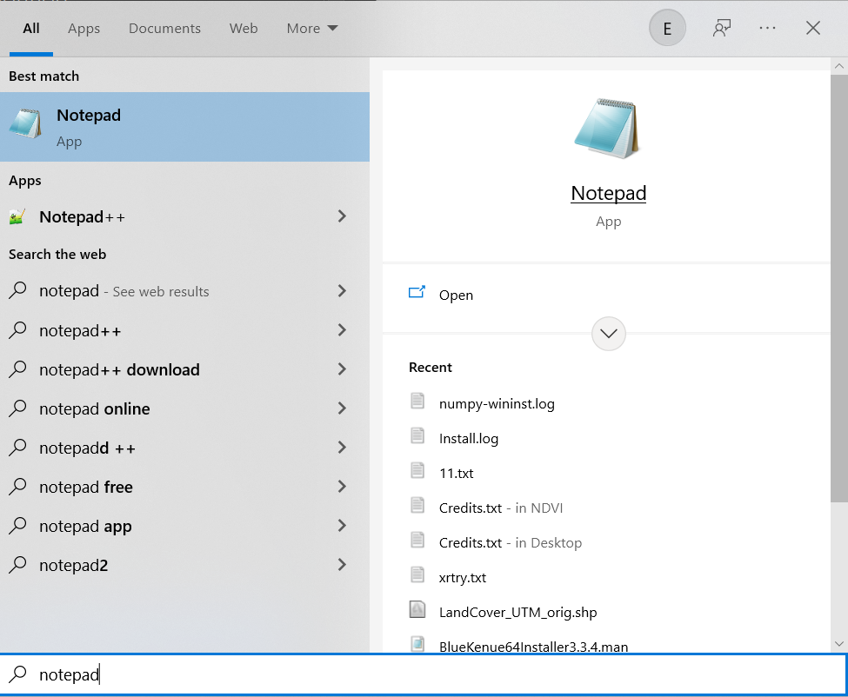

Figure 151. Using Notepad in the Windows Files and Programs Search Option

1. Paste (or manually type if preferred) the copied text files.

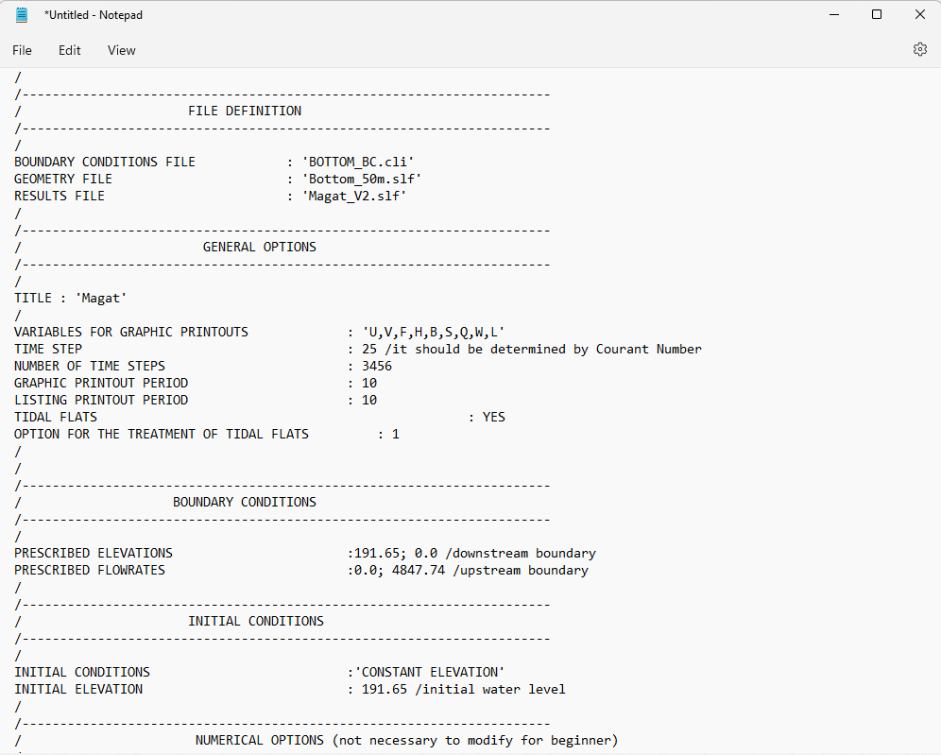

Figure 152. A Sample Steering File for a Purely Hydrodynamic Scenario

1. Click **File** >> **Save as:**

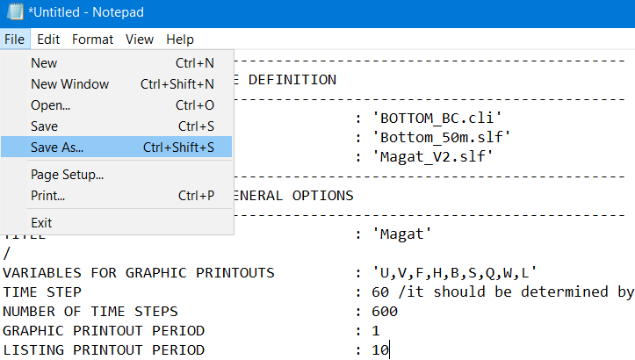

Or simply press **CTRL+Shift+S**.

1. Enter appropriate file name (i.e., Magat_2D.cas) and do not forget to add the **.cas** extension, and then click “**Save”.**

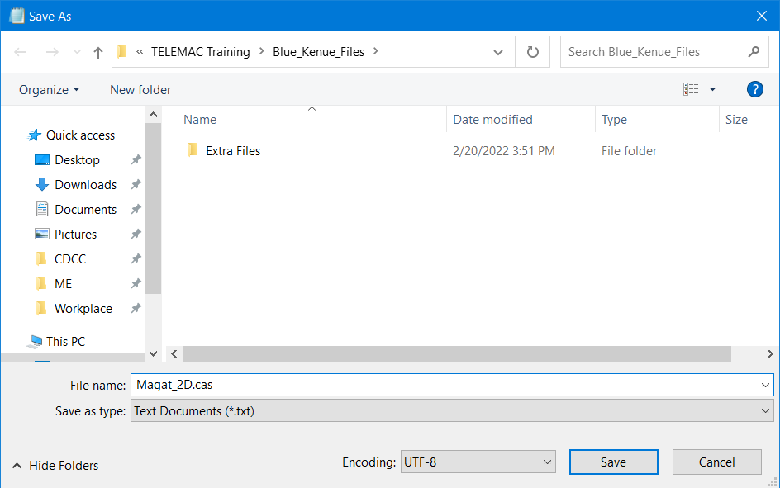

Figure 153. Adding .cas File Extension

# Running the Model Setup

With the steering file (*.cas) generated from the last section, all the necessary files for TELEMAC 2D simulation are now available. In summary, we have also generated geometry file (*.slf) which can be found in page 54, and the boundary conditions (*.cli) files in page 77.

Make sure that all these files are now located in a single simulation folder. For the trainees’ convenience, these files have been generated beforehand and are housed in the **Simulation_Files** folder.

## Running a Hydrodynamic Simulation on Windows Environment

### Step 1: Open DOS Command Prompt.

* 1. If you do not know where the command prompt is, go to the Windows start menu (or press windows key) and type “**cmd**” in the **“Search files and programs”** box, and press **Enter.**



Figure 154. Typing cmd in the Search Files and Programs Box

* 1. Pressing enter would open the windows command prompt terminal:



Figure 155. The Windows Command Prompt Terminal

### Step 2: Change the directory in the TELEMAC config file folder.

1. In the first line, enter the following:

**cd C:\opentelemac-mascaret\v8p2r1\configs**

Note:

*Depending on your TELEMAC version, you might have to change the* ***v8p2r1*** *into the version you are currently using.*

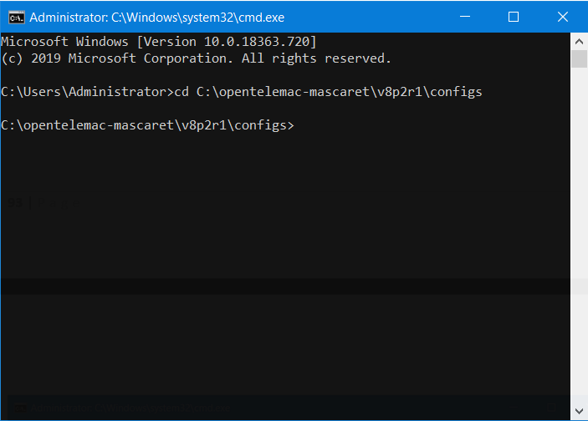

Figure 156. Command Line Interface after Changing Directory.

1. Once you are already in the directory where config file is located, type **dir** to display all the files inside that directory.

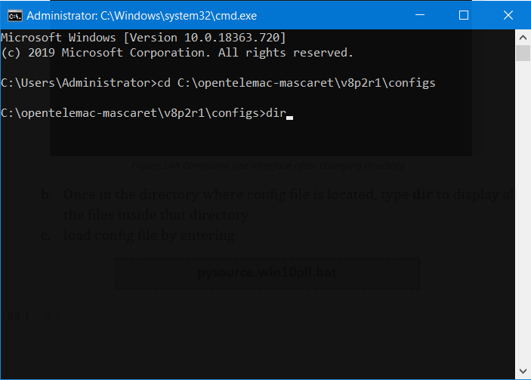

Figure 157. Typing dir to Display All Files inside the Directory

### Step 3: Load the config file.

1. See if **pysource.win10pll.bat** is in the present directory. If it is, continue to the next step. If not, make sure that the steps in page 37 is followed.

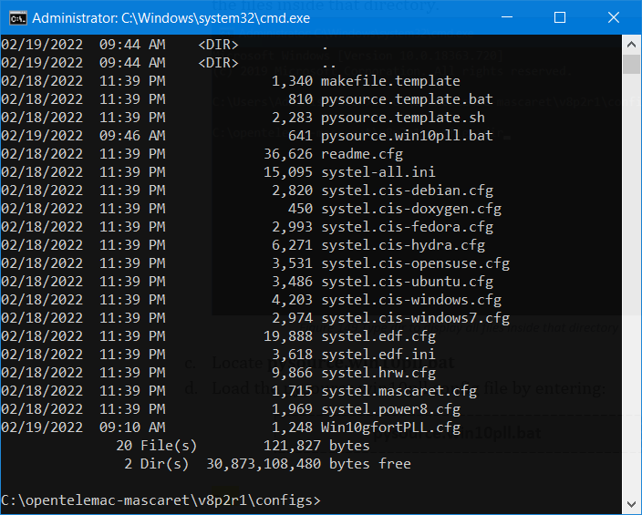

Figure 158. Directory Showing pysource.win10pll.bat

1. Remember that this directory is where we have extracted both the config and batch files from earlier. What we are going to do is to load the config file into the command prompt environment.
2. Load the config file by typing “**pysource.Win10pll.bat**” and pressing **Enter**.

**pysource.win10pll.bat**

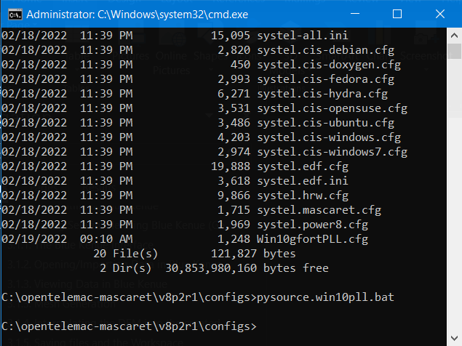

Figure 159. Directory Showing the Proper Loading to Avoid Returning Errors

### Step 4: Change the directory in the **Simulation_Files** folder

1. Given that the files from the drive folder have been downloaded and extracted in your **Desktop** folder, type the following in the next cmd line:

**cd C:\Users\*username*\Desktop\TELEMAC training\Simulation_Files\Magat_Sc1_hydro**

*Note: Insert your computer’s user name at the *username*, and make sure to remove the asterisk signs afterwards. Do not forget to press* ***Enter****.*

### Step 5: Start the simulation.

1. Continuing from the previous step, type **dir** in the next line.

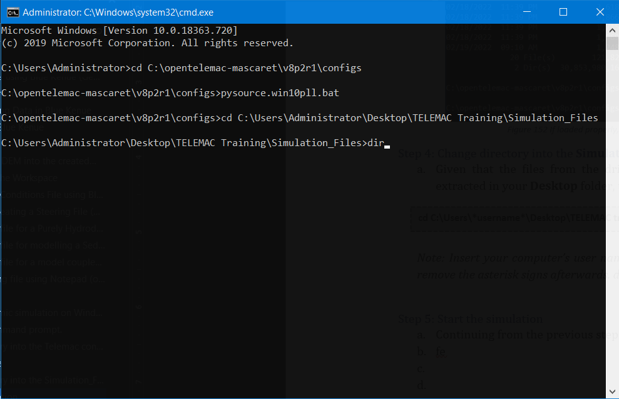

Figure 160. Typing dir in the Next Line

1. As demonstrated in page 39, this will display all the contents of the current directory. Do not forget to press **Enter**.
2. The content of the current directory is displayed below:

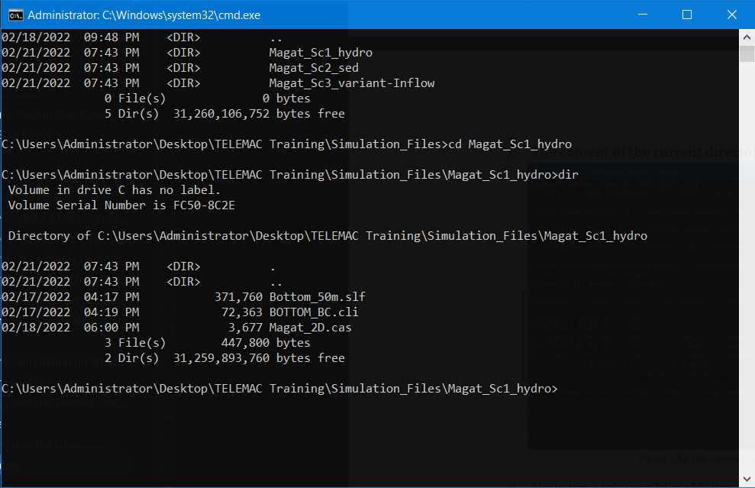

Figure 161. The Contents of the Current Directory

1. Now, type **telemac2d.py Magat_2D.cas**

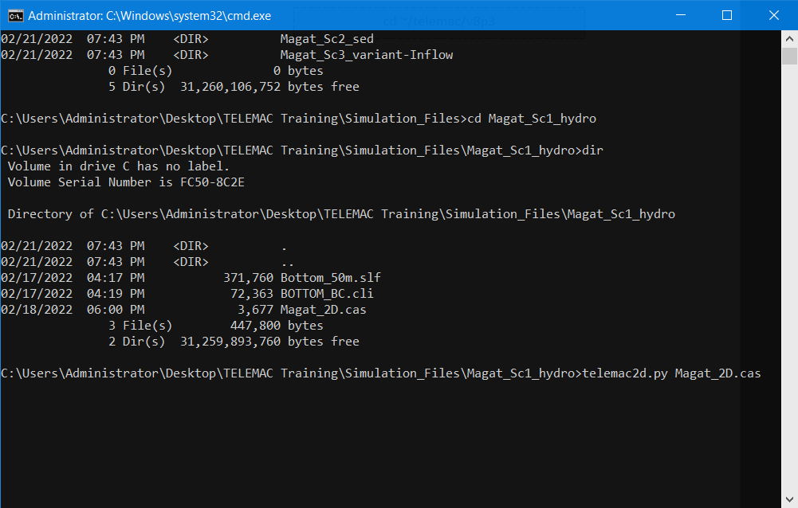

Figure 162. Starting the Simulation through Line of Code

1. Wait for the simulation to finish.

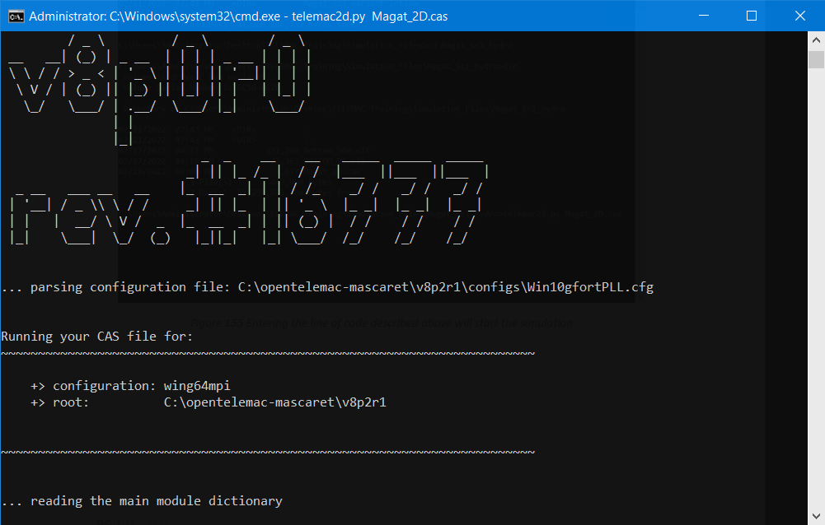

Figure 163. A Snapshot at the Start of the Simulation

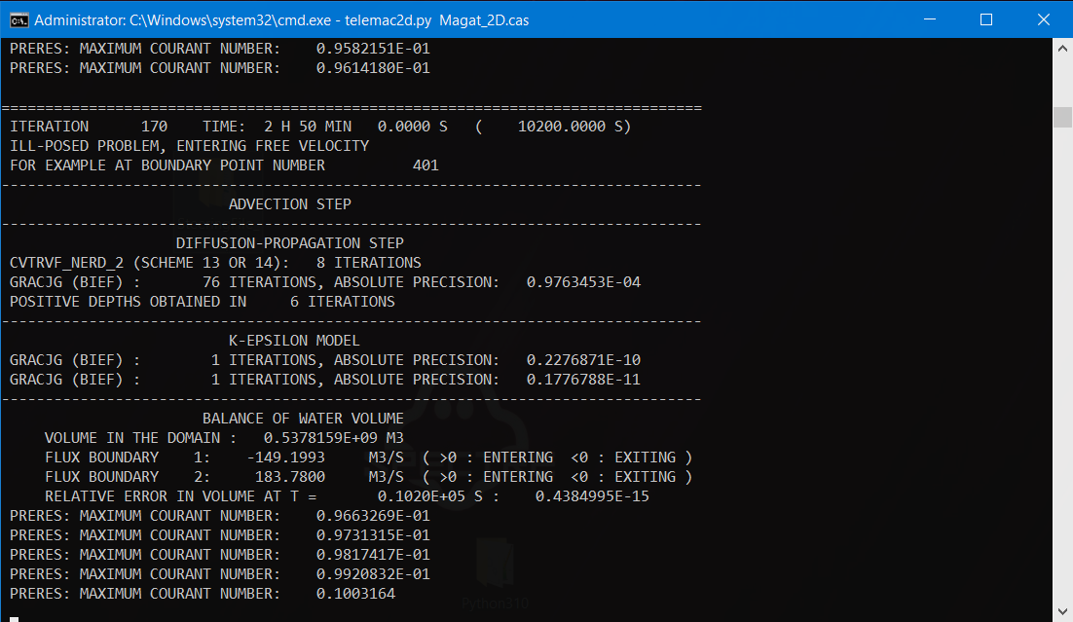

Figure 164. A Snapshot during the Simulation

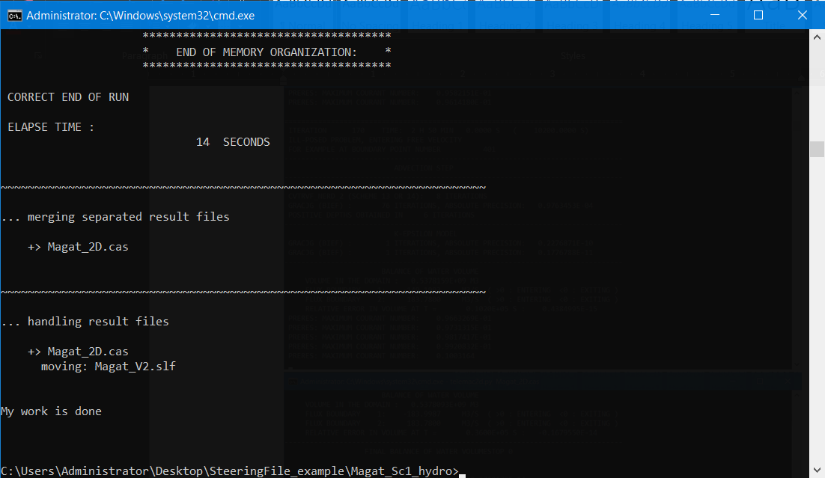

Figure 165. A Successful End of Run

*Note:*

*The steps shown above portray the steps in running the uncorrected steering file. To run the corrected steering file for the scenarios, simply change directory on where the files are stored and follow the same steps shown above.*

## Mint HyFo (Linux)

### Step 1: Boot up your virtual machine.



Figure 166. Booting the Virtual Machine

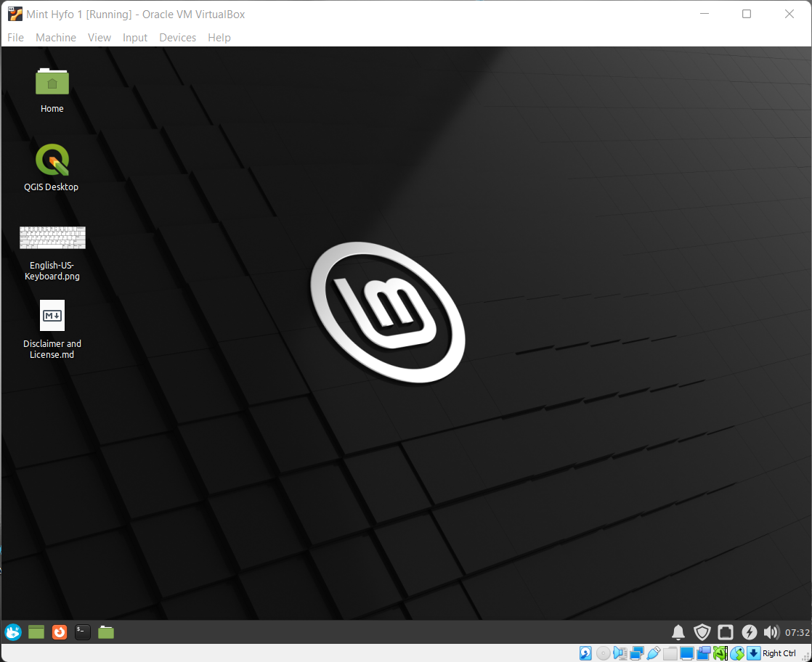

Figure 167. The Min Hyfo User Interface

### Step 2: Open Terminal.

Open **Terminal** by clicking this icon: 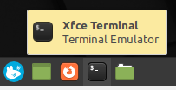

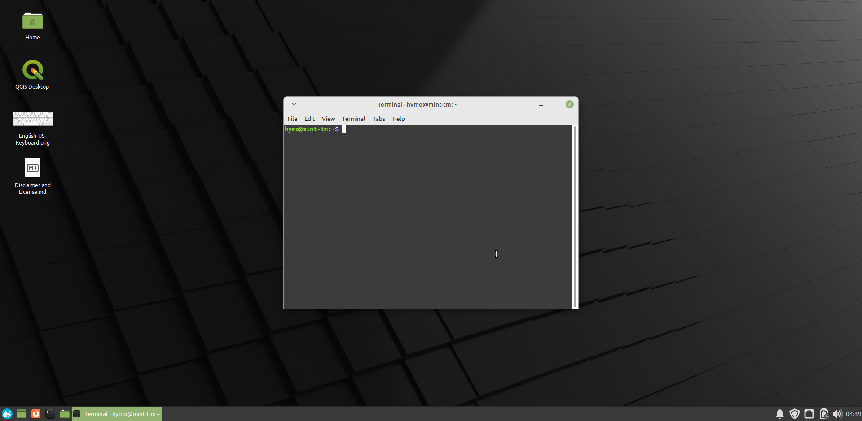

Figure 168. The Mint HyFo Terminal

### Step 3: Change the directory in the TELEMAC config file folder.

cd ~/telemac/v8p3/configs

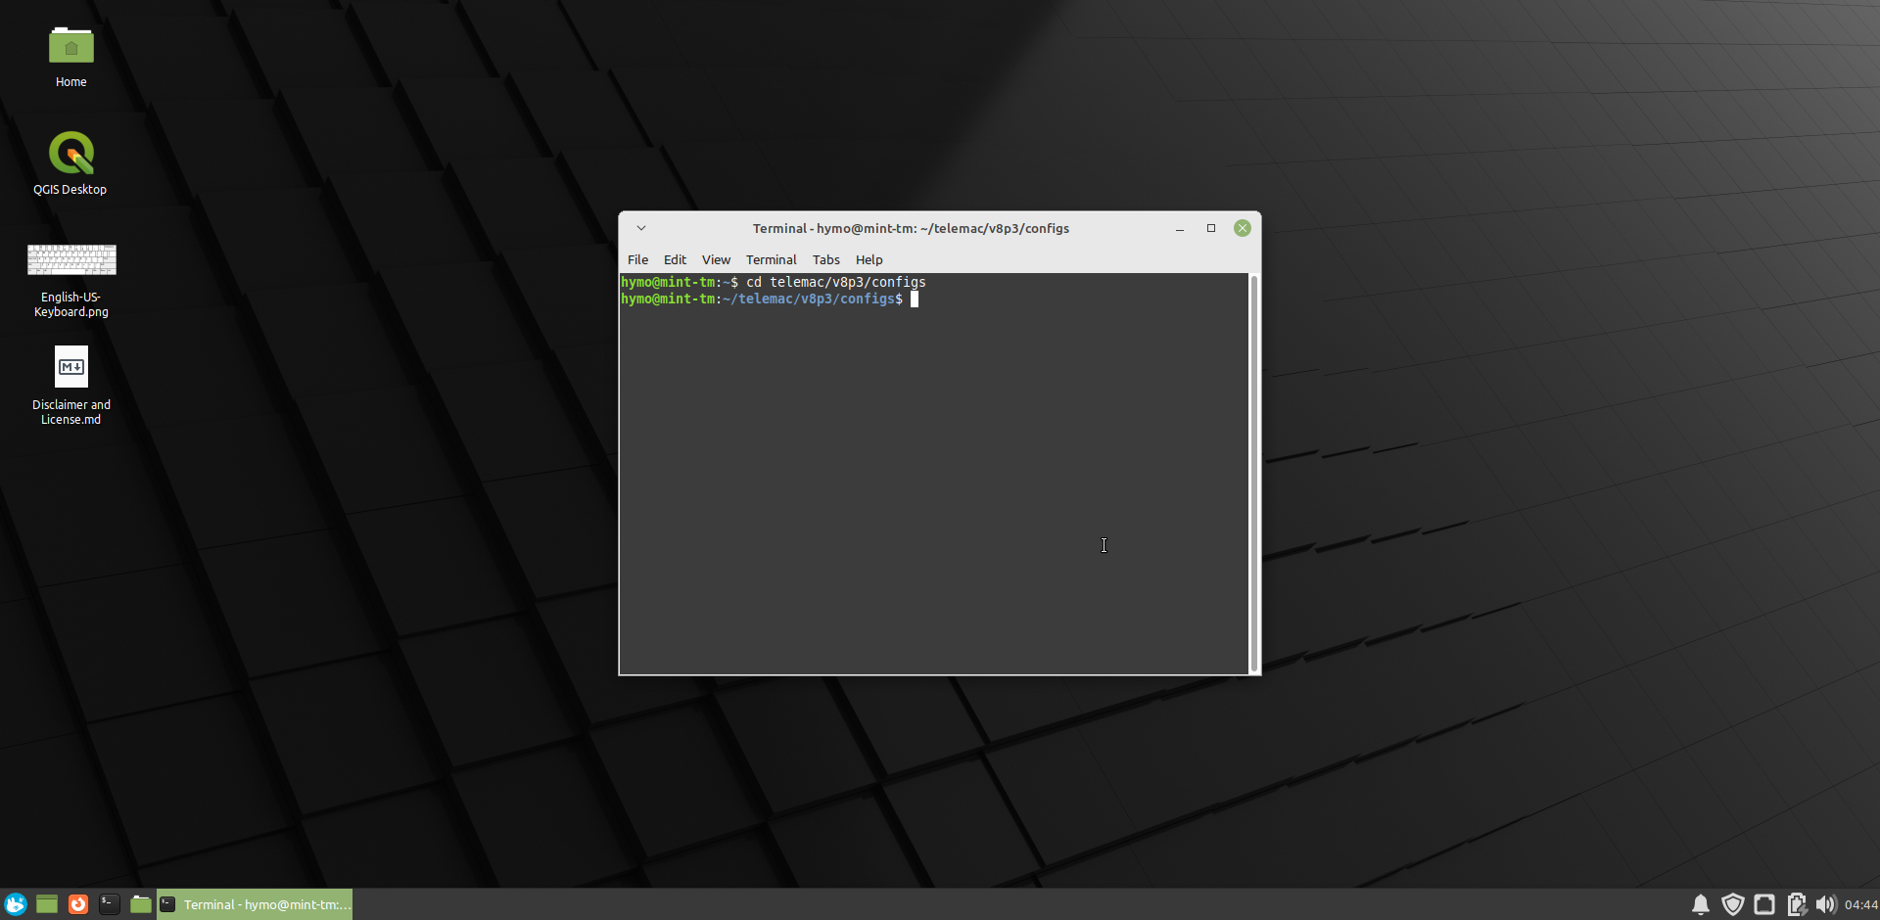

Figure 169. Changing the Directory (2)

### Step 4: Load the config file.

To load the config file:

source pysource.hyfo.sh

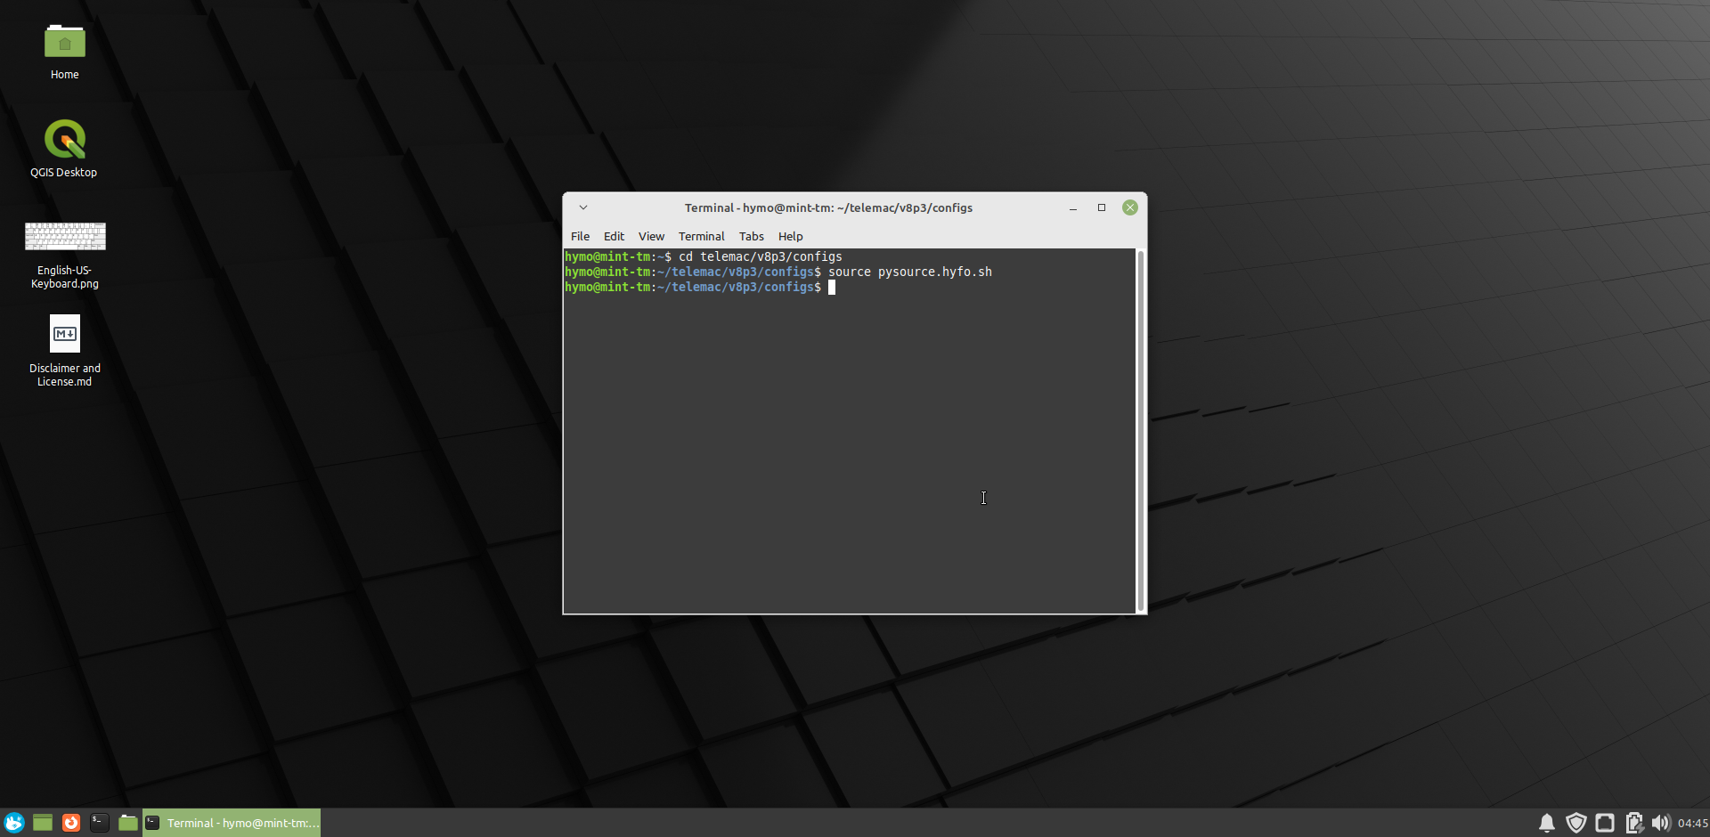

Figure 170. Loading the Config File

### Step 5: Change the directory in the **Simulation_Files** folder

cd~/Desktop/TELEMAC Training/Simulation_Files/Magat_Sc1_hydro

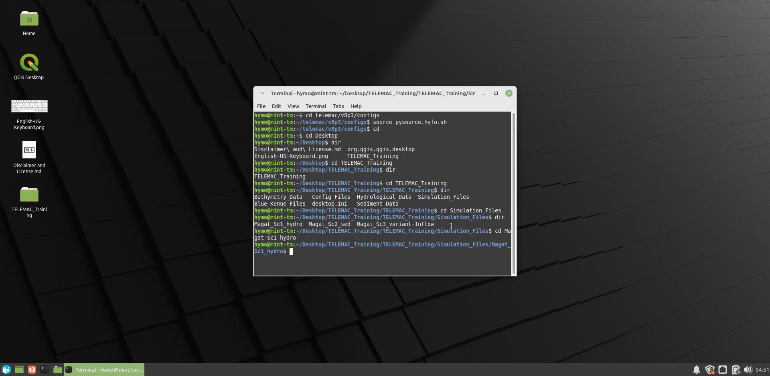

Changing directory again, but this time in the **Simulations_Files** folder

Figure 171. Changing the Directory (3)

### Step 6: Start the simulation.

telemac2d.py Magat_2D.cas

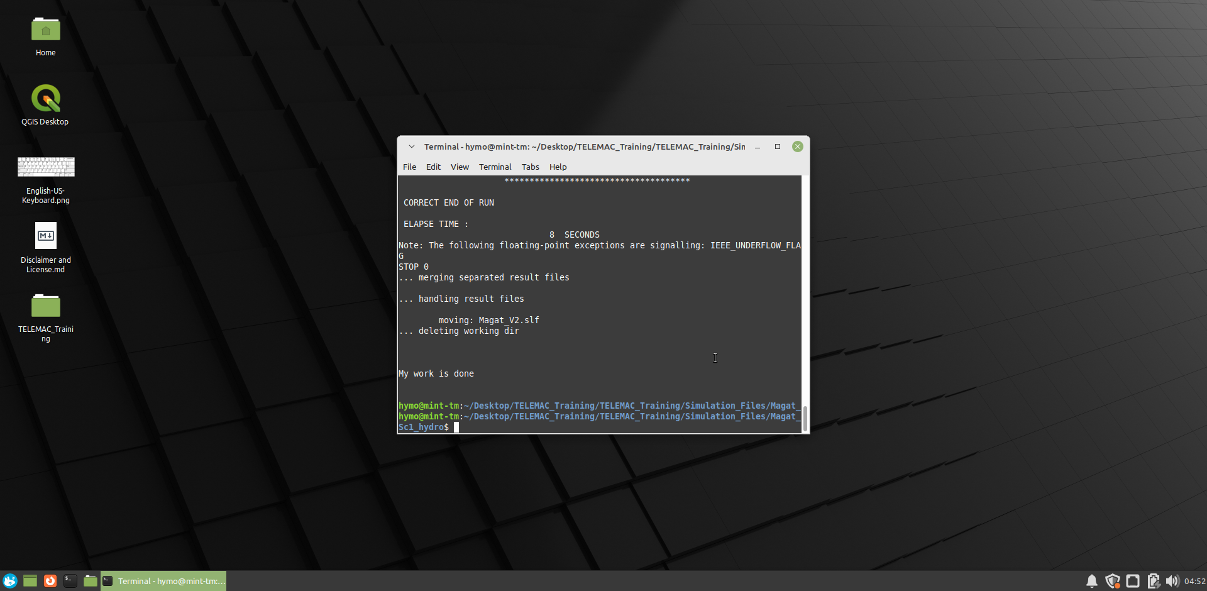

Figure 172. The Correct Run in Mint Hyfo

*Note:*

*The steps shown above portray the steps in running the uncorrected steering file. To run the corrected steering file for the scenarios, simply change directory on where the files are stored and follow the same steps shown above.*

# Post-Processing

## Post-Processing Using Blue-Kenue

1. Continuing from a successful run, a new *.slf file called “**Magat_V2.slf**” should have been created inside our simulations file folder.

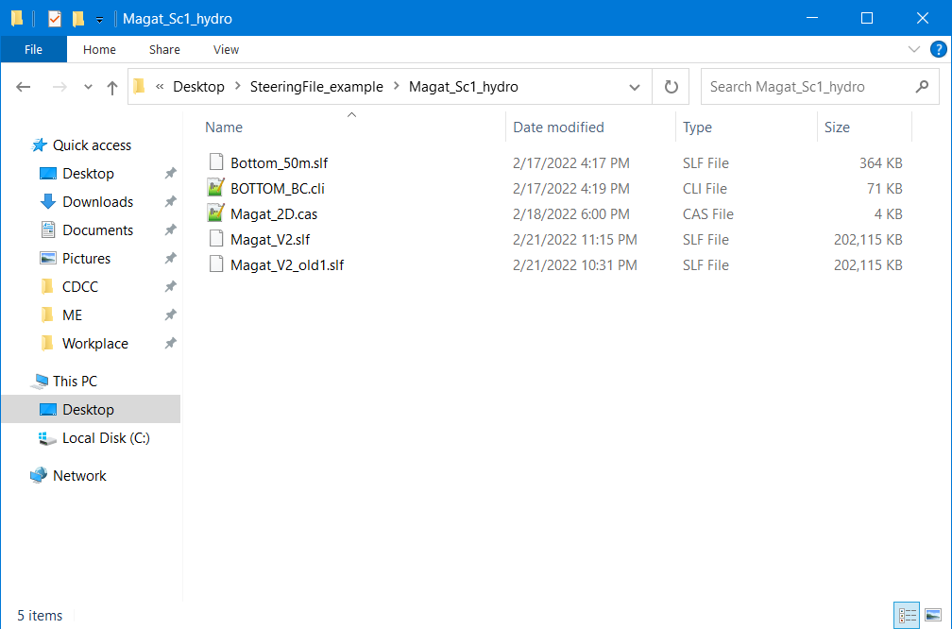

If ever you have run a simulation twice, a “**-old**” will be added into the file name of the first results file. (i.e., **Magat_V2_old.slf)**

Figure 173. The New File Called Magat_V2.slf

1. Open the Blue Kenue application.

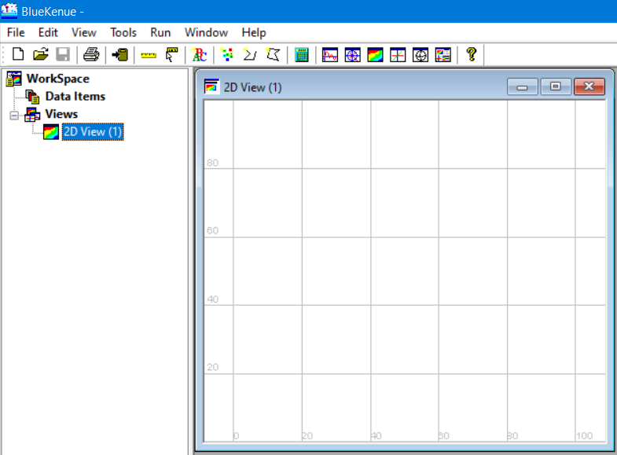

Open the newly generated result of the simulation.

Figure 174. The Blue Kenue User Interface

1. Open the Magat_V2.slf file.

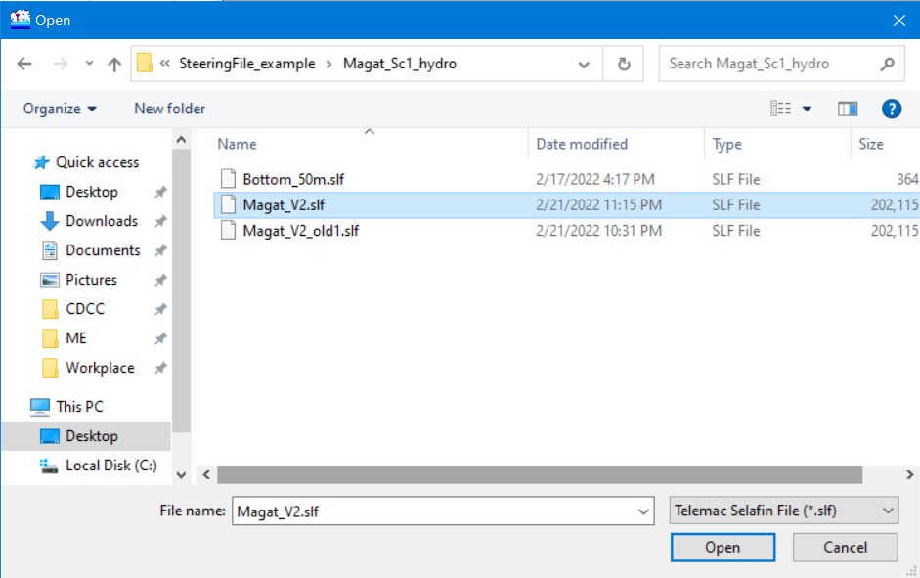

Figure 175. Opening Magat_V2.slf

1. Blue Kenue will read the Selafin file and after a few seconds, display a **Done** message window.

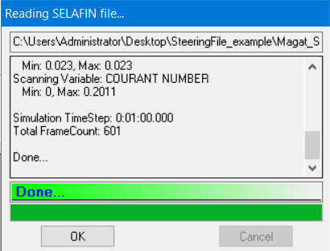

Click **OK.**

Figure 176. A successful Reading and Opening of the Results File

1. Results are now loaded and can be seen under the **Data Items** menu.

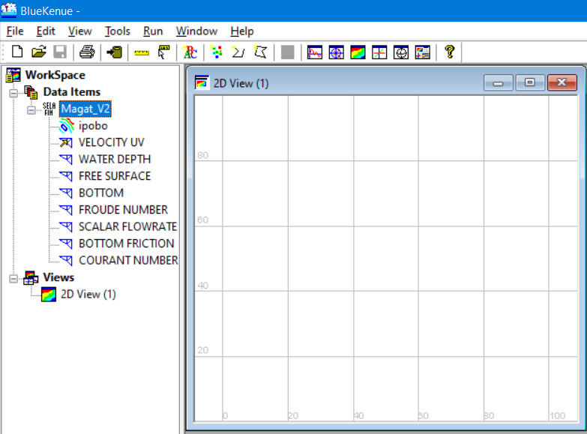

Figure 177 Results file content successfully loaded

### Visualizing Velocity in Blue Kenue

1. Drag the **VELOCITY UV** item into the **2D View.**

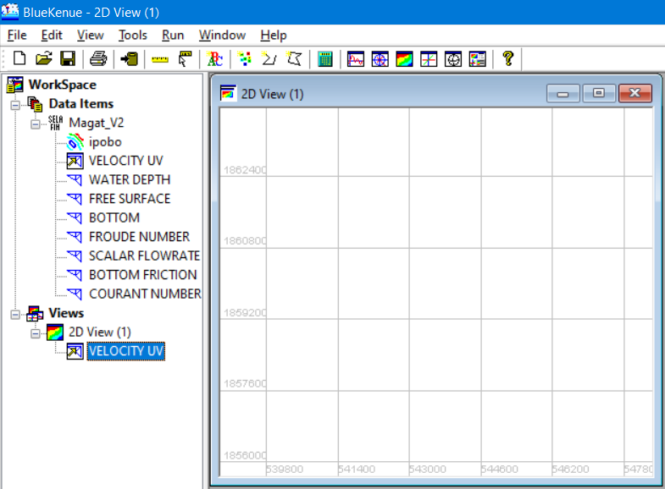

Figure 178. Velocity UV under 2D View

1. Notice that the 2D view window is still empty even after dragging the **VELOCITY UV item** into it.
2. To display the result, right click the **VELOCITY UV** (the one under 2D View) and select **Animate.**

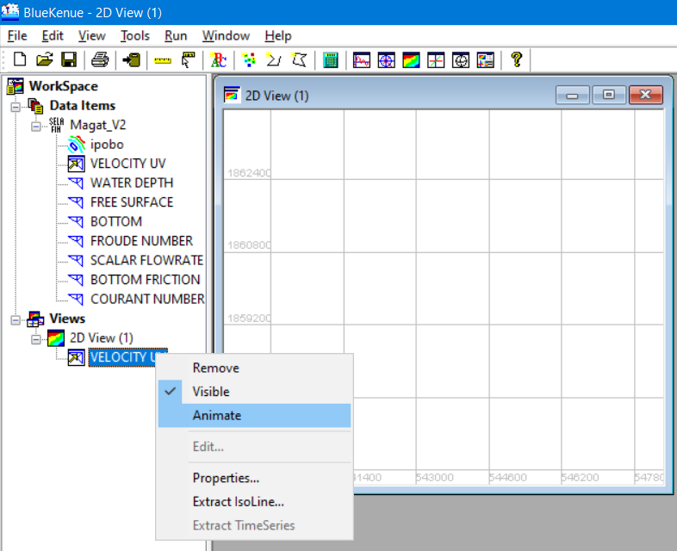

Right click>> **Animate.**

Figure 179. Right Clicking on the VELOCITY UV to Display the Result

1. Notice a new **Playback options** now added into the 2D View. Hit the “**play”** icon.

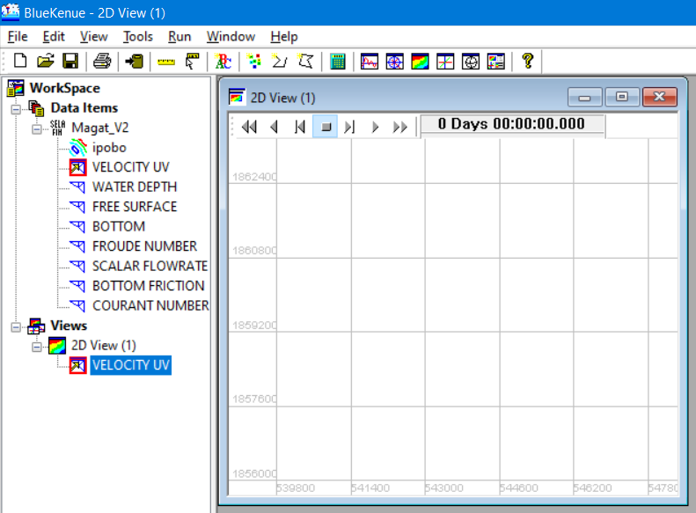

Click the “**play”** icon.

Figure 180. The 2D View with the Animate Playback Option

1. An animation showing the simulated velocity will be shown:

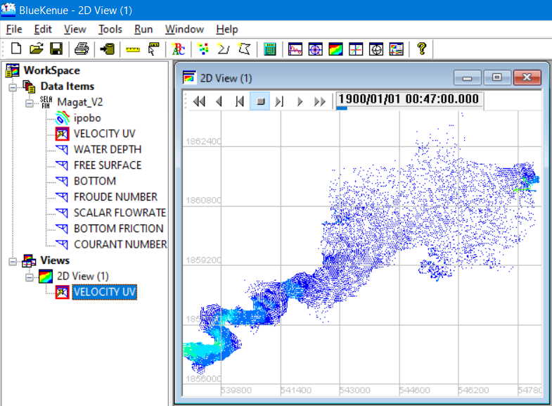

Figure 181. The Animated VELOCITY UV

1. You can modify the properties of the item to show another rendering style, show legend, etc.

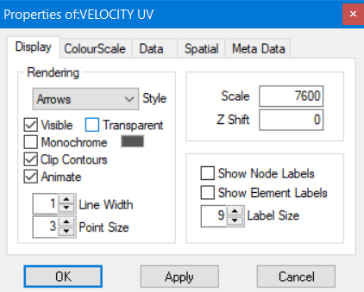

Figure 182. The Display Option Properties

1. Feel free to explore and tinker with the settings to suite preference.
2. To show the legend, select the “**ColourScale”** tab and activate the “**Legends”** tick box.

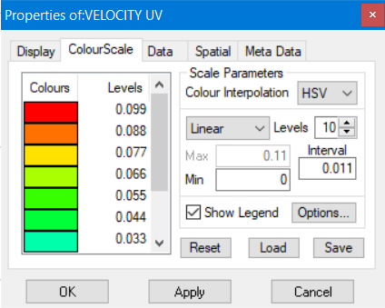

Activate “**Legend”.**

Figure 183. The Activation of the Legend Box

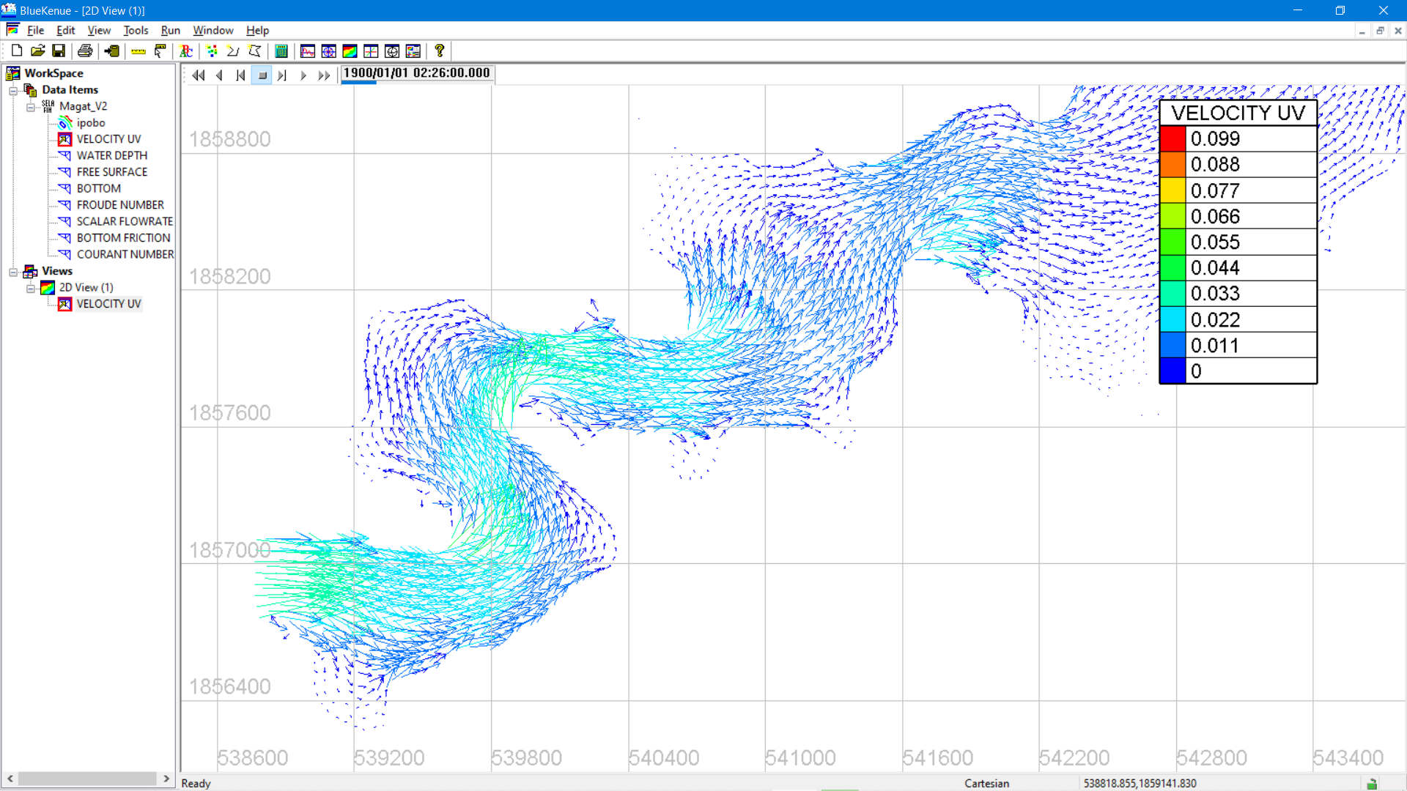

Figure 184. A Simple Visualization of the VELOCITY Profile Using Blue Kenue

# Appendix I: Enabling .NET Framework 3.5

1. Type and search for “**Windows Features**” on your windows start menu.

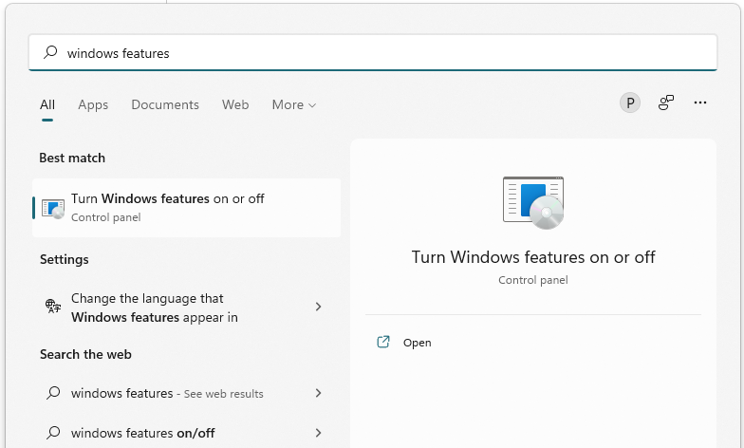

Figure 185. Searching for Windows Features

1. Select “**Turn Windows features on or off**”.

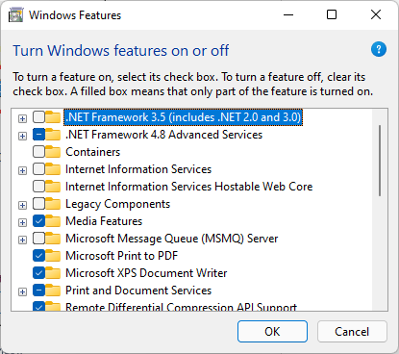

Figure 186. The Windows Features window

1. Make sure to select and enable the “**.NET Framework 3.5 (includes .NET 2.0 and 3.0)”.**

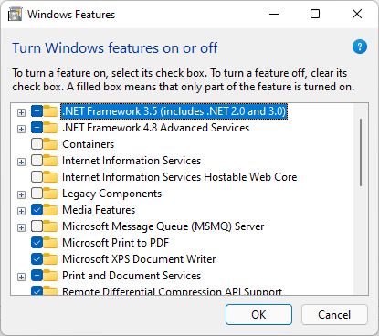

Figure 187. Enabling the .NET Framework 3.5

1. Click **“OK”** to finish. On some devices, your computer/s might have to search and download some components. This will be done automatically so the user/s don’t have to worry about it.

# Appendix II: List of Possible Errors

1. This happens when TELEMAC automatic installer fails.



Figure 188. TELEMAC Automatic Installation Failure

This error can be caused by unstable internet connection. To solve this, please see Automatic Installer Failure section.

1. This error occurs when pip3 is not recognized as an internal or external command, operable program or batch file.

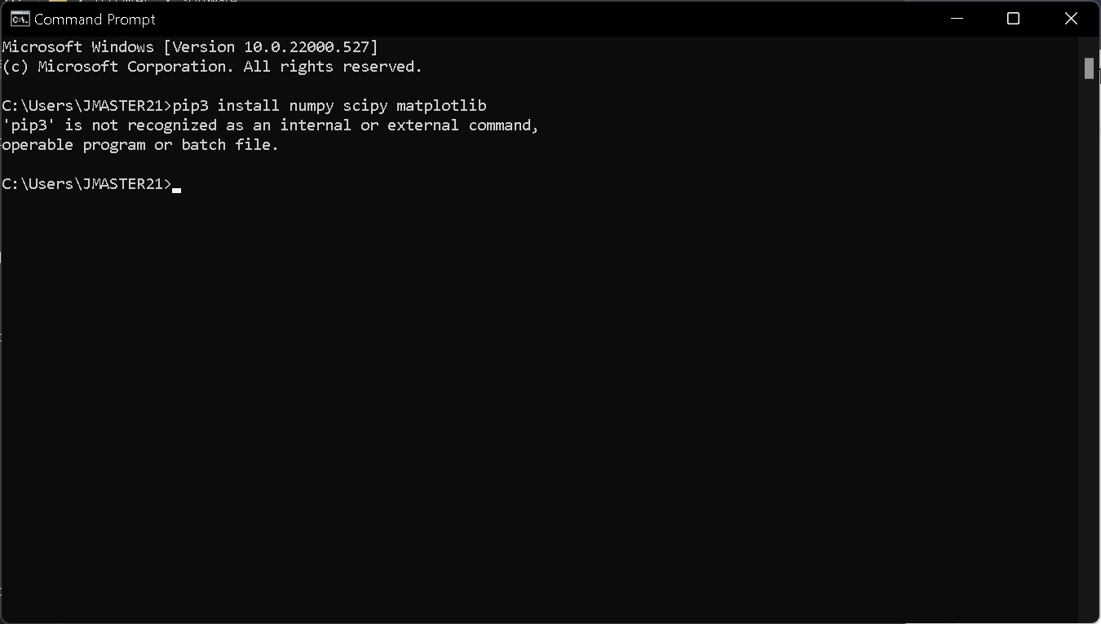

Figure 189. pip3 Error

This error can be possibly encountered after trying to manually install the numpy, scipy, and matplotlib libraries. Please see page 30 for reference.

Probable cause:

* Python 3.10 (or the newly installed python) is not added to the path.

Solution:

* Follow properly the steps in Installing Python 3. or
* Manually add it to the path. See Adding items into the System Variables Path.

1. ImportError: No module named configparser.

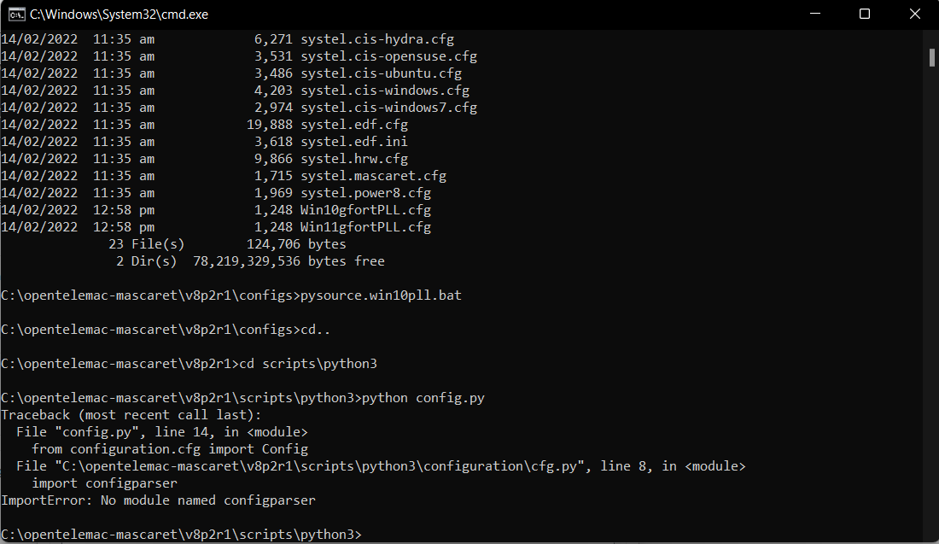

Figure 190. The Configparser Error

This same error might be encountered after trying to load the **config.py** file. This can be solved by making sure that both the config and batch files (**pysource.win10pll.bat** and **Win10gfortPLL.cfg**) are extracted in the correct directory. Please see Figure 43 on page 35.

Additionally, make sure also that the steps in Adding items into the System Variables Path in the system variables are correctly followed.

1. ImportError: No module named request.

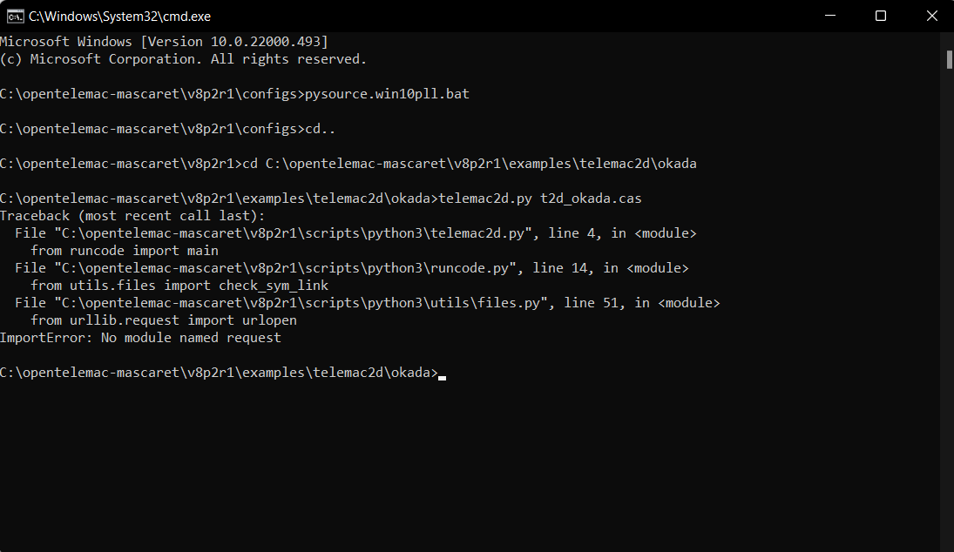

Figure 191. No Module Named Request Error

This error can be resolved also by making sure that the steps in Adding items into the System Variables Path in the system variables are correctly followed.

1. This occurs when telemac2d.py is not recognized as an internal or external command operable program or batch file.

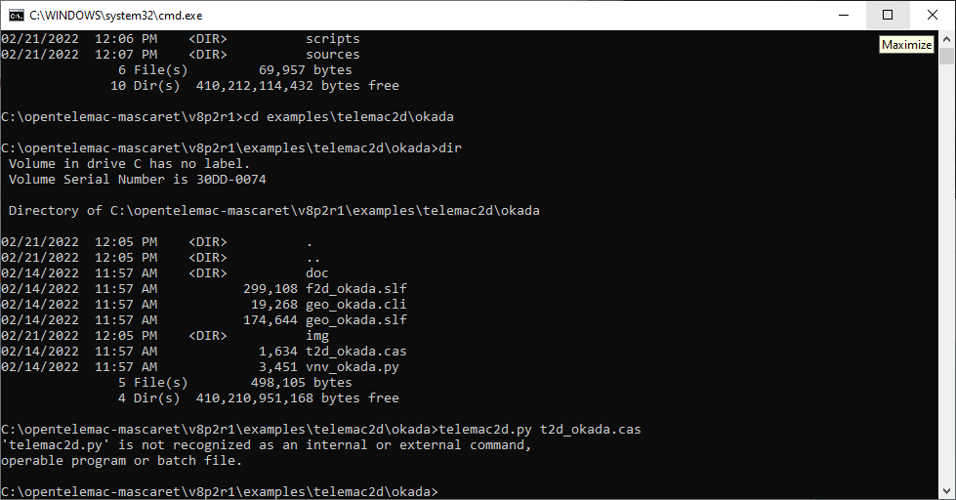

This error can be resolved also by making sure that the steps in Adding items into the System Variables Path in the system variables are correctly followed.

*Note:*

*If, for some reasons, the above steps do not solve the problem, try to uninstall Python and reinstall it again by following the steps described in the* *Installing Python 3* *section.*

*If the problem persists, then follow the steps in installing the Mint Hyfo Machine described in this* *section* *(Page 46).*

# Appendix III: General Summary of Steps in Running a Model

For both Windows and Linux (Mint HyFo) Environment

1. Load cmd environment.
2. Change the directory in the TELEMAC config file folder.
3. Load the provided config file.
4. Change the directory where simulation files are located.
5. Start the simulation by typing telemac2d.py *filename*.cas.

*Note:*

*Please see* *Running the Model Setup* *section for more information. Page 104.*

# Appendix IV: Visualized Results Files

## Scenario 1 – Initial/ Uncorrected Steering File

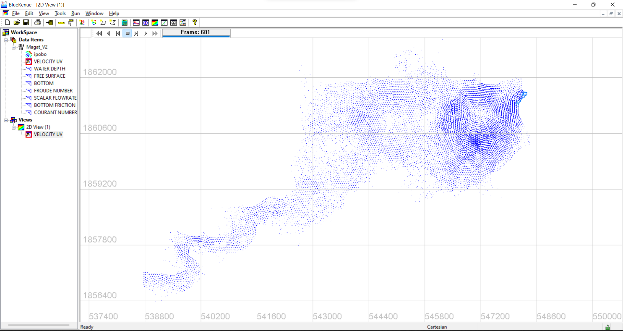

Figure 192. Scenario 1 Velocity Profile Visualized in BlueKenue

## Scenario 1– Adjusted Steering File

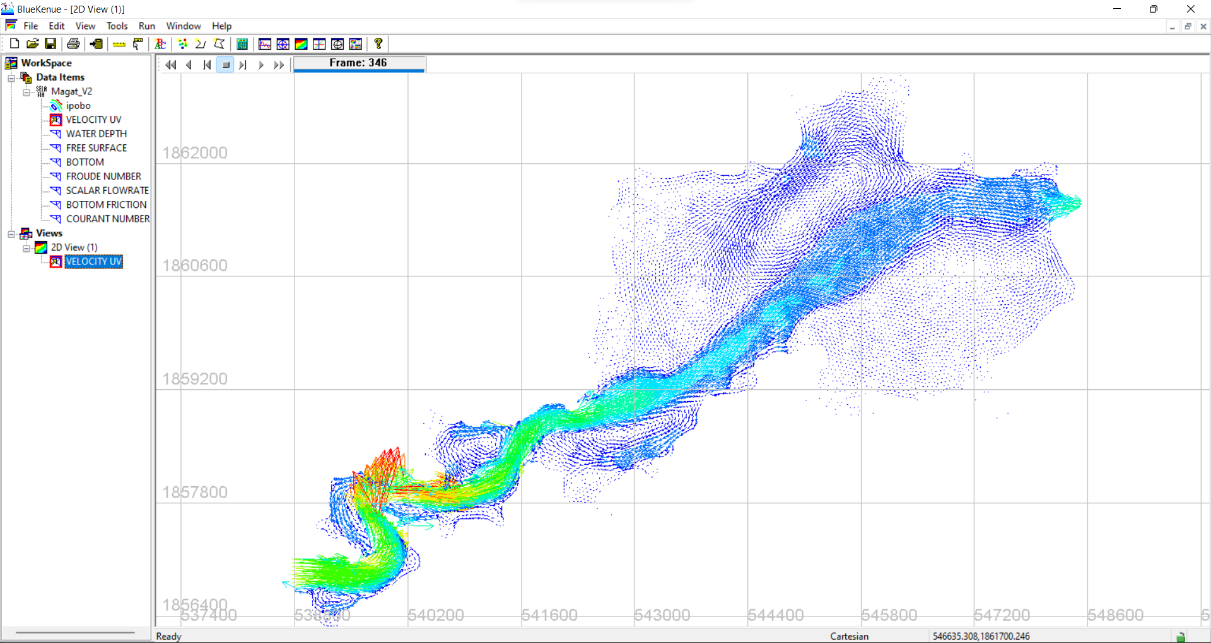

Figure 193 Scenario 1 Velocity Profile Visualized in BlueKenue

## Scenario 2 – Initial/ Uncorrected Steering File

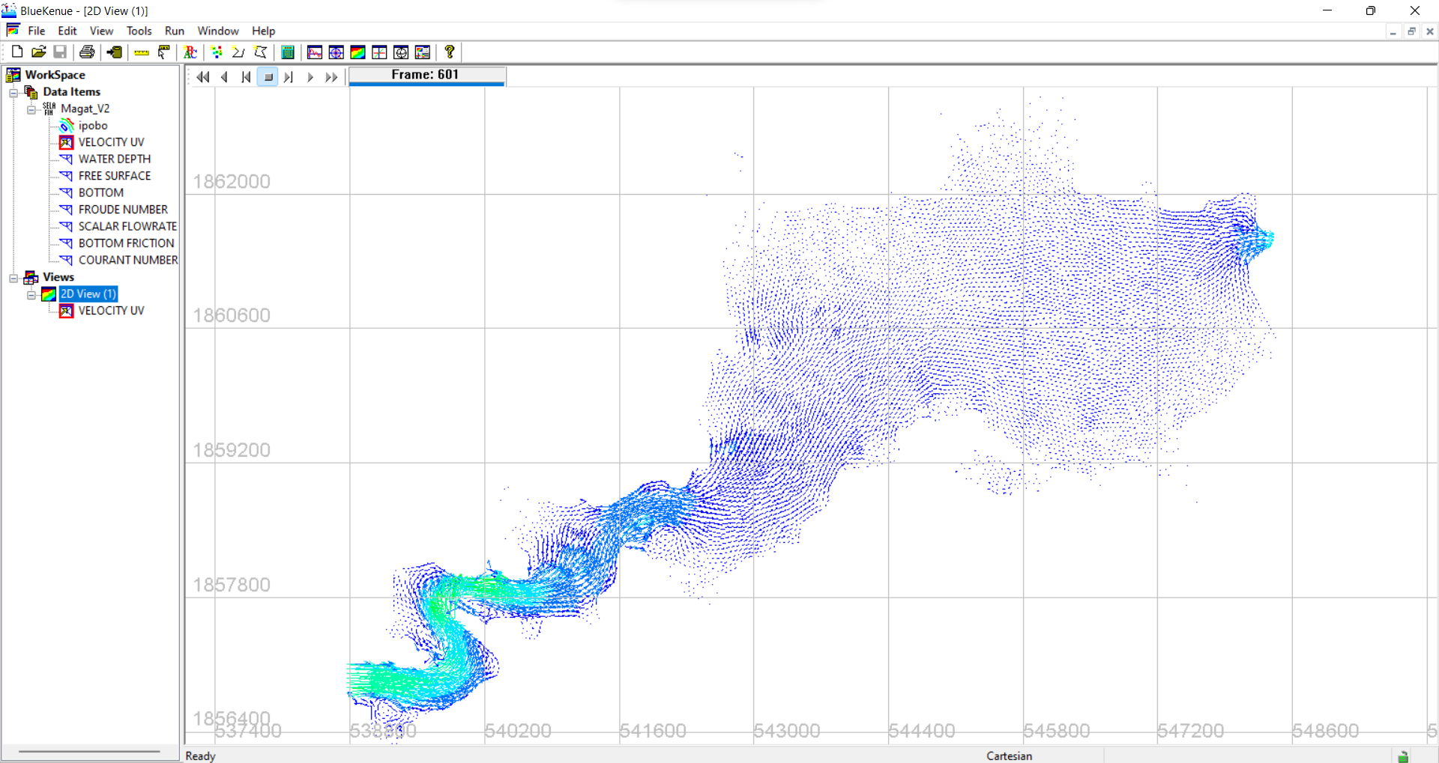

Figure 194. Scenario 2 Velocity Profile Visualized in BlueKenue

## Scenario 2 – Adjusted Steering File

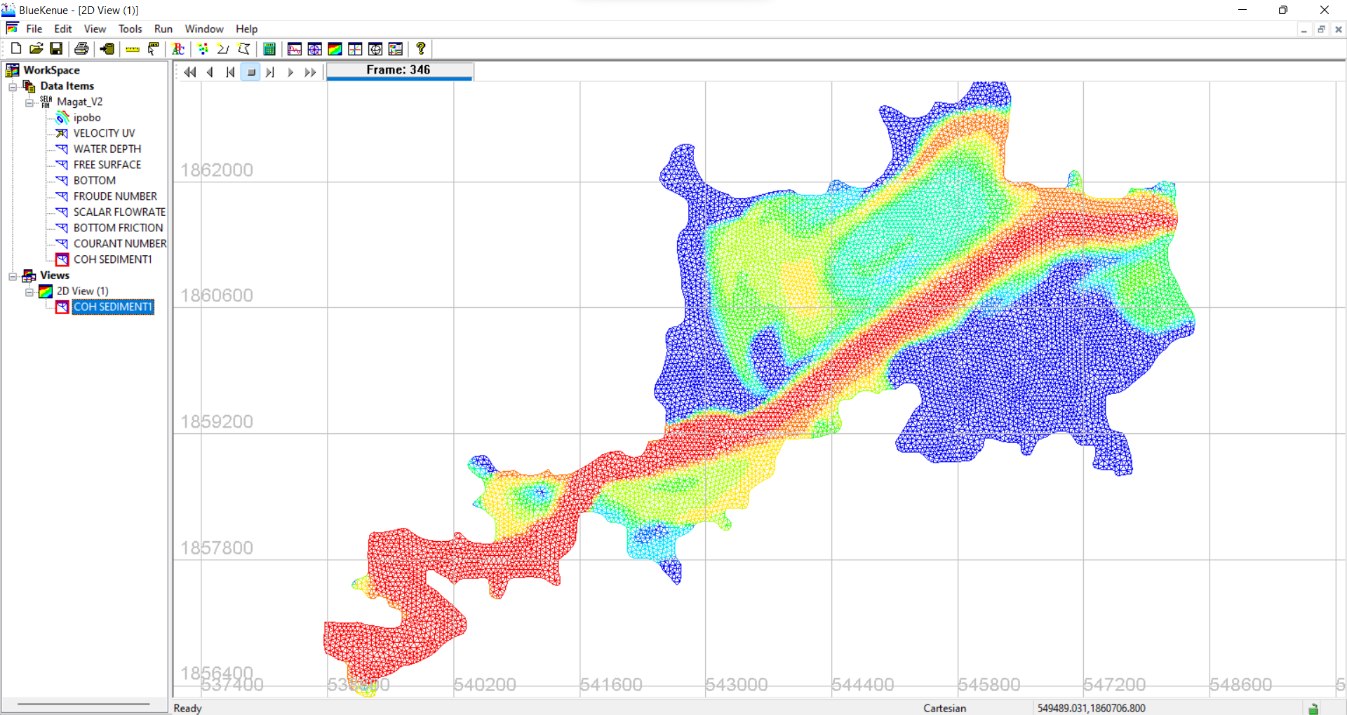

Figure 195. Scenario 2 Sediment Transport Profile Visualized in BlueKenue

## Scenario 3 – Initial/ Uncorrected Steering File

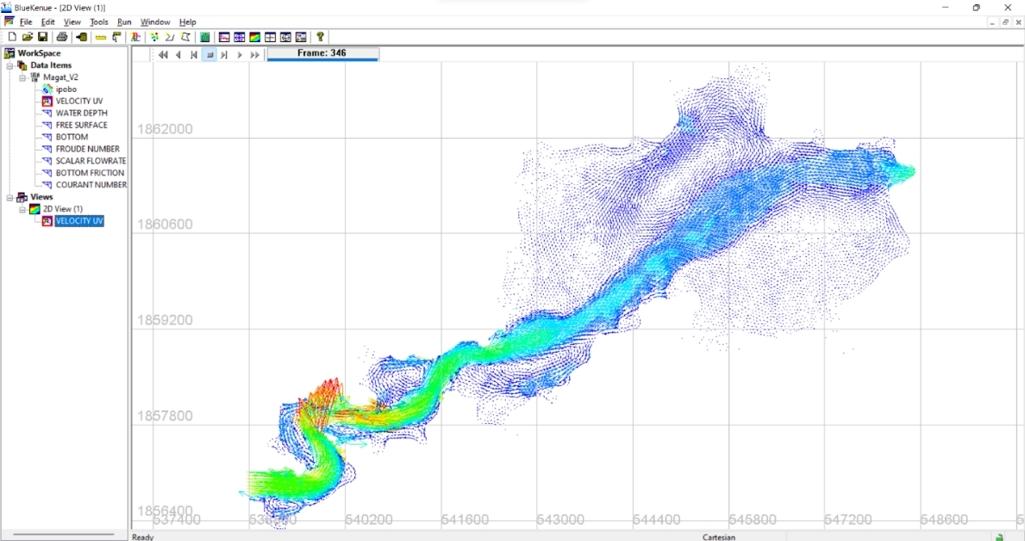

Figure 196. Scenario 3 Velocity Profile Visualized in BlueKenue

## Scenario 3 – Adjusted Steering File

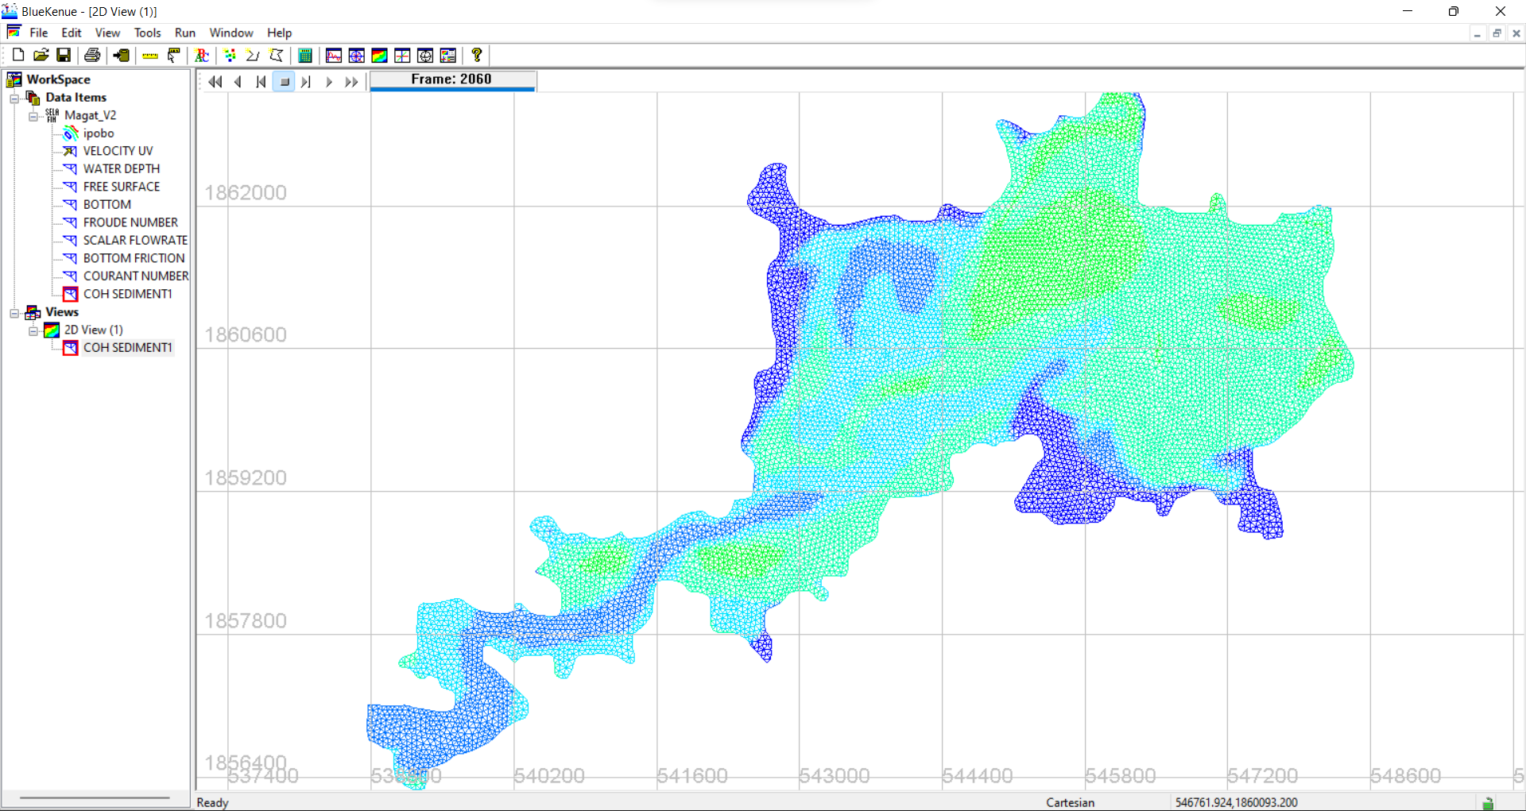

Figure 197. Scenario 3 Sediment Transport Profile Visualized in BlueKenue

# Appendix V: Downloading the latest release, TELEMAC v8p3

1. Go to <http://www.opentelemac.org/> and log in using your account.

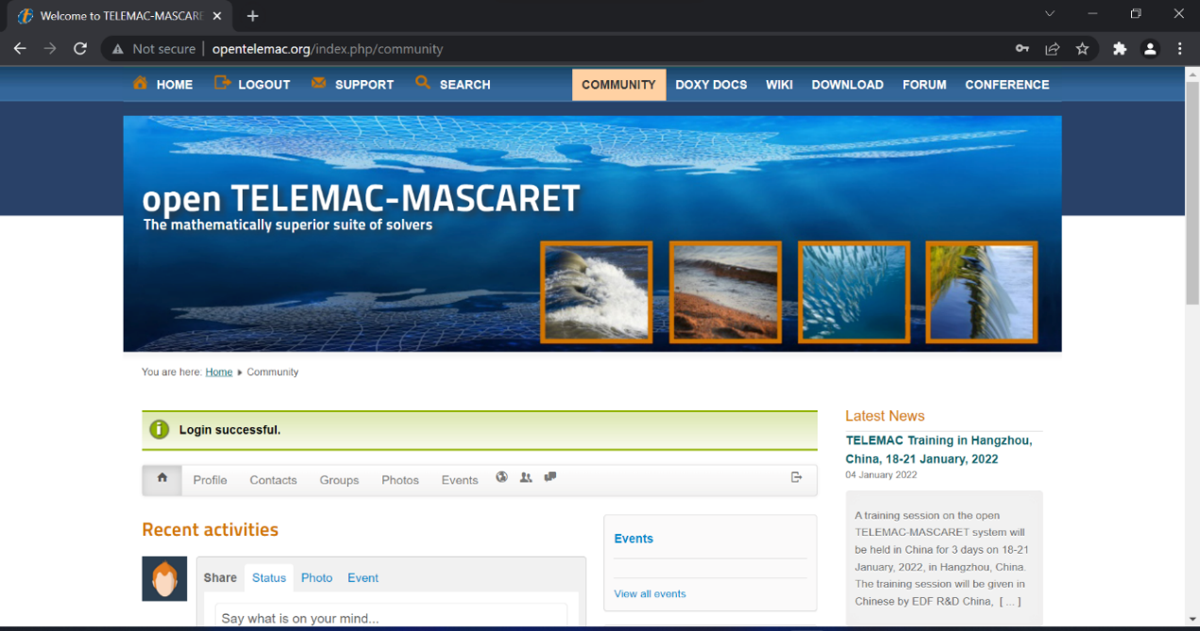

Figure 198. Logging-in to your Telemac account

1. On the search bar, type “v**8p3r0**” or you can check the latest version in the **Latest News** section located at the right side of your screen.

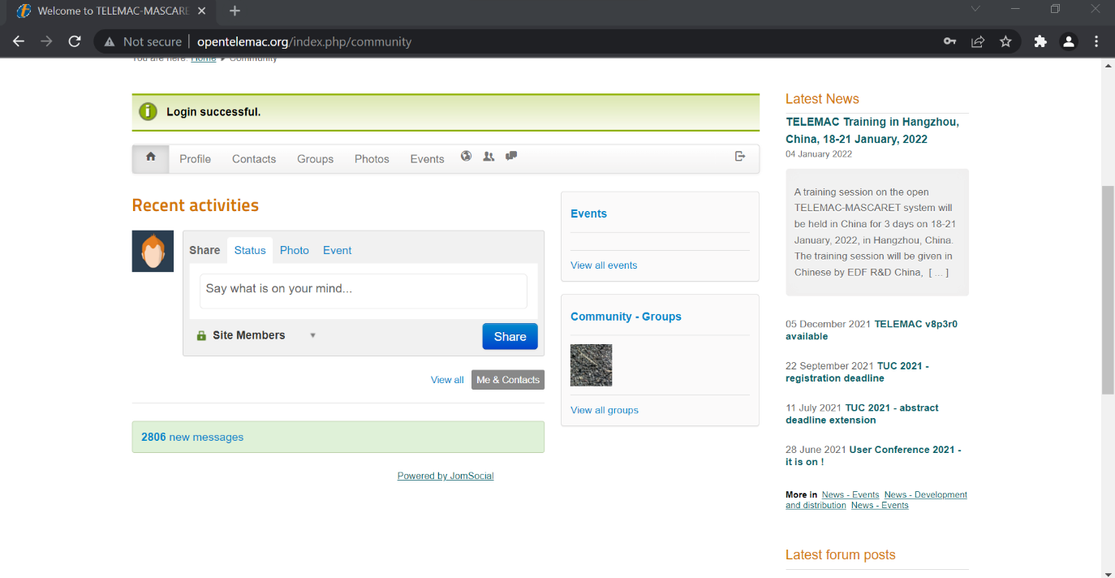

Figure 199. The Latest News section of the Telemac website

1. Click “**v8p3**” to navigate into the downloading page.

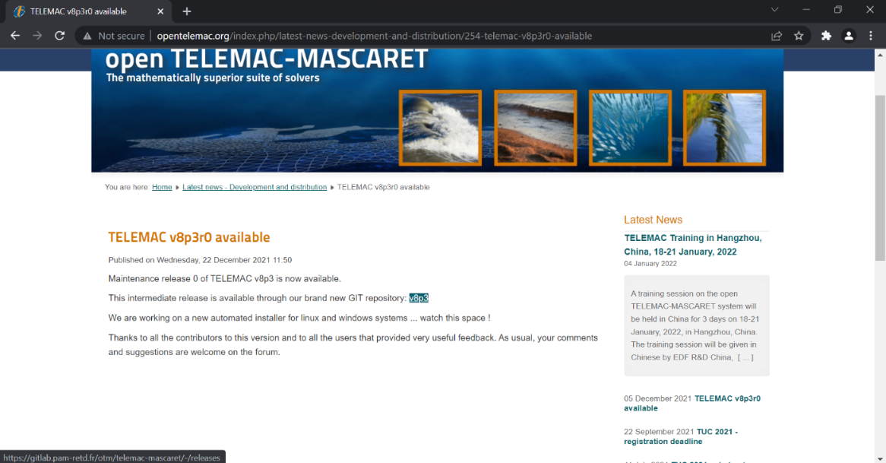

Figure 200. A short release statement regarding the availability of v8p3 version

1. The latest release is hosted through Git and will provide a faster checkout process compared to the traditional SVN. Click on “**Source Code”** to start downloading.

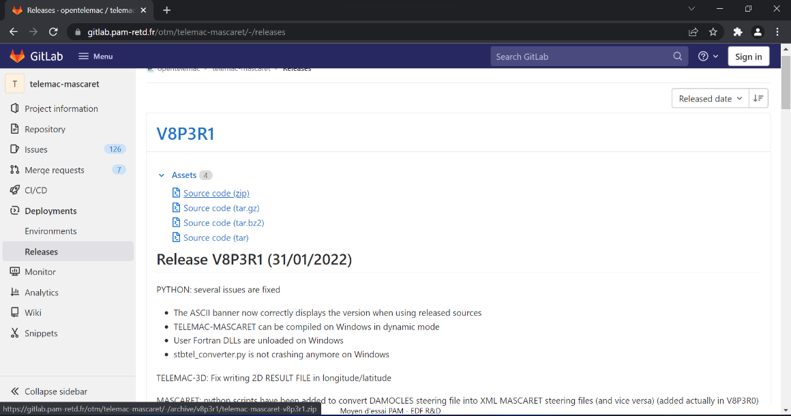

Figure 201. The source code download section

1. Download and save the compressed file into your TELEMAC installation folder (**C:\opentelemac-mascaret**).
2. Extract the contents of the downloaded compressed file.

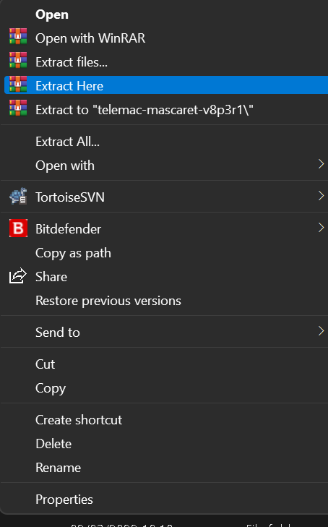

Figure 202. Extracting the contents of the downloaded compressed file

# Appendix VI: Importing an existing shapefile as an outline.

If, for instance, you have already generated an outline for your study area using any GIS application, you can use and import it into BlueKenue to save some time in drawing your outline.

1. Click on File >> Import >> ArcView Shape File.

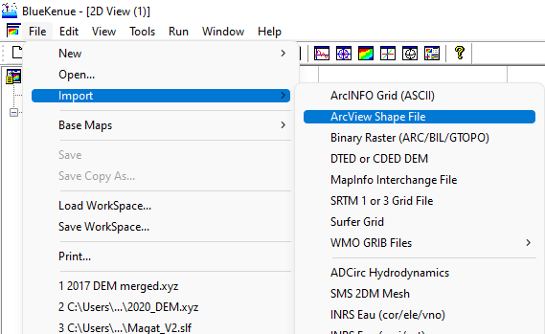

Figure 203. Importing a shapefile

1. Navigate into where your .shp is located and select and open it.

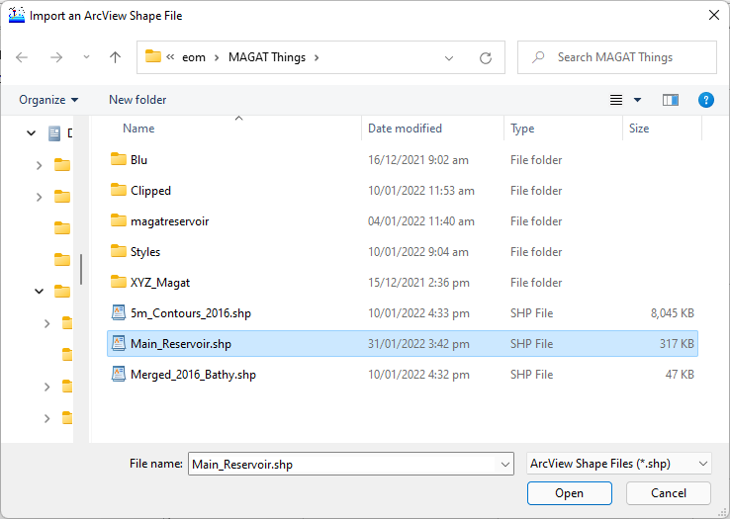

1. BlueKenue will try to read and load your file. If no errors were encountered, a “**DONE**” message shall appear. Click OK to close the message.

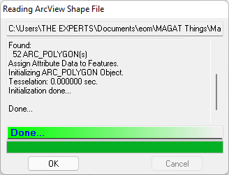

1. You can now drag and drop the loaded shp file into your 2D view to visualize it.

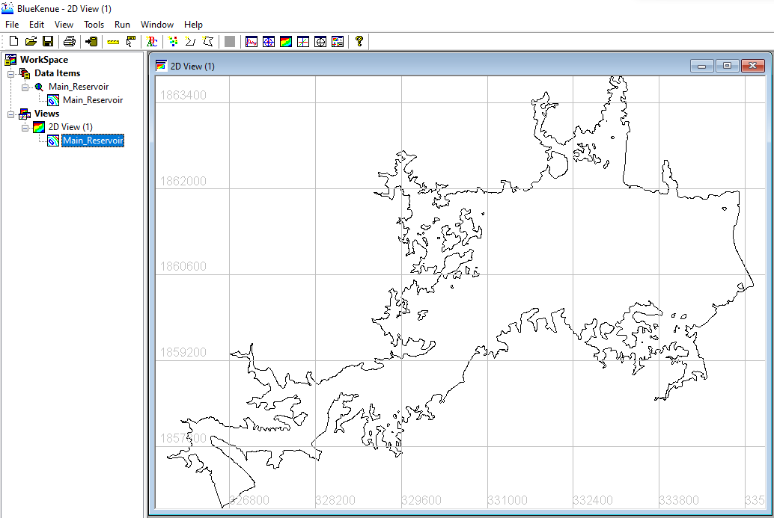

Figure 204. The Magat Reservoir outline loaded as a shapefile

# **References**

Canadian Hydraulics Center (CHC) - National Research Council (NRC). (2011, September ). Blue Kenue Referene Manual.

ELECTRICITE DE FRANCE (EDF). (2022, February). *Modules*. Retrieved from open TELEMAC-MASCARET: http://www.opentelemac.org/index.php/modules-list

Galland, J.-C., Goutal, N., & Hervouet, J.-M. (1991). TELEMAC: A new numerical model for solving shallow water equations. *Advances in Water Resources, 14*(3), 138-148.

Leon, A., & Gifford-Miears, C. (2013). Tutorial on the use of TELEMAC-2D Hydrodynamics model and Pre-/Post-processing with BlueKenue for flood-inundation mapping in Unsteady Flow Conditions. Oregon State University.

Schwindt, S. (2022). *TELEMAC.* Retrieved February 2022, from Hydro-Informatics: https://hydro-informatics.com/numerics/telemac.html